INVESTIGATION

ASSESSMENT

TASKS



MATHEMATICS

APPLICATIONS

UNITS 3 & 4

YEAR 12

**Foreword**

|  |
| --- |
| For each unit three types of tasks are included: |
| * **Extended investigation** – an investigation; the preparation activity of which could be done in class or in the student’s own time followed by an in-class validation. Solutions are provided where practicable for the preparation activity/investigation. For the in-class validation, there are solutions and marking keys, which identify the mathematical behaviours that students may exhibit. |
| * **In-class investigation** – an investigation for which no prior preparation is required. Solutions and marking keys are provided. |
| * **Investigative questions** – a series of short questions, which test the student’s ability to apply their learning, to justify their conclusions, to investigate and to generalise, or to solve problems. Such questions could be included in a response or examination assessment. Solutions and marking key are provided. |

Screen shots have been produced using the CASIO ClassPad II emulator

Most graphs and diagrams have been produced using efofex software.

The syllabus dot points are reproduced here under a licence agreement with the SCHOOL CURRICULUM AND STANDARDS AUTHORITY. The Authority is acknowledged as the owner of all dot points from the Year 12 Mathematics Applications syllabus.

© The investigations and solutions in this publication are for the sole use of staff and students of the purchasing school. It is a breach of copyright to distribute them in whole or part in any form now or in the future to any other school, company or person.

Students should not be given copies of the validation parts or the solutions to the investigations to take home.

Contents

MATHEMATICS APPLICATIONS: Year 12

**3.1 Bivariate data analysis**

Task 1: Extended investigation: Statistical investigations 4

Task 2: In-class investigation: Quantifying correlation 19

Task 3: Investigative questions 32

**3.2 Growth and decay in sequences**

Task 4: Extended investigation: Growth and decay 40

Task 5: In-class investigation: Constant and proportional change 57

Task 6: Investigative questions 68

**3.3 Graphs and networks**

Task 7: Extended investigation: Roads 74

Task 8: In-class investigation: Competition 89

Task 9: Investigative questions 106

**4.1 Times series analysis**

Task 10: Extended investigation: Seasonal change 115

Task 11: In-class investigation: Data smoothing 131

Task 12: Investigative questions 144

**4.2 Loans, investments and annuities**

Task 13: Extended investigation: Going down 153

Task 14: In-class investigation: Investigating interest 167

Task 15: Investigative questions 181

**4.3 Project planning and scheduling using critical path analysis (CPA)**

Task 16: Extended investigation: Planning 188

Task 17: In-class investigation: Trees 206

Task 18: Investigative questions 220

**TASK 1: STATISTICAL INVESTIGATIONS**

**Extended investigation**

**Unit 3**

**Topic 3.1: Bivariate data analysis**

**Course-related information**

The concepts and skills covered in this investigation relate to the following dot points within the WA Mathematics Applications syllabus:

3.1.1 review the statistical investigation process: identify a problem; pose a statistical question; collect or obtain data; analyse data; interpret and communicate results

Students will also be given the opportunity to

* identify and describe associations between two numerical variables
* fit a linear model to numerical data

The ability to chose and use appropriate technology to enhance and extend concept development is also required for some of the items.

**Background information**

The preparation activities are written with one particular problem to solve. Teachers may choose to work on this particular problem with the whole class or allocate some of the problems provided to small groups. The level of support provided by the teacher will vary according to the prior experience of the students. Solutions to questions posed will vary according to directions taken by students and are not given for these activities. Rather, comments on the activities are provided.

**Task conditions**

For the in-class component of this investigation, students will need about 40-50 minutes and access to calculator technology is not essential. Students should be allowed to bring their findings from the preparation activities to the in-class validation as the assessment is about understanding and using the statistical investigation process rather than memorising the associated details.

**Statistical investigations**

**Extended investigation Part 1:** **Preparation activities**

The purpose of this investigation is to provide students with experience in the statistical investigation cycle. There will be opportunities to

* clarify the problem and pose questions that can be answered with data
* design and implement a plan to collect data
* select and apply graphical or numerical techniques to analyse the data
* interpret and communicate the results of the analysis

(See glossary for Topic 3.1)

Completion of these activities is advised before accessing the in-class component of the investigation.

**Activity 1: The problem**

*Teachers in Agerla College are concerned about the amount of time that students have available to study on the weekends. In fact, the teachers believe that the students are undertaking too many hours of paid work and this is affecting the time spent studying.*

Consider this problem with respect to

* Are all words or phrases clearly understood?
* Do any words need to be defined?
* What is meant by the “weekend”? Does it include Friday night?
* What students are being considered? Should this investigation consider only one year group? Explain.
* What is meant by paid work? Should work around the home when pocket money is given for chores be included?
* What is meant by study? Does this include doing homework? Painting a piece of artwork for school?
* Does it matter who the teachers are? Or how many of them think this?

**Activity 2: Pose a question**

One question that could be answered by collecting data is

*Do students do enough study on the weekend?*

This question is one that related to the topic but there are better questions that related to the topic.

Write 3 more questions that can be answered with data and which relate to this topic.

Share the four questions with others and gather feedback on their suitability for investigation. Determine the best question before proceeding further with the investigation.

**Activity 3: Design the data collection**

Plan and design the collection of relevant data to answer the question. Use the following ideas to guide the planning.

* What data is needed? How many variables are there? What are they?
* What type of data will be collected? Numeric? Continuous or discrete?
* From where will data be collected? This school, which class, which year groups?
* How will the data be collected? Written or oral survey?
* How will the data be kept secure?
* Where will the data be stored? What backup of data is needed?
* How many students will provide data? How do we know that there is enough data to determine any relationships?
* Do the students need to be randomly selected for the survey?
* Is the sample biased? Will it represent the population of students which is the focus for this investigation?
* When will the data be collected?
* What procedures might be necessary to ensure the data is valid and reliable?

*Note: The original problem describes is suitable for the collection of bivariate data. Check that this fits with your design.*

**Activity 4: Data collection**

Implement your plan to collect the data.

**Activity 5: Analyse data**

For bivariate data consider the following actions for the analysis:

* Identify the response and the explanatory variables.
* Determine the measures of central tendency and variation for both variables.
* Construct a scatterplot.
* Does the scatterplot show a pattern? Describe any apparent pattern.
* Determine the correlation coefficient and the coefficient of determination.
* Determine the equation for the least-squares line.

**Activity 6: Interpret results**

* What type of relationship exists between the variables?
* How much variation in the response variable is explained by the explanatory variable?
* What other factors may have influenced your results?
* What does the gradient of the regression line infer?
* Is the regression line reliable for further predictions?
* How do your results answer the original question posed in Activity 2?
* Are there further questions to answer as a result of your findings?

**Activity 7: Communicate findings**

Present your findings to the class (oral presentation, poster, video) in a *systematic and concise manner.* [Glossary]

**Problems to consider.**

A

*Staff in the Physical Education department are concerned that students are spending too much time on social media during the week and this is affecting the students’ availability to play competition sport during the week. The teachers suggest that the time dedicated to competition sport is influenced by the time spent on social media.*

B

*One teacher was concerned that students in Year 10 did not do enough homework and believed they did less homework than students in Year 8. Investigate the claim that the “older the student is the more homework they are likely to do”.*

C

*The Year 12 Coordinator was concerned that students in Year 12 were not getting enough exercise during the week and thought that younger students were more likely to be exercising than the older ones*. *Investigate the claim that the “older the student is the less exercise they are likely to do”.*

D

*One of the teachers thought that there were more students in Year 9 checking their messages immediately after school than there were from Year 12. Another teacher believed it was age related and thought that older students tended to receive fewer texts. Investigate this situation.*

E

*One of the Year 12 students realised that her number of Facebook friends had not increased much in recent months and wondered if the number also levelled off for other students as they got older. She also wondered how did the increase in the number of Face book friends change as one got older; was it a steady increase from year 7 to Year 12?*

**Statistical investigations**

**Extended investigation Part 2:** **In-class validation (45 marks)**

**Part A (11 marks)**

The manager of a furniture store noticed that most of the people who came to buy a television on one particular Friday were aged between 60 and 70 years old. He was thinking of the types of televisions that he should stock and wondered if he should order more of the types of sets purchased by his older customers. He decided to conduct some market research to investigate the idea that “**the older adults became the more television they watched”**

Three questions were posed for the investigation.

1. Do pensioners watch more television than students?

2. Do adults spend more time watching television as they get older?

3. Do adults watch more television shows as they get older?

**Question 1 (3 marks)**

(a) Give one reason why the first question is not the most suitable for this investigation. (1)

(b) Give one reason to justify why question 3 is better than question 2. (1)

(c) The question selected for the investigation was question 2. Select one word or phrase that could be misinterpreted or that might need to be explained or clarified. Explain your selection. (1)

**Question 2 (8 marks)**

The two variables chosen for the investigation were *age* and *time spent watching television?*

(a) What further specification needs to be made for the variable *time spent watching television?* (1)

(b) Which is the response variable? Explain your decision. (2)

(c) Given that you want to collect data from adults of varying ages, what rounding would you apply for the variable *age*? (1)

(d) Give two reasons why it would not be useful to ask the adults to nominate the time they spent watching television to the nearest minute. (2)

(e) A scatter graph would be suitable to show the relationship between age and time spent watching television. Which variable should be placed along the horizontal axis? Explain your decision. (2)

**Part B (14 marks)**

**Question 1 (6 marks)**

Students in Year 12 have decided to investigate the relationship between the amount of money that students earn each week and the amount they spend on the Year 12 school dance. They will ask each student two questions.

How much money did you earn from paid employment last week?

How much did you spend at the school canteen last week?

Design and describe a process for collecting the data. In your design, address the following features:

* number of students to survey (1)
* process of selection of students to participate in the survey (2)
* time and date on which survey could occur (1)
* place for the survey to occur (1)
* method for recording data collected from students (1)

**Part B**

**Question 2 (8 marks)**

A student investigating the relationship between height and weight of men in a football team was given the statistics for 10 of the players. Represent these data in a suitable graph. Label the graph appropriately.

|  |  |  |  |  |  |  |  |  |  |  |
| --- | --- | --- | --- | --- | --- | --- | --- | --- | --- | --- |
| Player | 1 | 2 | 3 | 4 | 5 | 6 | 7 | 8 | 9 | 10 |
| Height | 194 | 200 | 183 | 175 | 190 | 195 | 185 | 180 | 174 | 186 |
| Weight | 85 | 102 | 88 | 82 | 92 | 101 | 83 | 82 | 72 | 86 |

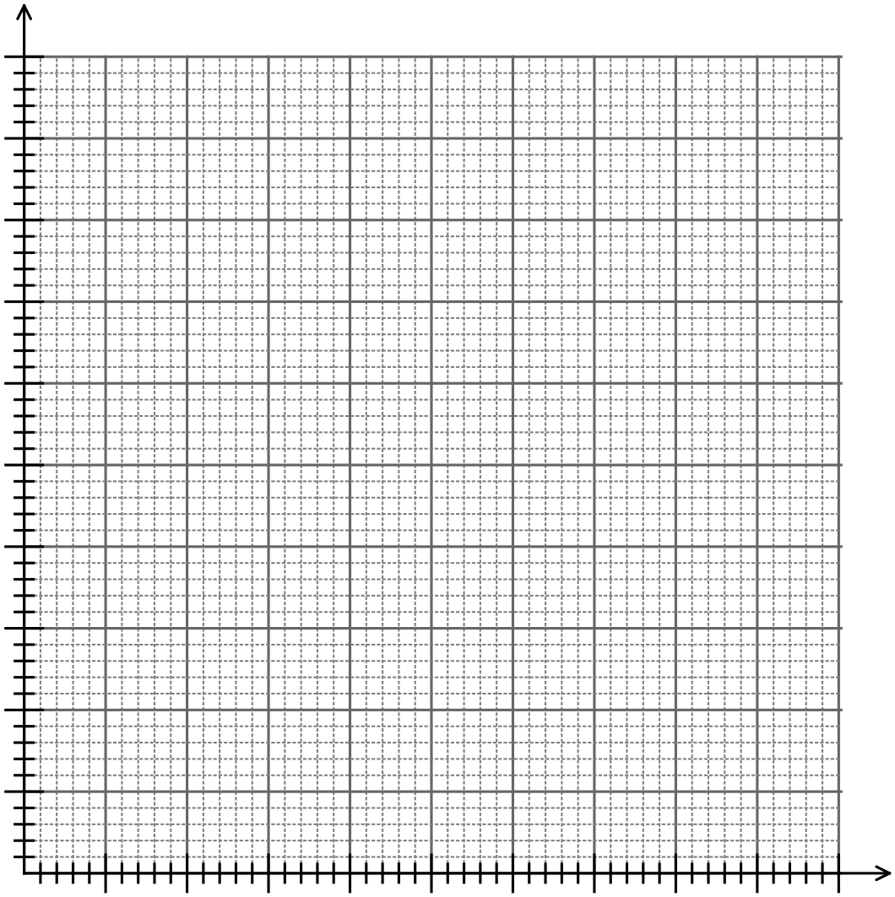

**Part C**

**Question 1 (13 marks)**

A tennis match between two or four players involves playing several games. The graph below shows the relationship between percentage of games lost and percentage of matches won.

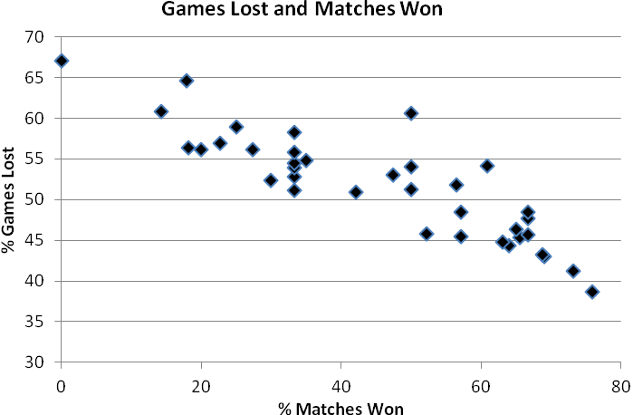

(a) The relationship between the percentage of matches won and the percentage of games lost is classified as a strong, negative, linear relationship. From the information provided on the graph, explain why the relationship is considered:

(i) strong

(ii) negative

(iii) linear (3)

(b) One of the following values is the correlation coefficient for these data.

0.89 -1 -0.88 0.73

State the correct correlation coefficient and justify your selection. (3)

(c) Is it true to say that *r*2 = 1 ( *r*2 is the coefficient of determination)?

Explain your answer. (2)

(d) The equation for the relationship between these variables is:

Percentage of games lost = –0.3 x percentage of matches won + 65

(i) Use the equation to predict the percentage of games lost for a player who won every match. (2)

(ii) Add this point to the graph provided. (1)

(ii) How reliable is your prediction in part (d)(i)? Justify your answer (2)

**Part D (7 marks)**

There has been an increase in the number of accidents involving cyclists aged 20-30 years throughout Australia and it has been suggested that the earlier a person learns to ride a bicycle the less likely they are to have an accident. Summarise the process you could use to implement the *statistical investigation process* to determine if there is a relationship between the number of accidents for cyclists aged 20-30 years and the age at which they learned to ride a bicycle.

**End of questions**

**Statistical investigations**

**Extended investigation Part 1:** **Preparation activities**

**Comments for teachers**

**General**

In some of the problems provided the investigation will be based on increasing age. It is suggested that the numbers given are more finely graded than just in years; so in months or to the nearest quarter.

**Activity 1**

Students are to be encouraged to thoroughly analyse the statement provided and to engage in discussion to confirm that they have a common understanding of the problem posed. These questions are designed to guide this discussion and to challenge the students’ understandings of the two variables indicated (time for paid work and time for study).

**Activity 2**

The final question posed for the study should be ratified by the teacher before the collection of data proceeds. A suitable question would be

*Is there a relationship between the number of hours that students study on the weekend and the number of hours that students work on the weekend?*

**Activity 3**

Students should be encouraged to collect data from only one year group and to consider the influence of other factors if more than one year group is selected. Collection of data for time needs to be consistent, e.g. to the nearest half hour. Whatever decisions are made in the defining of study and paid work, students need to find ways to communicate their meanings to those that are surveyed.

In designing the data collection process, students may discover that the question for the investigation will not be suitable and needs to be refined. All of the problems posed provide opportunities for the collection and analysis of **bivariate** data and students should be guided in that direction so that their preparation for the in-class component of this assessment is relevant.

**Activity 5**

In this situation the explanatory variable would be time spent doing paid work and the response variable, time spent on study.

**Activity 6**

Students should look for a linear relationship between the two variables. As a result of doing this investigation, students may have further questions e.g. what other factors might influence the amount of time students spend studying on the weekend? Does time spent using social media influence the amount of time students spent studying on the weekend?

**Statistical investigations**

**Extended investigation Part 2:** **In-class validation**

**Solutions and marking key**

**Part A: Question 1**

|  |  |  |  |
| --- | --- | --- | --- |
|  | Solution | Mathematical behaviours | Marks |
| (a) | It assumes pensioners are all old and students are all young | * identifies problem with terminology | 1 |
| (b) | Television shows have different lengths and the number of shows may not reflect the time spent. | * identifies problem with definition of time watched. | 1 |
| (c) | Adult – needs to be defined as being 18 onwards.  Watching television – does this include having it on while you work? Does it include watching a TV show on your computer or Ipad? | * identifies word/phrase requiring clarification. | 1 |

**Part A: Question 2**

|  |  |  |  |
| --- | --- | --- | --- |
|  | Solution | Mathematical behaviours | Marks |
| (a) | Needs to have a defined period eg over the last week | * identifies problem with terminology | 1 |
| (b) | *time spent watching television*  Time spent watching television is likely to depend on age and not age depend on time spent watching television | * identifies response variable * explains role of response variable | 1  1 |
| (c) | To the nearest year | * identifies appropriate rounding | 1 |
| (d) | Not easy to remember  Not easy to calculate | * identifies reason for difficulty * identifies reason for difficulty | 1  1 |
| (e) | Age  It is the explanatory / independent variable | * identifies variable * justifies choice | 1  1 |

**Part B: Question 1**

|  |  |
| --- | --- |
| Solution | |
| Suggests at least 50 students  Selects students at random  Describes the random process  Nominates suitable time and date to fit local situation  Nominates suitable place for the survey to occur  Students complete written survey / data recording sheets kept secure and backed up | |
| Mathematical behaviours | Marks |
| * selects suitable number of respondents * identifies need for random selection * describes random collection of data * nominates appropriate time for survey * nominates appropriate place for survey * describes data collection process | 1  1  1  1  1  1 |

**Part B: Question 2**

|  |  |
| --- | --- |
| Solution | |
|  | |
| Mathematical behaviours | Marks |
| * selects correct type of graph (scatter graph) * places variables on correct axes * labels axes with variable names * labels variables on axes with correct units * selects suitable scales for both axes * plots 4 points correctly * plots 3 points correctly * plots 3 points correctly | 1  1  1  1  1  1  1  1 |

**Part C**

**Question 1**

|  |  |  |  |
| --- | --- | --- | --- |
|  | Solution | Mathematical behaviours | Marks |
| (a) | (i) points are close together  (ii) points head downwards  (iii) points nearly in a line | * identifies strength from graphs * identifies negative slope * identifies linear pattern | 1  1  1 |
| (b) | -0.88  Needs to be negative  Is not perfect (-1) | * selects correct correlation * identifies negative value needed * identifies relationship not perfect | 1  1  1 |
| (c) | No  *r* would need to be 1 (it is not) | * identifies value incorrect * justifies decisions | 1  1 |
| (d) | (i)  %games lost = -0.3 x 100 + 65  = 35  (iii) Not reliable – extrapolated beyond the data provided. The trend may not continue. | * substitutes into given equation * determines % games lost * plots point on scatter graph * identifies lack of reliability * explains lack of reliability | 1  1  1  1  1 |
| (d)  (ii) |  | | |

**Part D**

|  |  |
| --- | --- |
| Solution | |
| Note: These will vary | |
| Mathematical behaviours | Marks |
| * identifies all components of the statistical investigation process * describes the data to be collected * describes how the data will be collected * describes the graph to display the data collected * describes the process to identify the trend – graphic analysis * identifies the need to determine the linear relationship and the correlation coefficient | 1  1  1  1  1  2 |

**TASK 2: QUANTIFYING CORRELATION**

**In-class investigation**

**Unit 3**

**Topic 3.1: Bivariate data analysis**

**Course-related information**

The concepts and skills developed in this investigation relate to the following dot points within the WA Mathematics Applications syllabus:

3.1.5 construct a scatterplot to identify patterns in the data suggesting the presence of an association

3.1.6 describe an association between two numerical variables in terms of direction (positive/negative), form (linear/non-linear) and strength (strong/moderate/weak)

3.1.9 use a scatterplot to identify the nature of the relationship between variables

**Background information**

For this investigation, it is not expected that students describe relationships as strong/weak, linear/non-linear or positive/negative; nor do they need to have studied correlation. However, they should be able to describe the relationships between variables in terms of “as variable one increases then the other increases/ decreases or does not show a pattern.” Previous experience with creating and interpreting scatterplots is assumed.

**Task conditions**

This task consists of an in-class investigation for which students might need 40 – 55 minutes to complete. Access to technology is not necessary for the investigation.

**Quantifying correlation**

**In-class investigation (Total marks: 50)**

In this investigation a process for measuring the relationship between two variables is examined. The measure is called the *q*-correlation coefficient.

To calculate the *q*-correlation coefficient

* Plot a scatter graph for the two variables.
* Determine the median for the values on the horizontal (*x*) axis.
* Determine the median for the values on the vertical (*y*) axis.
* Divide the region where the points occur into 4 quadrants by
  + Drawing a vertical line where *x* = median of values on the horizontal axis
  + Drawing a horizontal line where *y* = median of values on the vertical axis
* Label the quadrants e.g. A, B, C and D in the positions as shown on the graph below. The top right quadrant is always A, the top left is B, bottom left is C and bottom right is D.
* Count the points in each quadrant (do not count points on the dividing lines).
* Use the rule *q*-correlation coefficient = where *a* represents the number of points in quadrant A, *b* represents the number of points in quadrant B, *c* represents the number of points in quadrant C, and *d* represents the number of points in quadrant D.

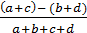

Example: M1 and M2 represent the scores of ten students in two mental Maths tests.

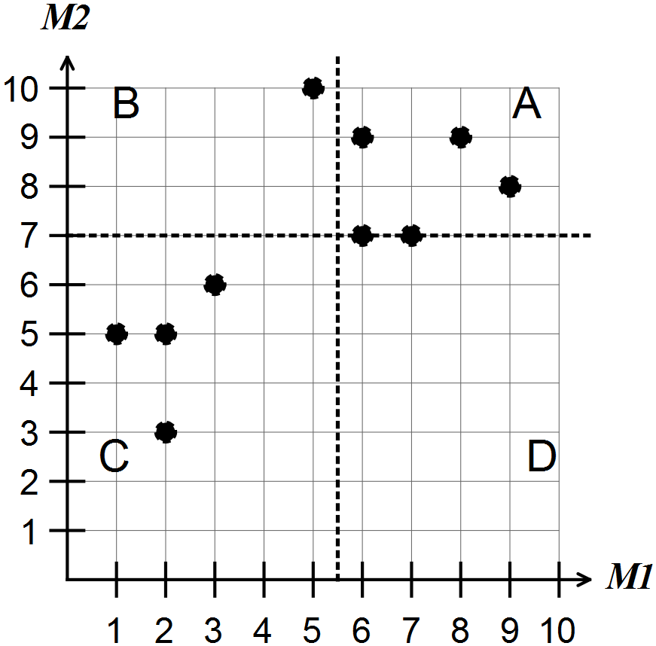

For the scatter graph shown above

* the median of M1 is 5.5
* the median of M2 is 7
* there are 3 points in A so *a* = 3. Similarly *b* = 1, *c* = 4, *d* = 0.

The points (6,7) and (7,7) are on a line and not counted in any quadrants.

Hence, the *q*-correlation coefficient is equal to 

**Question 1 (7 marks)**

M3 and M4 represent students’ scores in Mental Maths tests

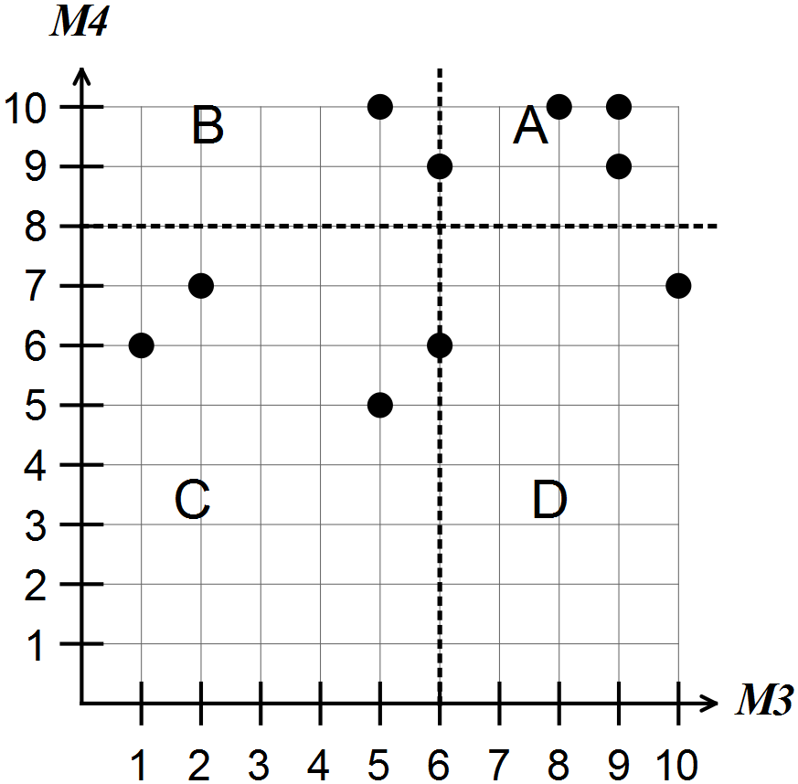

(a) How many students are represented? (1)

(b) What is the median for M3? (1)

(c) What is the median for M4? (1)

(d) How many students scored above the medians in both their tests?

In what quadrant are the points for these students located? (2)

(e) Determine the*q*-correlation coefficient for the relationship between M3 and M4.

(2)

**Question 2 (7 marks)**

The graph shows a sample of daily maximum temperatures and the number of pies sold at the canteen during lunch time at one particular school.

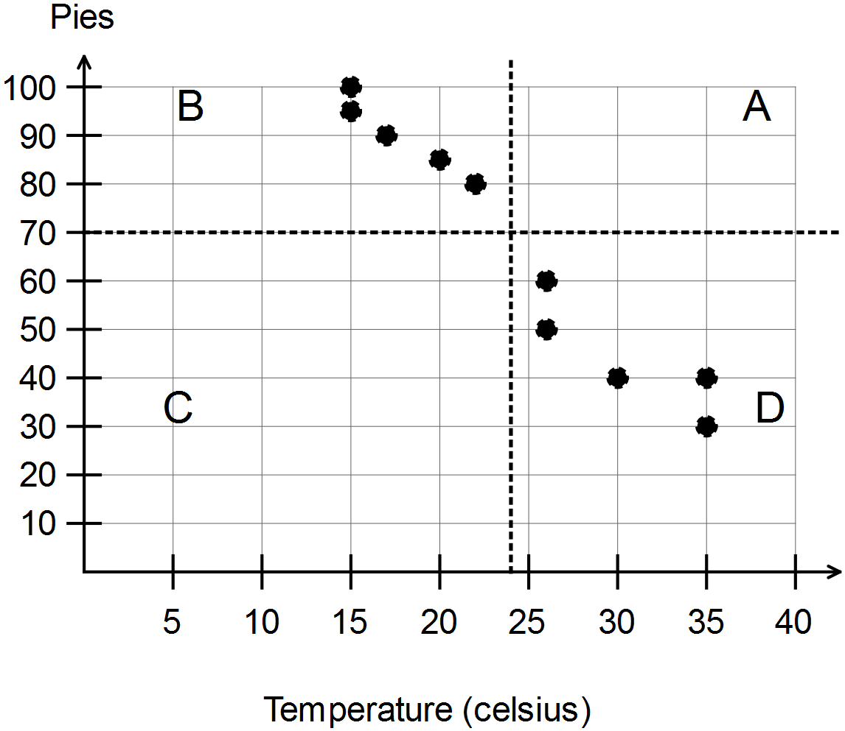

(a) Describe the relationship between the number of pies sold and the daily maximum temperature. (1)

(b) Determine the median number of pies sold at the canteen. (1)

(c) Explain why there are no points on the dotted lines on this graph. (2)

(d) Determine the*q*-correlation coefficient for the relationship between the number of pies sold and the daily maximum temperature. (2)

(e) Determine the highest value that the *q*-correlation coefficient can take. (1)

**Question 3 (8 marks)**

Students in each of the Years 1 to 12 were asked if they liked two particular sports. The percentages of students in each class liking the two different sports are shown on the scatter graph below.

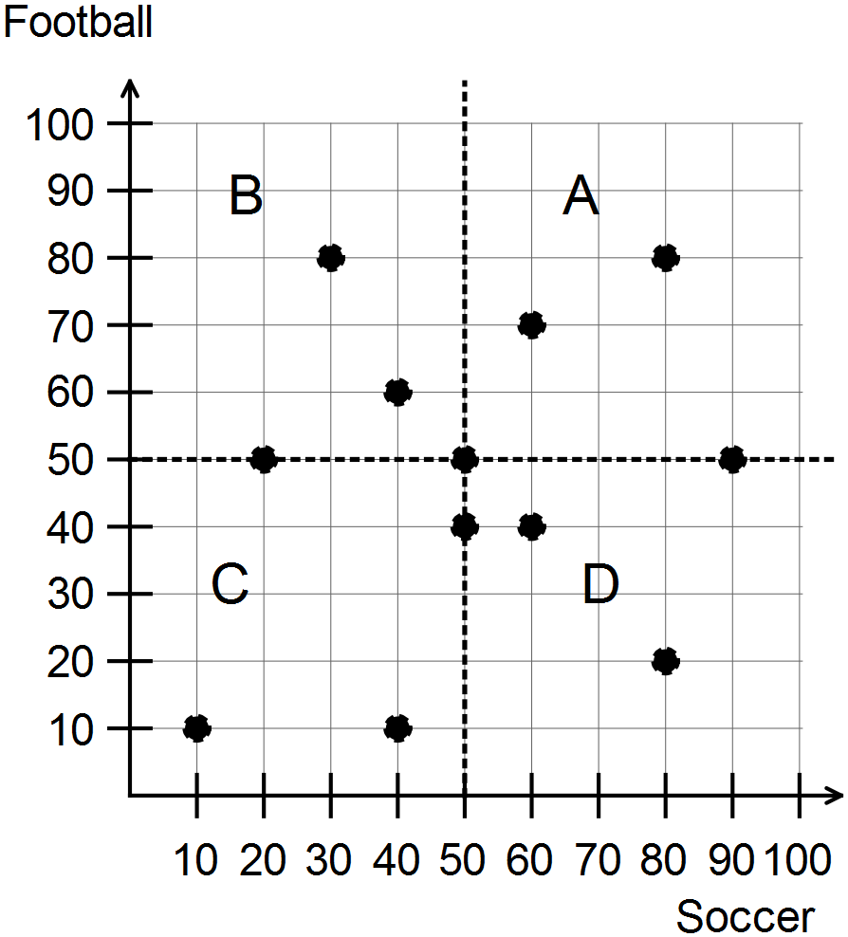

(a) What was the lowest percentage of students in any class liking football? (1)

(b) In any one class what was the highest percentage of students liking either sport?

(1)

(c) Describe what the point (50, 50) represents. (2)

(d) Determine the*q*-correlation coefficient for the relationship between the percentage of students liking football and the percentage of students liking soccer. (2)

(e) From the points on the scatter graph, what appears to be the relationship between the percentage of students liking football and the percentage of students liking soccer in each class? Justify your answer. (2)

**Question 4 (7 marks)**

In this question the process of determining the four quadrants will be further examined.

The following table shows the mental maths scores (out of 10) of two different tests for 10 students.

|  |  |  |  |  |  |  |  |  |  |  |
| --- | --- | --- | --- | --- | --- | --- | --- | --- | --- | --- |
| **Student** | **1** | **2** | **3** | **4** | **5** | **6** | **7** | **8** | **9** | **10** |
| **Test 1** | 1 | 2 | 6 | 6 | 7 | 10 | 8 | 5 | 5 | 8 |
| **Test 2** | 2 | 3 | 5 | 4 | 5 | 9 | 7 | 6 | 4 | 8 |

(a) Represent these data as a scatter graph on the axes below. (2)

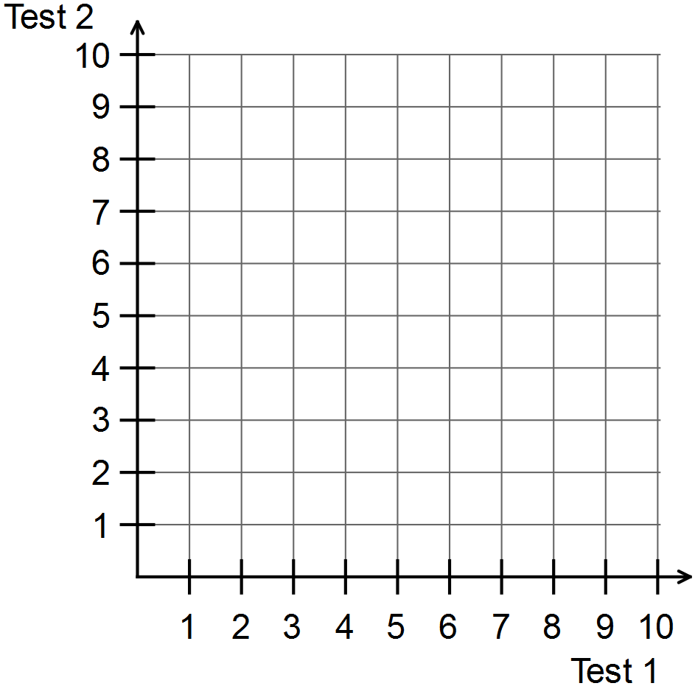

(b) Calculate the median of the Test 1 scores. (1)

(c) Calculate the median of the Test 2 scores. (1)

(d) Draw a vertical line to represent the location of the median for Test 1.

[Hint: consider the vertical lines in questions 1-3] (1)

(e) Draw a horizontal line to represent the location of the median for Test 2.

[Hint: consider the horizontal lines in questions 1-3] (1)

(f) Label the four quadrants as A, B, C and D. (1)

**Question 5 (12 marks)**

The following table shows the maximum wind speeds (km/h) and the maximum temperatures (degrees Celsius) for the first day of each of the last 12 months.

|  |  |  |  |  |  |  |  |  |  |  |  |  |
| --- | --- | --- | --- | --- | --- | --- | --- | --- | --- | --- | --- | --- |
| **Month** | **1** | **2** | **3** | **4** | **5** | **6** | **7** | **8** | **9** | **10** | **11** | **12** |
| **Wind speed** | 31 | 22 | 22 | 33 | 30 | 31 | 33 | 35 | 39 | 57 | 43 | 28 |
| **Maximum**  **temperature** | 22 | 21 | 23 | 24 | 24 | 29 | 31 | 25 | 29 | 34 | 31 | 28 |

Use the process described in the previous questions to

(a) draw a scatter graph to show the relationship between the wind speed and the maximum temperature (3)

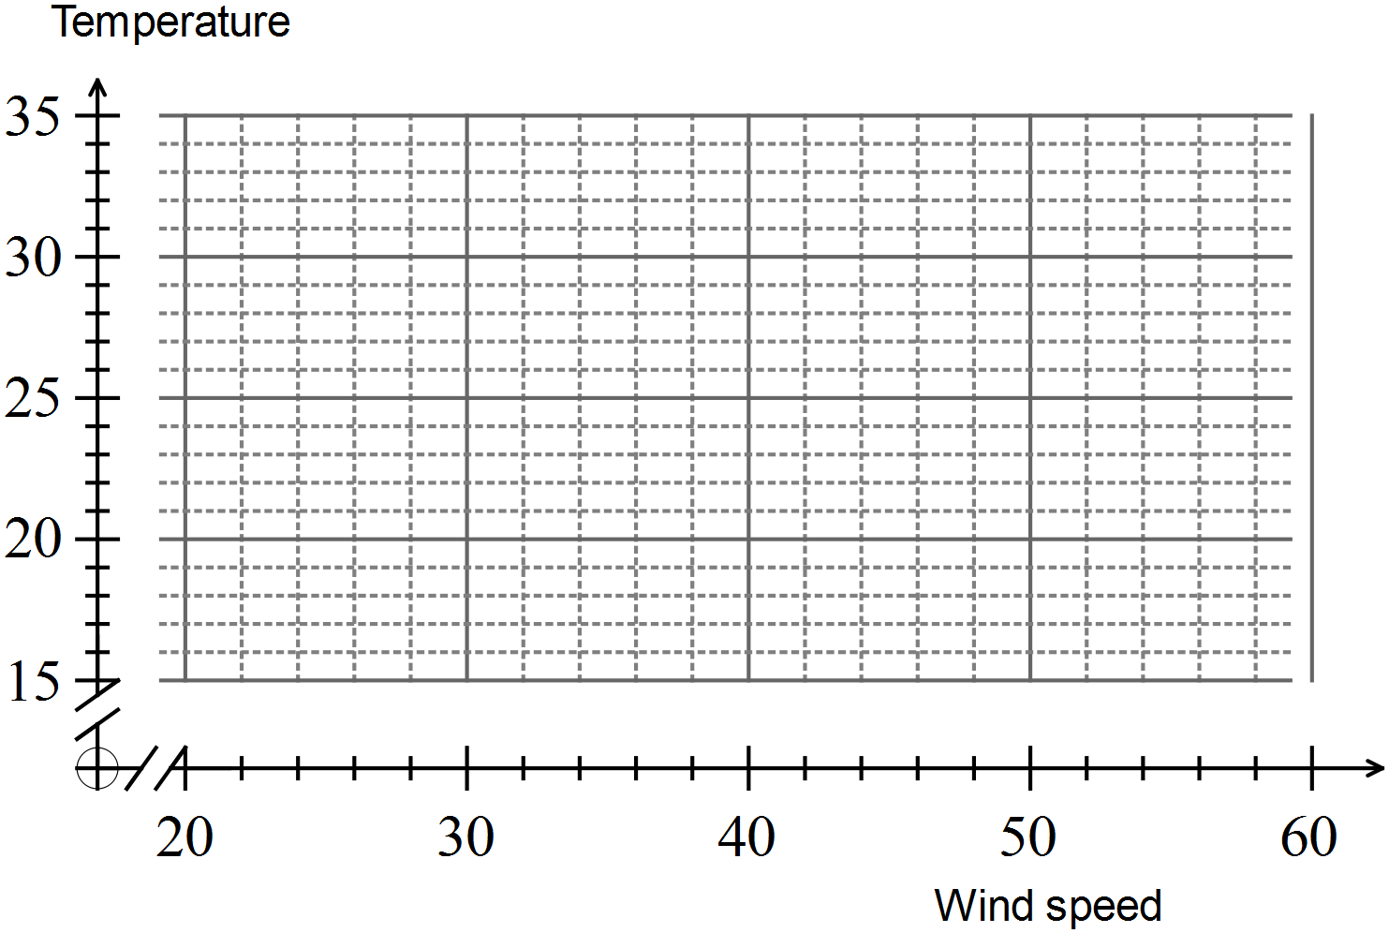

(b) Describe the relationship between maximum wind speed and maximum temperature referring to the location of the points to justify conclusions.

(3)

(c) divide the region of the plotted points into 4 labelled quadrants (4)

(d) calculate the *q*-correlation coefficient for the relationship between maximum wind speed and maximum temperature. (2)

**Question 6 (9 marks)**

(a) You are given a set of possible values for the *q*-correlation coefficient.

(6)

-1 -0.8 -0.6 0.1 0.5 0.9

Which of these values is most likely in each of the six situations given?

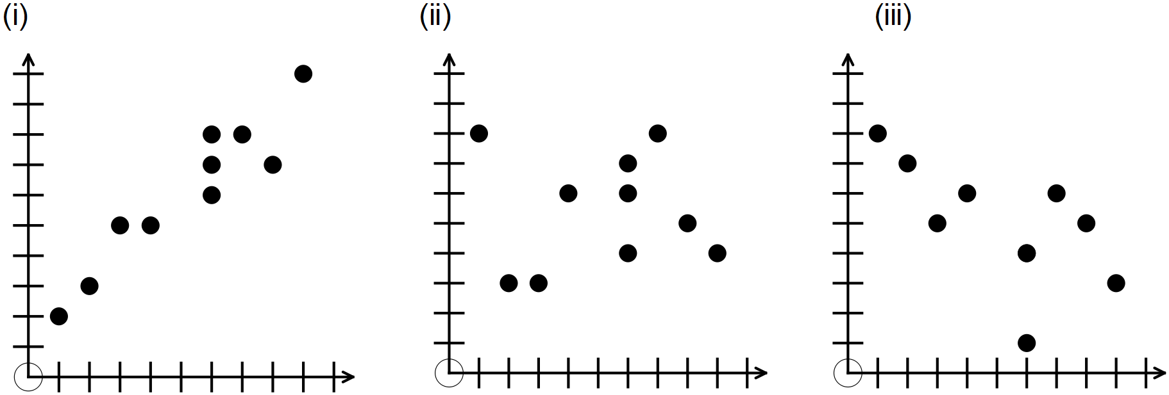

(iv) there is little or no relationship between the two variables

(v) there is a very strong positive linear relationship

(vi) as one variable increases the other decreases and the points lie in a straight line.

(b) State one possible advantage of using the *q*-correlation coefficient to determine the strength of a relationship between two variables. (1)

(c) State two possible disadvantages of using the *q*-correlation coefficient to determine the strength of a relationship between two variables. (2)

**End of questions**

**Quantifying correlation**

**In-class investigation**

**Solutions and marking key**

**Question 1**

|  |  |  |  |
| --- | --- | --- | --- |
|  | Solution | Mathematical behaviours | Marks |
| (a) | 10 | * reads number of points on scatter graph | 1 |
| (b) | 6 | * reads position of horizontal median line | 1 |
| (c) | 8 | * reads position of vertical median line | 1 |
| (d) | 3 in quadrant A | * interprets values on scatter graph * identifies location of points | 1  1 |
| (e) | *q*-correlation coefficient  = (3 + 3 - 2) ÷8  = 0.5 | * reads number of points on scatter graph * calculates *q*-correlation coefficient | 1  1 |

**Question 2**

|  |  |  |  |
| --- | --- | --- | --- |
|  | Solution | Mathematical behaviours | Marks |
| (a) | As the temperature rises the number of pies sold decreases | * interprets scatter graph | 1 |
| (b) | 70 | * reads position of horizontal median line | 1 |
| (c) | There are no days where the temperature was 24 nor where the number of pies sold was 70 | * identifies median not a score for temperature * identifies median not a score for pies sold | 1  1 |
| (d) | *q*-correlation coefficient  = )(0 + 0) – (5 + 5)) ÷ 10  = -1 | * reads number of points on scatter graph * calculates *q*-correlation coefficient | 1  1 |
| (e) | 1 | * interprets calculation of *q*-correlation coefficient | 1 |

**Question 3**

|  |  |  |  |
| --- | --- | --- | --- |
|  | Solution | Mathematical behaviours | Marks |
| (a) | 10% | * reads scatter graph | 1 |
| (b) | 90% | * reads scatter graph | 1 |
| (c) | The class in which 50% liked soccer and 50% liked football. | * interprets scatter graph * describes both variables | 1  1 |
| (d) | *q*-correlation coefficient  = ((2 + 2 – (2+2)) ÷8 = 0 | * reads number of points on graph * calculates *q*-correlation coefficient | 1  1 |
| (e) | No relationship. The points are scattered randomly. | * Describes lack of relationship * interprets scatter graph | 1  1 |

**Question 4(a)(d)(e)(f)**

|  |  |
| --- | --- |
| Solution | |
|  | |
| Mathematical behaviours | Marks |
| * plots most points accurately * plots all points accurately * draws vertical line at median for Test 1 * draws horizontal line for median at Test 2 * labels quadrants as previously instructed | 1  1  1  1  1 |

**Question 4(b)**

|  |  |
| --- | --- |
| Solution | |
| Median = 6 | |
| Mathematical behaviours | Marks |
| * calculates median | 1 |

**Question 4(c)**

|  |  |
| --- | --- |
| Solution | |
| Median = 5 | |
| Mathematical behaviours | Marks |
| * calculates median | 1 |

**Question 5(a)**

|  |  |
| --- | --- |
| Solution | |
|  | |
| Mathematical behaviours | Marks |
| * plots coordinates for each point in correct order * plots most points accurately * plots all points accurately | 1  1  1 |

**Question 5(b)**

|  |  |
| --- | --- |
| Solution | |
| As wind speed increases so does the temperature; the points are generally rising to the right | |
| Mathematical behaviours | Marks |
| * notes increasing wind speed is associated with increasing temperature * describes location of points | 2  1 |

**Question 5(c)**

|  |  |
| --- | --- |
| Solution | |
|  | |
| Mathematical behaviours | Marks |
| * determines median maximum wind speed * determines median maximum temperature * draws median lines and labels quadrants | 1  1  2 |

**Question 5(d)**

|  |  |
| --- | --- |
| Solution | |
| *q*-correlation coefficient = (8 - 4) ÷ 12 = | |
| Mathematical behaviours | Marks |
| * determines number of points in each quadrant * calculates the *q*-correlation coefficient | 1  1 |

**Question 6**

|  |  |  |  |
| --- | --- | --- | --- |
|  | Solution | Mathematical behaviours | Marks |
| (a) | (i) 0.9  (ii) 0.1  (iii) -0.6  (iv) 0.1  (v) 0.9  (vi) -1 | * identifies positive correlation from graph * identifies lack of relationship from graph * identifies negative correlation from graph * identifies lack of correlation from description * identifies positive correlation from description * identifies negative correlation from description | 1  1  1  1  1  1 |
| (b) | Easy to follow/calculate  More precise than guessing | * suggests one advantage | 1 |
| (c) | Inaccurate  Time-consuming | * suggests disadvantage of the process * suggests disadvantage of the process | 1  1 |

**TASK 3**

**Investigative questions**

**Unit 3**

**Topic 3.1: Bivariate data analysis**

**Course-related information**

The concepts and skills covered in these investigative questions relate to the following dot points within the WA Mathematics Applications syllabus:

3.1.3 use an appropriately percentaged two-way frequency table to identify patterns that suggest the presence of an association

3.1.4 describe an association in terms of differences observed in percentages across categories in a systematic and concise manner, and interpret this in the context of the data

3.1.5 construct a scatterplot to identify patterns in the data suggesting the presence of an association

3.1.6 describe an association between two numerical variables in terms of direction (positive/negative), form (linear/non-linear) and strength (strong/moderate/weak)

3.1.7 calculate, using technology, and interpret the correlation coefficient (*r*) to quantify the strength of a linear association

3.1.11 use a residual plot to assess the appropriateness of fitting a linear model to the data

The ability to choose and use appropriate technology to enhance and extend concept development is also required for some of the items

**Background information**

For Question 3, students should have covered dot points 3.1.3 and 3.1.4; they will have studied two-way tables. Questions 1 and 2 are best used at the end of the topic.

**Task conditions**

These items should be undertaken under test conditions, either as part of a test/examination or as stand-alone items. Student access to a graphical/CAS calculator is assumed. The time required to complete each question is left to the discretion of the teacher but the intention is that each question may be completed within 15 minutes.

**Investigative questions for Topic 3.1**

**Question 1 (12 marks)**

Follow the activities suggested to investigate the claim that the “regression lines should only be used to for predictions when the data contain no obvious outliers.”

The table below shows the marks for 11 students in the two different parts of a test.

|  |  |  |  |  |  |  |  |  |  |  |  |
| --- | --- | --- | --- | --- | --- | --- | --- | --- | --- | --- | --- |
| **Student** | A | B | C | D | E | F | G | H | I | J | K |
| **Part 1** | 10 | 12 | 12 | 9 | 10 | 12 | 14 | 7 | 12 | 14 | 12 |
| **Part 2** | 9 | 10 | 8 | 8 | 7 | 9 | 12 | 6 | 11 | 11 | 3 |

(a) Plot the data on the axes below. (2)

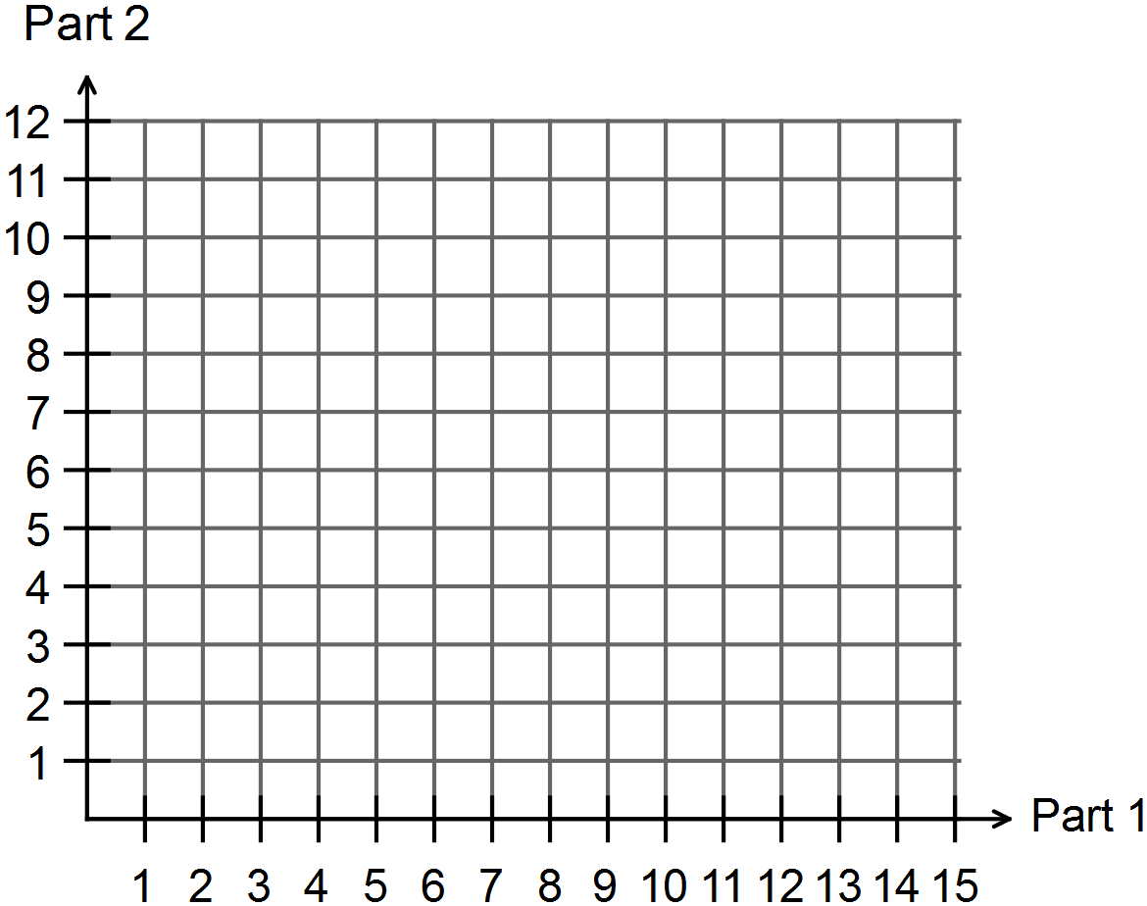

The regression line for the table data is Part 2 mark = 1.31 + 0.64 x Part 1 mark

The coefficient of correlation, r, is 0.5224.

(b) Use this equation to predict a Part 2 mark for a student who scored 13 in Part 1.

(2)

(c) Circle the point which represents the outlier. (1)

(d) Remove the outlier for the data and calculate the new

(i) correlation coefficient ii) equation for the regression line (2)

(e) Use the new equation to predict a Part 2 mark for a student who scored 13 in Part 1. (2)

(f) Which of the two predictions is the more reliable? Justify your answer. (2)

(g) Have you proved that the original claim that “regression lines should only be used to for predictions when the data contain no obvious outliers” is true? Explain. (1)

**Question 2 (11 marks)**

Follow the activities suggested to investigate the claim that the “closer the residuals are to the zero line, the stronger the relationship”.

For a small class of students, an analysis was done to check the correlation between students’ scores in mental maths test results (out of 10). Each time, two tests were compared and the correlation (*r* ) was calculated and the residuals graphed. The results of these four comparisons (A, B, C and D) are shown below.

|  |  |
| --- | --- |
| A: *r* = 0.592 | B: *r* = 0.7778 |
| C: *r* = 0.01997 | D: *r* = 0.957 |

(a) How many students in the class? (1)

(b) According to the graph A, what type of relationship exists between the two sets of scores? Justify your decision. (2)

(c) For which comparison (A, B, C or D), does the correlation coefficient indicate the relationship between the two test scores is the strongest? Explain your choice.

(2)

(d) The values of the residuals in comparison B are as follows:

-2.3 0.7 -0.6 -0.7 -1.0 1.7 1.8 0.4

Determine the average for these residuals. (1)

(e) The average distance of the residual from the zero line can be found by ignoring the negative sign and taking the mean of the values. Using this process the average distance of the residuals in part (c) is 1.1 units. Determine the average distance for the residuals in comparison C where the residuals are:

0.7 4.6 -0.5 -1.3 -0.4 -1.3 -4.4 2.6 (1)

(f) Complete the table below. (1)

|  |  |  |  |  |
| --- | --- | --- | --- | --- |
| Comparison | A | B | C | D |
| Average distance | 2.4 |  |  | 0.4 |
| Correlation coefficient | 0.592 |  |  | 0.957 |

(g) Using the data in the table in part (f), comment on the claim that the “closer the residuals are to the zero line, the stronger the relationship”. (3)

**Question 3 (11 marks)**

To investigate Year 12 student behaviour on Saturday afternoons, a group of Year 11 students conducted a survey in their school. They asked the Year 12 students “Which of the following activities would you most prefer to do on a Saturday afternoon?” Some of the results of the survey are given in the table below.

**Percentage of students choosing the various activities**

|  |  |  |
| --- | --- | --- |
| **Activity** | **Males** | **Females** |
| Watch reality television shows | 4 | 5 |
| Engage with social media | 18 | 15 |
| Play sport | 36 | 28 |
| Paid work | 29 | 30 |
| Shopping with friends |  | 22 |

(a) Enter the missing data value. (1)

(b) What percentage of females did not prefer to play sport? (1)

(c) Given that the Year 11 students wanted to *investigate Year 12 student behaviour on Saturday afternoons* suggest a better question for this survey and explain why the question is better (2)

(d) There were 120 boys and 124 girls in Year 12 who responded to the survey.

(i) How many boys would prefer to play sport on Saturday afternoon? (2)

(ii) How many students would prefer to work on Saturday afternoon? (1)

(e) What type of graph would be best to display this data? Explain your choice of graph. (2)

(f) What can you learn from these data about the activities that students in Year 12 in **your** school would prefer to do on a Saturday afternoon? Explain your answer.

(2)

**Investigative questions in Topic 3.1**

**Solutions and marking key**

**Question 1(a)(c)**

|  |  |
| --- | --- |
| Solution | |
|  | |
| Mathematical behaviours | Marks |
| * plots most points accurately * plots all points accurately * identifies outlier | 1  1  1 |

**Question 1**

|  |  |  |  |
| --- | --- | --- | --- |
|  | Solution | Mathematical behaviours | Marks |
| (b) | 1.31 + 0.64 x 13 = 9.63 | * substitutes into equation * calculates result | 1  1 |
| (d) | (i) 0.866  (ii) Part 2 mark = 0.67 + 0.75 x Part 1 mark | * calculates correlation coefficient * determines gradient and intercept in the form of a linear equation | 1  1 |
| (e) | Part 2 mark = 0.67 + 0.75 x 13 = 10.42 | * substitutes into equation * calculates result | 1  1 |
| (f) | Both round to 10 so are equivalent and thus neither prediction is more reliable OR  10.42 is more reliable - the correlation coefficient is higher (closer to 1) | * identifies the more reliable prediction * justifies choice of reliability | 1  1 |
| (g) | Not proved  Further evidence is needed | * denies proved; identifies need for more evidence | 1 |

**Question 2**

|  |  |  |  |
| --- | --- | --- | --- |
|  | Solution | Mathematical behaviours | Marks |
| (a) | 8 | * reads scatter graph | 1 |
| (b) | Linear  Residuals are randomly scattered about the zero line | * identifies trend * justifies decision | 1  1 |
| (c) | D  Correlation coefficient is closest to 1 (or -1) | * selects correct option * justifies decision | 1  1 |
| (d) | 0 | * identifies zero mean of residuals | 1 |
| (e) | 1.975 (or 2.0) | * calculates mean | 1 |

**Question 2(f)**

|  |  |
| --- | --- |
| Solution | |
| |  |  |  |  |  | | --- | --- | --- | --- | --- | | Comparison | A | B | C | D | | Average distance | 2.4 | 1.1 | 2.0 | 0.4 | | Correlation coefficient | 0.592 | 0.7778 | 0.01997 | 0.957 | | |
| Mathematical behaviours | Marks |
| * completes table | 1 |

**Question 2(g)**

|  |  |
| --- | --- |
| Solution | |
| The trend in the table indicates the claim is true though not in every case.  Certainly a very high correlation coefficient is linked to the lowest distance and the next highest correlation is linked to the next lowest distance.  The two comparisons with the lower correlation coefficients have much higher average distances  (You would expect the average distance in C to be higher than the average distance in A if the claim were true all the time – perhaps the residuals are not accurate because the prediction in unreliable with such a low correlation coefficient) | |
| Mathematical behaviours | Marks |
| * comments on the truth of the claim * links highest correlation coefficients with shortest distances * links longer average distance with lower correlation | 1  1  1 |

**Question 3**

|  |  |  |  |
| --- | --- | --- | --- |
|  | Solution | Mathematical behaviours | Marks |
| (a) | 13 | * interprets two-way table | 1 |
| (b) | 72% | * calculates percentage | 1 |
| (c) | What activity would you prefer to do on Saturday afternoon?  It is better because it does not restrict students to choosing one of the options given. | * identifies limitations of question * explains limitations of question | 1  1 |
| (d) | (i) 0.36 x 120 = 43  (ii) 0.29 x 120 + 0.3 x 124 = 72 | * calculates percentage * calculates percentage * identifies different totals for males and females | 1  1  1 |
| (e) | Column graph  Data is categorical | * nominates suitable graph * explains choice of graph | 1  1 |
| (f) | Nothing  One does not know where these students are located, the opportunities they have and cannot extrapolate to a wider population | * identifies inappropriate extrapolation * explains lack of relevance to other situations | 1  1 |

**TASK 4: GROWTH AND DECAY**

**Extended investigation**

**Unit 3**

**Topic 3.2: Growth and decay in sequences**

**Course-related information**

The concepts and skills covered in this investigation relate to the following dot points within the WA Mathematics Applications syllabus:

3.2.5 use recursion to generate a geometric sequence

3.2.6 display the terms of a geometric sequence in both tabular and graphical form and demonstrate that geometric sequences can be used to model exponential growth and decay in discrete situations

3.2.7 deduce a rule for the term of a particular geometric sequence from the pattern of the terms in the sequence, and use this rule to make predictions



3.2.8 use geometric sequences to model and analyse (numerically, or graphically only) practical problems involving geometric growth and decay

The ability to chose and use appropriate technology to enhance and extend concept development is also required for some of the items.

**Background information**

Students should have some knowledge of sequences; they should know the difference between a recursive rule and a general rule. The preparation activities provide an opportunity for students to investigate and review the concepts that relate to sequences. They are a guide to the tasks to be completed in the in-class assessment.

**Task conditions**

Students should bring the completed preparation activities to the in-class component of this investigation. It is assumed that students have access to technology that allows them to calculate the terms of a sequence using recursion or the general rule.

Statistics on the population of Australia and related areas was obtained from the website of the Australian Bureau of Statistics.

Data relating to the Borneo pygmy elephant was obtained from <http://www.wwf.org.au/our_work/saving_the_natural_world/wildlife_and_habitats/iucn_levels_of_threatened_species/>

**Growth and decay**

**Extended investigation Part 1:** **Preparation activity**

**Question 1**

According to the dot-point 3.2.6 “geometric sequences can be used to model exponential growth and decay in discrete situations”.

(a) Distinguish between *growth* and *decay*.

(b) Sketch a graph highlighting the difference between linear growth and exponential growth.

(c) Explain the difference between discrete and continuous data: use an example to illustrate the difference.

(d) What type of calculations would be associated with exponential change?

(e) A rule used to calculate the value of a variable subject to exponential growth is



Use this rule to calculate

(i) The population of North Coogee in 2016 if it continued to grow at 20.7% p.a. from its population of 1400 in 2014.

(ii) The population of the ACT in 2020, given it was 386 000 in 2014 and was growing an annual rate of 1.2%.

(iii) The population of Hobart in 2050 if it continues to grow at an annual rate of 0.6% from its 2014 population of 219 200.

(f) If the variable undergoes exponential decay rather than growth, the rule is



Use this rule to calculate

(i) the value of a fridge in 5 years time if it is currently worth $1600 and is losing value at 10% per year.

(ii) the population of Nhulunbuy in 2020 if it continues to decline at an annual rate of 13% from a 2014 population of 4385.

**Question 2**

(a) Calculate a 15% increase of 2 million by:

(i) determining 15% of 2 million.

adding this answer to 2 million

(ii) multiplying 2 million by 115%

(iii) multiplying 2 million by 1.15

(b) What do you notice about your answers to part (a)? What conclusions can you make?

(c) Determine three similar ways by which 2 million could be reduced by 15%.

**Question 3**

In this question *P*0 represent the initial population, *Pt* represents the population after *t* years and *P* *t* +1 represents the population the following year (next year after year *t*). The annual growth rate is represented by *r* and is given as a percentage, e.g. 60%

1. 

2. 

3. 

(a) Describe what each of the previous equations represents.

(b) Which rule(s) are recursive in nature?

(c) Which rule would be used to determine the population after 5 years when the population of the previous year and the growth rate are known?

(d) If *t* had represented the number of months what calculations are needed for *r*?

(e) If, instead of growing the population was declining, what changes (if any) would be needed in each of these three formulae?

(f) Which rule most resembles the difference rule for a geometric sequence?

(g) Which rule is most similar to the rule for calculating compound interest?

(h) Why is *r* divided by 100?

(i) What values can each of the variables *P*, *r* and *t* not take?

**Question 4**

The estimated resident population of the greater capital cities is shown in the table below. (Data from Australian Bureau of Statistics)

|  |  |  |  |
| --- | --- | --- | --- |
| **ESTIMATED RESIDENT POPULATION** | | | |
| **Greater Capital City Statistical Areas** | | | |
| |  | | --- | |  | | **Estimate** | **Increase** | |
|  | **2014** | **2013-2014** | |
| Area | Population estimate | Population increase | Percentage change |
|  | | | |
| Greater Sydney | 4 840 600 | 84 200 | 1.8 |
| Greater Melbourne | 4 440 300 | 95 700 | 2.2 |
| Greater Brisbane | 2 274 600 | 38 500 | 1.7 |
| Greater Adelaide | 1 304 600 | 13 300 | 1 |
| Greater Perth | 2 021 200 | 48 400 | 2.5 |
| Greater Hobart | 219 200 | 1200 | 0.6 |
| Greater Darwin | 140 400 | 3000 | 2.2 |
| Australian Capital Territory | 386 000 | 4700 | 1.2 |
| |  | | --- | | Total Greater Capital Cities | | 15 627 000 | 289 000 | 1.9 |
|  | | | |
| **Total Australia** | **23 490 700** | **364 900** | **1.6** |

Assume the populations continue to grow at these annual rates.

Consider the following questions:

(a) Which city is growing at the fastest rate?

(b) Which city had the largest population in 2014?

(c) In what year will the population of Darwin exceed that of Hobart?

(d) When will Melbourne become the city with the largest population?

(e) Was the population of Adelaide exactly 1 291 300 a year before this measurement was recorded?

(f) If these trends continue, which cities will always have a greater population than the ACT?

(g) How was the 1.6% growth rate for Australia determined? Is it an average of the growth rate for all areas recorded in the table?

(h) How many years will it take for the population of Brisbane to double?

**Question 5**

The Borneo pygmy elephant is an endangered species and the population is thought to have halved in the last 70 years to the present day estimate of 1500 elephants. If the rate of decline from now on reduces to a rate of 5% every 10 years, how long will it take for the population to halve again?

To investigate this question:

1. Draw a graph which shows the population every 10 years for the next 200 years.

2. Determine the population after 70 years.

3. Determine the time that it would take the population to halve given these conditions continue (decline is 5% every ten years).

4. What does this information indicate about the previous rate of decline?

[Hint: Let 1 decade be the unit of time]

Note: Further information about saving the Borneo pygmy elephant from extinction can be found on <http://www.wwf.org.au/>

**Growth and decay**

**Extended investigation Part 2:** **In-class validation (50 marks)**

**Question 1 (19 marks)**

The following table shows 2014 data from the Australian Bureau of Statistics.

|  |  |  |  |
| --- | --- | --- | --- |
|  | **Population**  **(Dec 2014)** | **Population increase from previous year** | **Change over previous year** |
|  | thousands | thousands | Percentage (%) |
| New South Wales | 7 544.5 | 106.4 | 1.4 |
| Victoria | 5 866.3 | 102 | 1.8 |
| Queensland | 4 740.9 | 69.4 | 1.5 |
| South Australia | 1 688.7 | 14.3 | 0.9 |
| Western Australia | 2 589.1 | 53.7 | 2.1 |
| Tasmania | 515 | 1.6 | 0.3 |
| Northern Territory | 246.3 | 2.8 | 1.1 |
| Australian Capital Territory (ACT) | 387.1 | 4.4 | 1.2 |
| **Australia** | **23 581.0** | **354.6** | **1.5** |

(a) Consider the population of Australia at the end of 2014. (4)

(i) State the population.

(ii) By how much had it grown in the previous 12 months?

(iii) Are the given figures actual data or estimated values?

Justify your decision.

(b) In which state or territory was the population the greatest in 2014? (1)

(c) Which state or territory had the fastest growth rate? (1)

(d) If the current trend continues, which states or territories will always have populations less than the ACT? (1)

(e) A general rule to calculate the population after t years is . (2)

(i) Which state or territory would have the lowest *P*0 ?

(ii) Which state or territory would have the lowest *r*?

(f)Use the rule from part (e) to determine the population of Western Australia in 2017.

(3)

(g) State the recursive (difference) rule to determine the population of Western Australia. (2)

(h) Use the recursive rule to determine the population of Western Australia for each of the years 2015, 2016 and 2017. (3)

(i) Which rule, the one given in part (e) or the one determined in part (g) would be best to use to determine the population of Western Australia in 2050? Explain your decision. (2)

**Question 2 (10 marks)**

This question refers to the same data as for question 1. The 2014 data from the Australian Bureau of Statistics is reproduced in the table below. Assume the current trends continue.

|  |  |  |  |
| --- | --- | --- | --- |
|  | **Population**  **(Dec 2014)** | **Change**  **(2013-2014)** | **Change over previous year** |
|  | thousands | thousands | % |
| New South Wales | 7 544.5 | 106.4 | 1.4 |
| Victoria | 5 866.3 | 102 | 1.8 |
| Queensland | 4 740.9 | 69.4 | 1.5 |
| South Australia | 1 688.7 | 14.3 | 0.9 |
| Western Australia | 2 589.1 | 53.7 | 2.1 |
| Tasmania | 515 | 1.6 | 0.3 |
| Northern Territory | 246.3 | 2.8 | 1.1 |
| (ACT) | 387.1 | 4.4 | 1.2 |
| **Australia** | **23 581.0** | **354.6** | **1.5** |

(a) Is the growth in the Australian population linear or exponential? Explain.

(3)

(b) Give the calculation that could be used to determine that the growth rate for the population of Australia for 2013 to 2014 is 1.5%.

(2)

(c) Complete the table for the estimated population of Western Australia. (2)

|  |  |  |  |  |  |  |
| --- | --- | --- | --- | --- | --- | --- |
| **Year** | 2014 | 2016 | 2018 | 2020 | 2022 | 2023 |
| **Population (thousands)** | 2589.1 |  |  |  |  | 3121.6 |

(d) The population of Western Australia was growing at 2.1% per year in 2013. By what percentage did it grow over the 10 years? Justify your answer. (3)

**Question 3 (11 marks)**

Iodine-131 is a form of Iodine and it has a half-life of approximately 8 days. This means that every 8 days the amount of iodine present is half of the amount that was there 8 days earlier. Assume the amount present at the start is 4000 mg.

(a) Complete the table below. (3)

|  |  |  |  |  |  |  |  |  |
| --- | --- | --- | --- | --- | --- | --- | --- | --- |
| Time  (days) | 0 | 8 | 16 | 24 | 32 | 40 |  |  |
| Amount (mg) | 4000 | 2000 | 1000 |  |  |  |  |  |

(b) Write the recursive rule to determine the number of mg of Iodine-131. (3)

(c) On the axes below, plot the discrete data from the table above. (3)

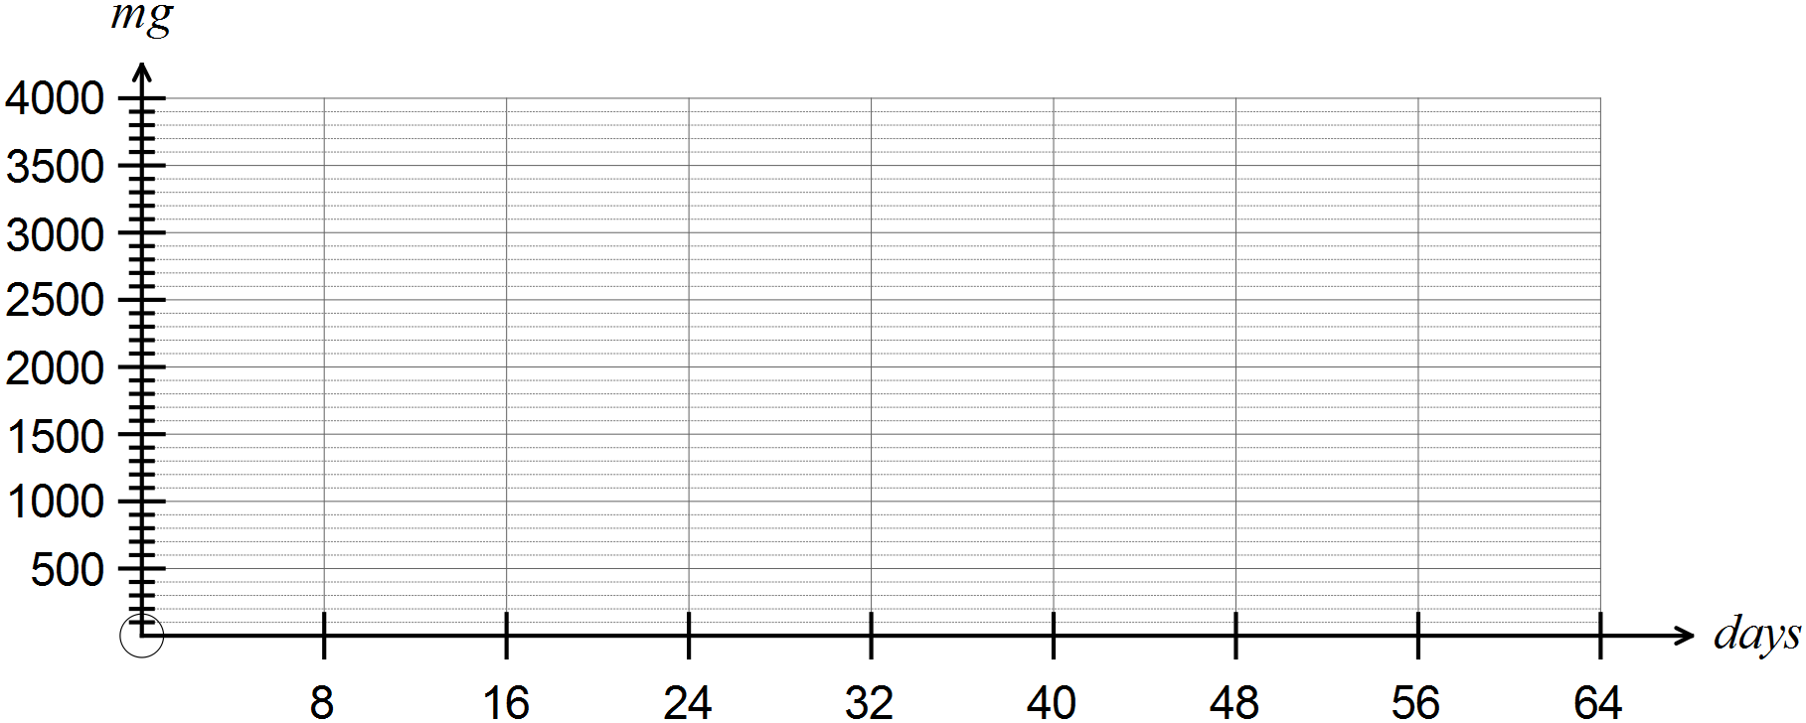

(d)Describe the change in the amount of Iodine-131 as either linear or exponential and either growth or decay. (2)

**Question 4 (10 marks)**

The population of the Goldfields fell by 1.8% during the year from the end of 2013 to the end of 2014. The population at the end of 2014 was 800 people.

(a) What was the population at the end of 2013? (1)

(b) Write a general rule to determine the population at the end of *t* years: *t* is the number of years after the end of 2014. Assume the rate of decline continues. (3)

(c) Use the rule from part (b) to determine the population at the end of 2020. (2)

(d) If the trend continues, in what year will the population first fall below 600? (2)

(e) Concerned by falling population the local council considered organising for an extra 50 people per year to settle in the area. Determine the difference rule that could be used to predict the population at the end of each year from 2014: include the 50 extra people and the 1.8% decline each year. (2)

**End of questions**

**Growth and decay**

**Extended investigation Part 1:** **Preparation activity**

**Solutions**

**Question 1**

|  |  |
| --- | --- |
|  | Solution |
| (a) | Growth indicates that the value is increasing whereas in decay the value is decreasing |
| (b) |  |
| (c) | Discrete data have values which are generally whole numbers and relate to variables which can be counted e.g. number of people, number of trees. Continuous data have decimal and fractional values and an infinite number of values between any two given values; they are generally found in measurements e.g. height, time, distance |
| (d) | Multiplication / division |
| (e) | (i) Population = 1400 (1 + 0.207)2 = 2040  (ii) Population = 386 000 (1 + 0.012)6 = 414 640  (iii) Population = 219 200 (1 + 0.006)36 = 271 874 |
| (f) | (i) Value = 1600 (1 - 0.1)5 = $945  (ii) Population = 4385(1 - 0.13)6 = 1901 |

**Question 2**

|  |  |
| --- | --- |
| (a) | (i) 2 300 000  (ii) 2 300 000  (iii) 2 300 000 |
| (b) | They are all the same |
| (c) | 1. Determine 15% of 2 million. Subtract the answer from 2 million  2. Multiply 2 million by 85%  3. Multiply 2 million by 0.85 |

**Question 3**

|  |  |
| --- | --- |
|  | Solution |
| (a) | 1. Calculation of the population in the second year  2. Calculation of the population after any number of years  3. Calculation of the population for the next year. |
| (b) | Rule 3 |
| (c) | Rule 3 |
| (d) | Divide *r* by 12 |
| (e) | 1.  2.  3. |
| (f) | Rule 3 |
| (g) | Rule 2 |
| (h) | *r* is a % and the value of *r* % is not the value of *r* |
| (i) | Negative values |

**Question 4**

|  |  |
| --- | --- |
|  | Solution |
| (a) | Perth |
| (b) | Sydney |
| (c) | 2043 |
| (d) | The two cities to consider are Melbourne and Sydney because of their current population and growth rates. A spreadsheet can be used to show the population over the years. In 2037 the population of Melbourne (7 324 583) would exceed that of Sydney (7 296 223) |
| (e) | Most unlikely as these figures are estimates and not every person was counted in 2013. |
| (f) | Perth, Sydney, Brisbane and Melbourne. [In the long term Darwin] |
| (g) | It is not the average of all the growth rates. It is the total increase in population over the year 2013-2014 divided by the population in 2013. |
| (h) | 41 years |

**Question 5**

|  |
| --- |
| Solution |
| The population after 70 years is 1500 x 0.957 = 1048  The population reaches 750 after 13 decades (130 years)  This implies a much greater rate of decline in the previous 70 years because it takes nearly twice as long for the population to halve. |

**End of questions**

**Growth and decay**

**Extended investigation Part 2: In class validation**

**Solutions**

**Question 1**

|  |  |  |  |
| --- | --- | --- | --- |
|  | Solution | Mathematical behaviours | Marks |
| (a) | (i) 23 581 000  (ii) 354 600  (iii) Estimate  No census for that year OR  Difficult to be accurate when counting population because of ongoing changes | * reads table of data * considers numbers are in thousands * identifies type of data * justifies selection on data type | 1  1  1  1 |
| (b) | New South Wales | * identifies starting population | 1 |
| (c) | Western Australia | * identifies highest growth rate | 1 |
| (d) | Northern Territory | * compares starting populations and growth rates | 1 |
| (e) | (i) Northern Territory  (ii) Tasmania | * identifies meaning of *P*0 in rule * identifies meaning of *r*in rule | 1  1 |
| (f) |  | * substitutes correct values for variable in rule provided * calculates population * considers numbers in thousands | 1  1  1 |
| (g) |  | * identifies recursion * identifies initial term | 1  1 |
| (h) |  | * calculates *P*1 * calculates *P*2 * calculates *P*3 | 1  1  1 |
| (i) | Rule in part (e)  Quicker and more efficient OR  Previous term not required | * Selects most appropriate rule * Justifies choice of rule | 1  1 |

**Question 2(a)**

|  |  |
| --- | --- |
| Solution | |
| Growth is exponential because it grows in proportion to the existing population rather than as a constant amount. | |
| Mathematical behaviours | Marks |
| * selects correct type of growth * identifies growth in proportional * identifies growth is not linear | 1  1  1 |

**Question 2(b)**

|  |  |
| --- | --- |
| Solution | |
|  | |
| Mathematical behaviours | Marks |
| * identifies correct denominator for fraction * uses correct numerator to create a fraction less than 1 | 1  1 |

**Question 2(c)**

|  |  |
| --- | --- |
| Solution | |
| |  |  |  |  |  |  |  | | --- | --- | --- | --- | --- | --- | --- | | **Year** | 2014 | 2016 | 2018 | 2020 | 2022 | 2023 | | **Population (thousands)** | 2589.1 | 2699.0 | 2813.5 | 2932.9 | 3057.4 | 3121.6 | | |
| Mathematical behaviours | Marks |
| * calculates population in 2016 * calculates population to 2023 | 1  1 |

**Question 2(d)**

|  |  |
| --- | --- |
| Solution | |
| Population in 2013 = 2589.1 – 53.7 = 2535.4  Growth over 10 years = 3121.6-2535.4 = 586.2  %Change = 586.2 ÷ 2535.4 x 100 = 23.1% | |
| Mathematical behaviours | Marks |
| * determines population for 2013 * determines population growth over 10 years * determines percentage growth | 1  1  1 |

**Question 3(a)**

|  |  |
| --- | --- |
| Solution | |
| |  |  |  |  |  |  |  |  |  | | --- | --- | --- | --- | --- | --- | --- | --- | --- | | Time  (days) | 0 | 8 | 16 | 24 | 32 | 40 | 48 | 56 | | Amount (mg) | 4000 | 2000 | 1000 | 500 | 250 | 125 | 62.5 | 31.25 | | |
| Mathematical behaviours | Marks |
| * completes row for time * provides amount for 24 and 32 days * provides amount for 40–56 days | 1  1  1 |

**Question 3(b)**

|  |  |
| --- | --- |
| Solution | |
|  | |
| Mathematical behaviours | Marks |
| * identifies recursion * identifies initial term * relates *n* to the number of lots of 8 days | 1  1  1 |

**Question 3(c)**

|  |  |
| --- | --- |
| Solution | |
|  | |
| Mathematical behaviours | Marks |
| * calculates population in 2016 * calculates population to 2023 * plots points | 1  1  1 |

**Question 3(d)**

|  |  |
| --- | --- |
| Solution | |
| Exponential decay | |
| Mathematical behaviours | Marks |
| * identifies nature of growth * identifies direction of growth | 1  1 |

**Question 4(a)**

|  |  |
| --- | --- |
| Solution | |
| 800 x 100 ÷ (100 – 1.8)  =815 | |
| Mathematical behaviours | Marks |
| * calculates population | 1 |

**Question 4(b)**

|  |  |
| --- | --- |
| Solution | |
|  | |
| Mathematical behaviours | Marks |
| * selects correct general rule for substitution * identifies correct rate * identifies correct *P*0 | 1  1  1 |

**Question 4(c)**

|  |  |
| --- | --- |
| Solution | |
|  | |
| Mathematical behaviours | Marks |
| * identifies correct value for *t* * determines population | 1  1 |

**Question 4(d)**

|  |  |
| --- | --- |
| Solution | |
| 16 years later than the end of 2014  After the end of 2029 ... by the end of 2030 | |
| Mathematical behaviours | Marks |
| * determines table entry for population less than 600 * identifies year in which population is less than 600 | 1  1 |

**Question 4(e)**

|  |  |
| --- | --- |
| Solution | |
|  | |
| Mathematical behaviours | Marks |
| * selects a difference rule with the correct rate of decline * includes the 50 extra people into the difference rule | 1  1 |

**TASK 5: Constant and proportional change**

**In-class investigation**

**Unit 3**

**Topic 3.2: Growth and decay in sequences**

**Course-related information**

The concepts and skills developed in this investigation relate to the following dot points within the WA Mathematics Applications syllabus:

3.2.2 display the terms of an arithmetic sequence in both tabular and graphical form and demonstrate that arithmetic sequences can be used to model linear growth and decay in discrete situations

3.2.3 deduce a rule for the term of a particular arithmetic sequence from the pattern of the terms in an arithmetic sequence, and use this rule to make predictions



3.2.6 display the terms of a geometric sequence in both tabular and graphical form and demonstrate that geometric sequences can be used to model exponential growth and decay in discrete situations

3.2.7 deduce a rule for the term of a particular geometric sequence from the pattern of the terms in the sequence, and use this rule to make predictions



**Background information**

Students should have had opportunities to generate the terms of arithmetic and geometric sequences from their recursive formulae. They should already have an awareness of the major differences between the two types of sequences. Students should have studied simple and compound interest in earlier years and they should have a basic knowledge of financial terms, for example, investment and account balances.

**Task conditions**

This task consists of an in-class investigation for which students might need 40 – 55 minutes to complete. Students need to be familiar with using recursive formulae, tabulation and graphing using technology and it is expected that access to such technology will be available during the investigation.

**Constant and proportional change**

**In-class investigation (Total marks: 45)**

The focus of this investigation is the comparison of constant and proportional change.

**Question 1 (8 marks)**

Ben has $100 in his savings account. He adds an extra $10 at the end of each month and does not withdraw any money.

(a) Complete the table to show the balance of Ben’s account at the end of the given month. (2)

|  |  |  |  |  |  |  |
| --- | --- | --- | --- | --- | --- | --- |
| **Month** | 1 | 2 | 3 | 4 | 5 | 10 |
| **Account balance** | $110 |  |  |  |  |  |

(b) On the axes below, draw a graph to show the balance of Ben’s account over the given time. (2)

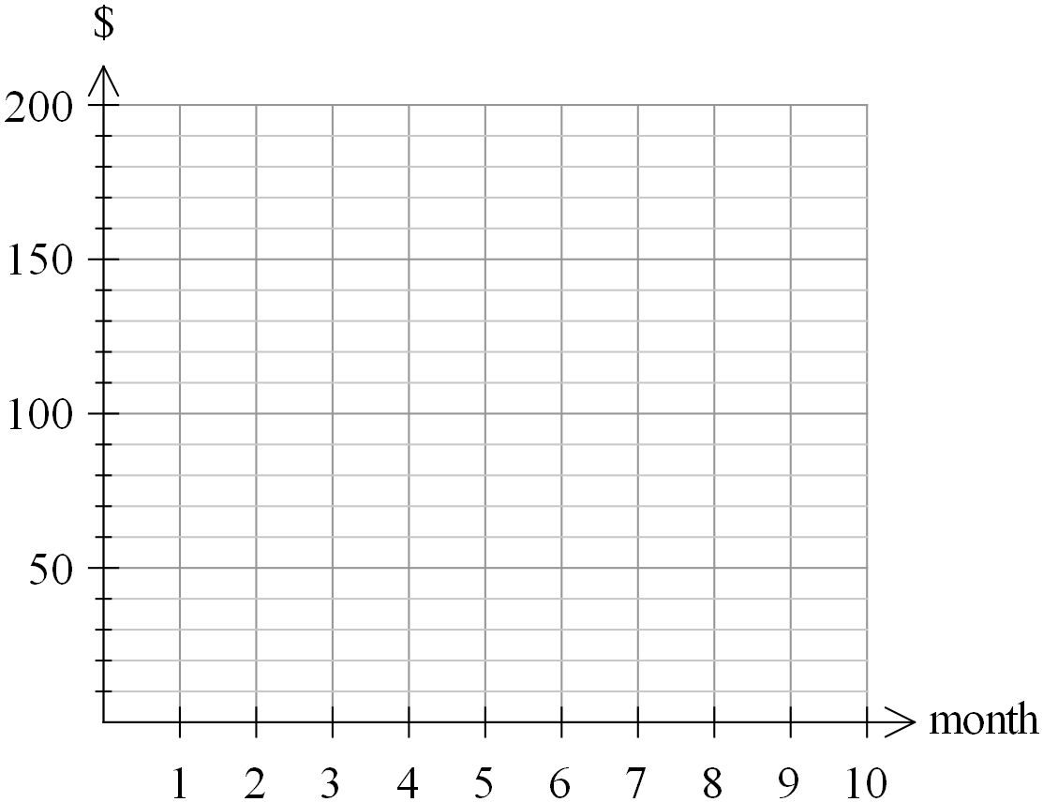

(c) State the recursive rule to describe the amount in Ben’s account at the end of each month. (2)

(d) The formula to specify the amount in Ben’s account is *A* = 100 + 10*t* where *A*

represents the balance and *t* represents the number of months since the start.

State two restrictions on the values that *t* can take. (2)

**Question 2 (8 marks)**

Lana has $100 in her savings account. She gains an extra 10% at the end of each month and does not withdraw any money.

(a) State the recursive rule to describe the amount in Lana’s account at the end of each month. (2)

(b) Complete the table to show the balance of Lana’s account at the end of the given month. (2)

|  |  |  |  |  |  |  |
| --- | --- | --- | --- | --- | --- | --- |
| **Month** | 1 | 2 | 3 | 4 | 5 | 6 |
| **Account balance** | $110 |  |  |  |  |  |

(c) Draw a graph to show the balance of Lana’s account over the time specified. (2)



(d) The change to Ben’s account is classified as constant change whereas the change to Lana’s account is classified as proportional change. Describe the difference between these two types of change. (2)

**Question 3 (11 marks)**

(a) Greg has $200 in his account and he withdraws $20 each month. Complete the table to show the balance of Greg’s account at the end of the given month. (2)

|  |  |  |  |  |  |  |
| --- | --- | --- | --- | --- | --- | --- |
| **Month** | 1 | 2 | 3 | 4 | 5 | 10 |
| **Account balance** |  |  |  |  |  |  |

(b) Julie has $200 in her account and she loses 10% of the balance at the end of each month. Complete the table to show the balance of Julie’s account at the end of the given month. (2)

|  |  |  |  |  |  |  |
| --- | --- | --- | --- | --- | --- | --- |
| **Month** | 1 | 2 | 3 | 4 | 5 | 6 |
| **Account balance** |  |  |  |  |  |  |

(c) On the axes below, draw graphs to show:

(i) the balance of Greg’s account over the ten months

(ii) the balance of Julie’s account over the ten months. (4)

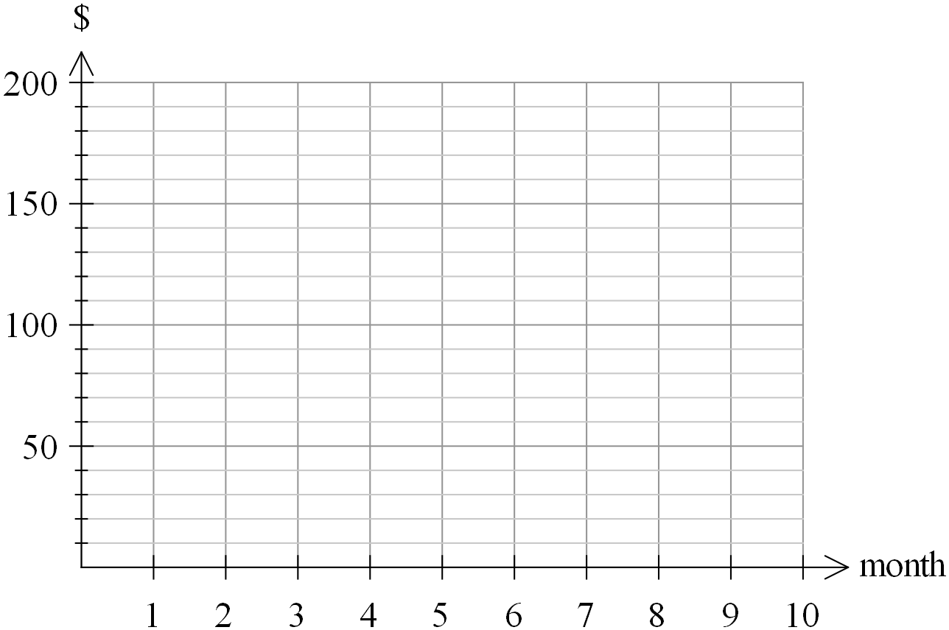

(d) In whose account is the balance decreasing by a constant amount? (1)

(e) What type of change, constant or proportional, has resulted in the smallest decrease in the balance of the account? Explain why this has happened. (2)

**Question 4 (8 marks)**

For the situations described in Questions 1 to 3 and for Graphs A to D, complete the table below.

|  |  |  |  |  |  |
| --- | --- | --- | --- | --- | --- |
|  | **Name** | **Starting amount** | **Proportional or constant change** | **Increase or decrease** | **Value of change** |
| (a) | Ben | $100 | constant | increase | $10 |
| (b) | Lana | $100 | proportional | increase | 10% |
| (c) | Greg |  |  |  |  |
| (d) | Julie |  |  |  |  |
| (e) | Graph A |  |  |  |  |
| (f) | Graph B |  |  |  |  |
| (g) | Graph C |  |  |  |  |
| (h) | Graph D |  |  |  |  |

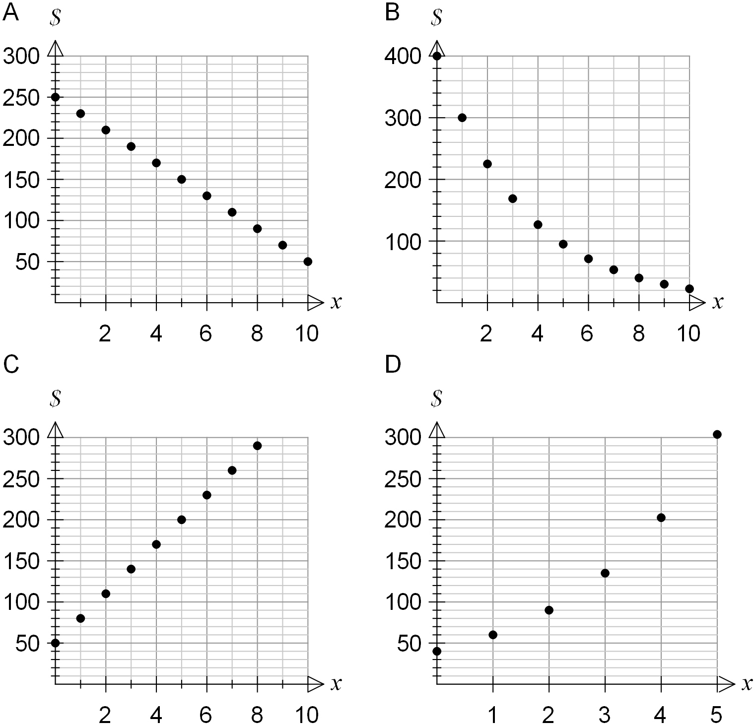**Question 5 (10 marks)**

(a) Of the two types of change, one type is associated with an arithmetic sequence and the other with a geometric sequence. Explain the relationship between the types of change and the nature of the sequence. (3)

(b) Of the two types of change, one type is associated with simple interest and the other with compound interest. Explain the relationship between the types of change and the types of interest. (3)

(c) A: Two increases of $40 on a $200 investment results in a value of $280.

B: Two consecutive increases of 20% are applied to a $200 investment.

(i) What is the value of investment B after the two increases? (2)

(ii) What is the overall percentage increase for investment B? (1)

(iii) Complete this calculation of the final amount after two increases of 20%.

Final amount = original amount _______________________________

(1)

**End of questions**

**Constant and proportional change**

**In-class investigation**

**Solutions and marking key**

**Question 1(a)**

|  |  |
| --- | --- |
| Solution | |
| |  |  |  |  |  |  |  | | --- | --- | --- | --- | --- | --- | --- | | **Month** | 1 | 2 | 3 | 4 | 5 | 10 | | **Account balance** | $110 | $120 | $130 | $140 | $150 | $200 | | |
| Mathematical behaviours | Marks |
| * determines balance for first 5 months * determines balance after 10 months | 1  1 |

**Question 1(b)**

|  |  |
| --- | --- |
| Solution | |
|  | |
| Mathematical behaviours | Marks |
| * plots all points correctly * selects appropriate type of graph | 1  1 |

**Question 1(c)**

|  |  |
| --- | --- |
| Solution | |
| *T*1 = $100, *T* *n* + 1 = *T* *n* + 10 | |
| Mathematical behaviours | Marks |
| * describes recursion * identifies first term of sequence | 1  1 |

**Question 1(d)**

|  |  |
| --- | --- |
| Solution | |
| *t* must be zero or positive  *t* must be a whole number | |
| Mathematical behaviours | Marks |
| * identifies integer values for *t* * identifies *t* is positive or zero | 1  1 |

**Question 2(a)**

|  |  |
| --- | --- |
| Solution | |
| *T*1 = $100, *T* *n* + 1 = 1.1 *T* *n* | |
| Mathematical behaviours | Marks |
| * describes recursion * identifies first term of sequence | 1  1 |

**Question 2(b)**

|  |  |
| --- | --- |
| Solution | |
| |  |  |  |  |  |  |  | | --- | --- | --- | --- | --- | --- | --- | | **Month** | 1 | 2 | 3 | 4 | 5 | 6 | | **Account balance** | $110 | $121 | $133.10 | $146.41 | $161.05 | $177.16 | | |
| Mathematical behaviours | Marks |
| * determines balance for months 2,3 * determines balance for months 4,5,6 | 1  1 |

**Question 2(c)**

|  |  |
| --- | --- |
| Solution | |
|  | |
| Mathematical behaviours | Marks |
| * plots all points correctly * selects appropriate type of graph | 1  1 |

**Question 2(d)**

|  |  |
| --- | --- |
| Solution | |
| Constant change involves change by a fixed amount whereas proportional change means that the amount by which the balance alters is a part or fraction of what amount is there at the time – so the amount of change changes. | |
| Mathematical behaviours | Marks |
| * identifies fixed amount of change when change is constant * identifies change is variable when it is proportional | 1  1 |

**Question 3(a)**

|  |  |
| --- | --- |
| Solution | |
| |  |  |  |  |  |  |  | | --- | --- | --- | --- | --- | --- | --- | | **Month** | 1 | 2 | 3 | 4 | 5 | 10 | | **Account balance** | $180 | $160 | $140 | $120 | $100 | $0 | | |
| Mathematical behaviours | Marks |
| * determines balance for first 5 months * determines balance after 10 months | 1  1 |

**Question 3(b)**

|  |  |
| --- | --- |
| Solution | |
| |  |  |  |  |  |  |  | | --- | --- | --- | --- | --- | --- | --- | | **Month** | 1 | 2 | 3 | 4 | 5 | 6 | | **Account balance** | $180 | $162 | $145.80 | $131.22 | $118.10 | $106.29 | | |
| Mathematical behaviours | Marks |
| * determines balance for months 1,2,3 * determines balance for months 4,5,6 | 1  1 |

**Question 3(c)**

|  |  |
| --- | --- |
| Solution | |
|  | |
| Mathematical behaviours | Marks |
| * correctly plots initial values for each account balance * correctly plots constant decrease of $20 * correctly plots proportional decrease for 6 months * correctly plots proportional decrease for months 7 to 10 | 1  1  1  1 |

**Question 3(d)**

|  |  |
| --- | --- |
| Solution | |
| Greg | |
| Mathematical behaviours | Marks |
| * identifies constant change | 1 |

**Question 3(e)**

|  |  |
| --- | --- |
| Solution | |
| Proportional change  Each change to the account is reduced because it is a proportion of a smaller amount than for the previous month. | |
| Mathematical behaviours | Marks |
| * identifies change with the smallest decrease * justifies selection of correct option | 1  1 |

**Question 4**

|  |  |
| --- | --- |
| Solution | |
| |  |  |  |  |  |  | | --- | --- | --- | --- | --- | --- | |  | **Name** | **Starting amount** | **Proportional or constant change** | **Increase or decrease** | **Value of change** | | (a) | Ben | $100 | constant | increase | $10 | | (b) | Lana | $100 | proportional | increase | 10% | | (c) | Greg | $200 | constant | decrease | $20 | | (d) | Julie | $200 | proportional | decrease | 10% | | (e) | Graph A | $250 | constant | decrease | $20 | | (f) | Graph B | $400 | proportional | decrease | 25% | | (g) | Graph C | $50 | constant | increase | $30 | | (h) | Graph D | $40 | proportional | increase | 50% | | |
| Mathematical behaviours | Marks |
| * correctly completes data provided for Greg and Julie * identifies initial values for each account balance * distinguishes constant and proportional change * distinguishes increase and decrease * determines value of decrease in Graph A * determines value of increase in Graph C * determines proportional decrease in Graph B * determines proportional increase Graph D | 1  1  1  1  1  1  1  1 |

**Question 5(a)**

|  |  |
| --- | --- |
| Solution | |
| Arithmetic sequences describe constant change whereas geometric sequences describe proportional change.  In both arithmetic sequences and in constant change a fixed amount is either subtracted or added.  In both geometric sequences and for proportional change the existing amount is multiplied by the same number each time | |
| Mathematical behaviours | Marks |
| * links types of change to types of sequences * describes similarity of arithmetic sequences and constant change * describes similarity of geometric sequences and proportional change | 1  1  1 |

**Question 5(b)**

|  |  |
| --- | --- |
| Solution | |
| Proportional change occurs when interest is compounded and constant change occurs when simple interest is used for an investment.  Compounding and involves multiplication of the current balance by a fraction or percentage so this is proportional change.  For simple interest the interest is fixed and the same amount is added to the account balance each time. | |
| Mathematical behaviours | Marks |
| * links types of change to types of interest * identifies similar mathematical operations for both compounding and proportional change * explains that addition of a fixed amount occurs with constant change and simple interest | 1  1  1 |

**Question 5(c)**

|  |  |
| --- | --- |
| Solution | |
| (i) $288  (ii) 44%  (iii) Final amount = original amount x 1.2 x 1.2 | |
| Mathematical behaviours | Marks |
| * applies 20% increase to initial amount * applies further 20% increase to new amount * determines overall percentage increase * identifies correct calculation | 1  1  1  1 |

**TASK 6**

**Investigative questions**

**Unit 3**

**Topic 3.2: Growth and decay in sequences**

**Course-related information**

The concepts and skills covered in these investigative questions relate to the following dot points within the WA Mathematics Applications syllabus:

3.2.3 deduce a rule for the term of a particular arithmetic sequence from the pattern of the terms in an arithmetic sequence, and use this rule to make predictions



3.2.4 use arithmetic sequences to model and analyse practical situations involving linear growth or decay

3.2.7 deduce a rule for the term of a particular geometric sequence from the pattern of the terms in the sequence, and use this rule to make predictions



3.2.8 use geometric sequences to model and analyse (numerically, or graphically only) practical problems involving geometric growth and decay

The ability to choose and use appropriate technology to enhance and extend concept development is also required for some of the items

**Background information**

It is assumed that students have completed topic 3.2. They should have had several opportunities to identify arithmetic and geometric sequences as well as to determine their recursive and general equations.

**Task conditions**

These items should be undertaken under test conditions, either as part of a test/examination or as stand-alone items. Student access to a graphical/CAS calculator is assumed. The time required to complete each question is left to the discretion of the teacher but the intention is that each question may be completed within 15 minutes.

**Investigative questions for Topic 3.2**

**Question 1 (10 marks)**

Families may be described by the gender and number of children. If there is one child in the family, there are two types of families: B (boy) and G (girl). For two children in the family there are four types of families: BB, BG, GG and GB.

(a) If there are three children in the family, there are 8 types of families. One of these is BGB. List all other types. (2)

(b) Complete the table below, to show the number of types of families according to the number of children. (2)

|  |  |  |  |  |  |  |
| --- | --- | --- | --- | --- | --- | --- |
| **Number of children** | 1 | 2 | 3 | 4 | 5 | 6 |
| **Number of types of families** | 2 |  |  |  |  |  |

(c) The number of types of families forms a sequence where *n* represents the number of children. Using *Tn* to represent the number of types of families, state the recursive rule to determine *Tn + 1* (2)

(d) The recursive rule from part (c) could also be used to describe the number of different outcomes when different numbers of lights are ON or OFF. Justify the use of this same rule to describe the number of different outcomes. (2)

(e) Identify and describe another situation to which the rule from part (c) could also be applied. (2)

**Question 2 (10 marks)**

Tina makes squares with wool. Each square is made up of 6 rounds and in each round there are different numbers of trebles. The numbers of trebles in some of the different rounds are shown in the table below.

|  |  |  |  |  |  |  |
| --- | --- | --- | --- | --- | --- | --- |
| **Round** | 1 | 2 | 3 | 4 | 5 | 6 |
| **Number of trebles** | 4 | 8 | 12 |  |  | 24 |

(a) Complete the table. (1)

(b) Determine the recursive rule to describe the number of trebles. (2)

(c) The total number of trebles in all the rounds can be represented by the following rule:  where *n* represents the round number, *d* is the difference and *a* is the starting term. Use this ruleto show that thetotal number of trebles in one square is 84. (2)

(d) One ball of wool will be just enough to make 192 trebles. How many balls of wool will be needed for a blanket which is made of 48 squares? (2)

(e) If Tina had one ball of wool and made one square as large as possible, how many rounds would the square have? Justify your answer. (3)

**A crochet square with 6 rounds**

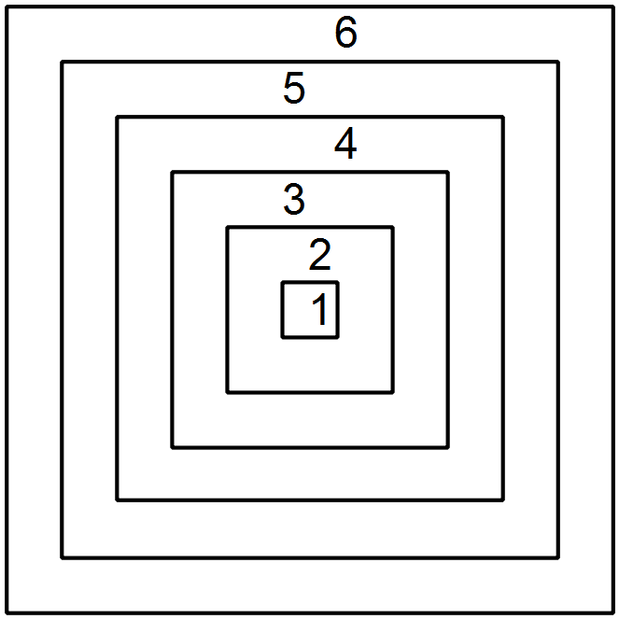

**Round 2 with 8 trebles (yellow)**

The sixth round of this large square is white**Question 3 (8 marks)**



Two bushwalkers have 5 days in which to complete their journey. They walk 20 km on the first day and after that, the distance walked each day will be 60% of the previous day’s journey.

(a) Write a recursive rule to describe the distance to be walked each day. (2)

(b) Record the distance to be walked each day in the table provided. (2)

|  |  |  |  |  |  |
| --- | --- | --- | --- | --- | --- |
| **Day** | 1 | 2 | 3 | 4 | 5 |
| **Distance walked each day (km)** | 20 |  |  |  |  |

1. Determine the total distance walked during these five days. (1)
2. Three rules to estimate the total distance walked are provided. In each rule “*a*” represents the distance walked on the first day and “*r*” represents the ratio or proportional change, in this case 60%.

(i) 

(ii) 

(iii) 

Which of these three rules gives the best estimate of the total distance walked?

Justify your choice of rule. (3)

**Investigative questions in Topic 3.2**

**Solutions and marking key**

**Question 1**

|  |  |  |  |
| --- | --- | --- | --- |
|  | Solution | Mathematical behaviours | Marks |
| (a) | BBB, BBG, BGG  GGG, GGB, GBG, GBB | * identify 6 different types * identify 2 types | 1  1 |
| (b) | |  |  |  |  |  |  |  | | --- | --- | --- | --- | --- | --- | --- | | *n* | 1 | 2 | 3 | 4 | 5 | 6 | | *Tn* | 2 | 4 | 8 | 16 | 32 | 64 | | * completes table with data provided * continues pattern of numbers | 1  1 |
| (c) |  | * identifies initial term * identifies recursion | 1  1 |
| (d) | There are two states for each light  There are different numbers of lights: 1, 2, 3, ...  Conditions are the same.  A labelled table could be used to summarise these features | * links On/OFF to B/G * links number of lights to number of children | 1  1 |
| (e) | Coin tossing: two results, heads and tails. There are a discrete number of coins 1, 2, 3, ... | * identifies situation * describes situation | 1  1 |

**Question 2**

|  |  |  |  |
| --- | --- | --- | --- |
|  | Solution | Mathematical behaviours | Marks |
| (a) | |  |  |  |  |  |  |  | | --- | --- | --- | --- | --- | --- | --- | | *r* | 1 | 2 | 3 | 4 | 5 | 6 | | *t* | 4 | 8 | 12 | 16 | 20 | 24 | | * continues pattern of numbers | 1 |
| (b) |  | * identifies initial term * identifies recursion | 1  1 |
| (c) |  | * substitutes correctly for *n* * substitutes correctly for *a* and *d* | 1  1 |
| (d) | Balls = 84 × 48 ÷ 192 = 21 | * determines total number of trebles * determines total number of balls | 1  1 |
| (e) | 6 rounds is 84 trebles  7 rounds = 84 + 28 = 112  8 rounds = 112 + 32 = 144  9 rounds = 144 + 36 = 180  9 rounds | * identifies number of trebles is 192 * shows systematic process to determine value * determines integer value from calculations | 1  1  1 |

**Question 3**

|  |  |  |  |
| --- | --- | --- | --- |
|  | Solution | Mathematical behaviours | Marks |
| (a) |  | * identifies initial term * identifies recursion | 1  1 |
| (b) | |  |  |  |  |  |  | | --- | --- | --- | --- | --- | --- | | *n* | 1 | 2 | 3 | 4 | 5 | | *d* | 20 | 12 | 7.2 | 4.32 | 2.592 | | * determines 2 distances * determines 2 distances | 1  1 |
| (c) |  | * determines total | 1 |
| (d) | (i) Total distance = 33.3 km  (ii) Total distance = 12.5 km  (iii) Total distance = 50 km  Closest estimate from rule (iii) | * substitutes correct *a* and *r* in each equation * correctly determines each total * identifies best rules is (iii) | 1  1  1 |

**TASK 7: ROADS**

**Extended investigation**

**Unit 3**

**Topic 3.3: Graphs and networks**

**Course-related information**

The concepts and skills covered in this investigation relate to the following dot points within the WA Mathematics Applications syllabus:

3.3.1 demonstrate the meanings of, and use, the terms: graph, edge, vertex, loop, degree of a vertex, subgraph, simple graph, complete graph, bipartite graph, directed graph (digraph), arc, weighted graph, and network

3.3.2 identify practical situations that can be represented by a network, and construct such networks

3.3.4 demonstrate the meanings of, and use, the terms: planar graph and face

3.3.5 apply Euler’s formula, to solve problems relating to planar graphs.



3.3.6 demonstrate the meanings of, and use, the terms: walk, trail, path, closed walk, closed trail, cycle, connected graph, and bridge

3.3.7 investigate and solve practical problems to determine the shortest path between two vertices in a weighted graph (by trial-and-error methods only)

3.3.8 demonstrate the meanings of, and use, the terms: Eulerian graph, Eulerian trail, semi-Eulerian graph, semi-Eulerian trail and the conditions for their existence, and use these concepts to investigate and solve practical problems

3.3.9 demonstrate the meanings of, and use, the terms: Hamiltonian graph and semi-Hamiltonian graph, and use these concepts to investigate and solve practical problems

**Background information**

Students need to have started topic 3.3 for this investigation.

**Task conditions**

Calculator technology is not required for this investigation. Students should bring a page of notes as indicated in the preparation activity. Approximately 50 minutes should be allocated to the in-class investigation. It is suggested that a separate sheet of extra copies of the network used, is provided to the students.

**Roads**

**Extended investigation Part 1:** **Preparation activity**

To prepare for the in-class component of this investigation create two pages of notes which describe the following terms as they apply to networks and which provide information to complete the set tasks.

**Terminology**

|  |  |  |  |
| --- | --- | --- | --- |
| graph | node | vertex | edge |
| face | planar | simple | trail |
| cycle | shortest path | loop | multiple edge |

**Tasks**

* Apply Euler’s formula to identify a planar graph
* Identify a Hamiltonian path or cycle
* Identify a Eulerian trail

**Roads**

**Extended investigation Part 2:** **In-class validation (50 marks)**

The network below shows a newly developed ring road alignment. Only the major roads are shown and the letters mark the intersections of these roads. The distances have been estimated to the nearest kilometre.

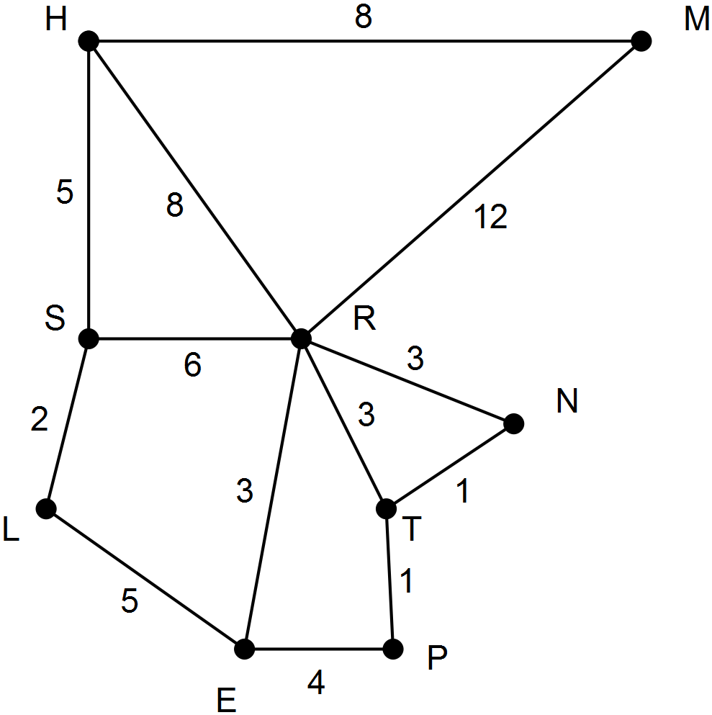

**Question 1 (16 marks)**

Rob wants native plants to be established at each intersection and they will need regular watering during their first summer. For this question the distance travelled by the watering truck is considered.

(a) Starting at R, then going to T then N determine a route for the truck. [1]

(b) Determine the length of the route described in part (a). [1]

(c) Is the route you have described Hamiltonian in nature? Explain [2]

(d) Determine four different watering routes. Each route is to start at a different intersection, finish at the starting intersection and visit every other intersection just once. Determine the length of each route and enter your results in the table provided. [5]

|  |  |  |  |
| --- | --- | --- | --- |
| **Route** | **Starting intersection** | **Route – order of roads travelled** | **Distance** |
| 1 |  |  |  |
| 2 |  |  |  |
| 3 |  |  |  |
| 4 |  |  |  |

(e) Which roads should the driver not use when making a watering route which begins and ends at the same intersection and in which each intersection is visited just once? [2]

(f) Anna decides it is not necessary for the watering truck to return to its starting position but still wants the plants at each intersection watered. Identify three routes of different lengths. State the length of each route. [3]

(g) When the price of petrol is high, which of your three routes in part (f) would be the most economical to use. Justify your answer. [2]

**Question 2 (8 marks)**

The question refers to the same ring road described in the previous question. The diagram is reproduced below.



Mike normally goes for a run before work, running along the road from T to H.

(a) Determine the minimum distance that he would be running. [1]

(b) One particular day the road from T to R was closed. Assuming Mike does not run through any intersection more than once but still begins at T determine

(i) five other running routes [5]

(ii) the difference between the shortest and the longest possible routes. [2]

**Question 3 (13 marks)**

The ring road from the earlier questions is also used here. It is reproduced below.



**End of questions**

Sue will be organising a local marathon and she wants every road included just once and it does not matter where the marathon starts. However, her mathematics students have told her that it will not be possible.

(a) What is the term used to describe a graph for which it is possible to travel on every connection just the once? [1]

(b) Start at M, go to H. Describe why it is impossible to achieve Sue’s plan. [2]

(c) What features of the network would enable Sue’s mathematics students to identify that the plan was impossible without having to try every route in the network? [2]

By making extra roads it would be possible for Sue to achieve her plan.

(d) Which roads could be made? [2]

(e) Using the new roads, name two possible routes for the marathon. [4]

(f) Assuming any new roads were the same length, which of your marathon routes would be the shortest? Explain. [2]

**Question 4 (13 marks)**



Sue’s mathematics students were asked to describe the network. Ben said it was a simple graph and Sarah said it was planar.

(a) Describe two ways by which roads could be added so that the network is no longer simple. [2]

(b) What did Sarah mean when she said the graph was planar? [1]

(c) Show how you could use Euler’s formula to confirm Sarah’s description. [4]

(d) Add roads to the network so that it is no longer planar. [3]



(e) If such a road network were to be built so that it was not planar

(i) identify one feature relating to the network structure it could have [1]

(ii) identify an advantage of such a road system [1]

(iii) identify a limitation of such a road system [1]



**Roads**

**Extended investigation Part 2:** **In-class validation**

**Solutions and marking key**

**Question 1(a)**

|  |  |
| --- | --- |
| Solution | |
| RTNRMHSLEPTR or RTNRMHSLEPT  Any route could be given as no limitations are provided | |
| Mathematical behaviours | Marks |
| * identifies series of edges in network | 1 |

**Question 1(b)**

|  |  |
| --- | --- |
| Solution | |
| 47 or 44 | |
| Mathematical behaviours | Marks |
| * calculates distance | 1 |

**Question 1(c)**

|  |  |
| --- | --- |
| Solution | |
| No  Vertex R was re-visited | |
| Mathematical behaviours | Marks |
| * identifies network is not Hamiltonian * explains conclusion | 1  1 |

**Question 1(d)**

|  |  |
| --- | --- |
| Solution | |
| |  |  |  |  | | --- | --- | --- | --- | | **Route** | **Starting intersection** | **Route – order of roads travelled** | **Distance** | | 1 | R | RMHSLEPTNR | 41 km | | 2 | M | MHSLEPTNRM | 41 km | | 3 | L | LSHMRNTPEL | 41 km | | 4 | E | ELSHMRNTPE | 41 km | | |
| Mathematical behaviours | Marks |
| * calculates distance * identifies four routes each with a different starting point | 1  4 |

**Question 1(e)**

|  |  |
| --- | --- |
| Solution | |
| The driver should not travel on any route from R to H, S, E or T | |
| Mathematical behaviours | Marks |
| * identifies one route other than RT on which not to travel * identifies two further routes on which not to travel | 1  1 |

**Question 1(f)**

|  |  |
| --- | --- |
| Solution | |
| MHRSLEPTN (35 km)  MHSLEPTNR (29 km)  MHSLERNTP (28 km) Other possibilities exist. Routes can start at any vertex. | |
| Mathematical behaviours | Marks |
| * identifies 3 paths of different lengths | 3 |

**Question 1(g)**

|  |  |
| --- | --- |
| Solution | |
| MHSLERNTP  It is the shortest route so less petrol used and lowest cost | |
| Mathematical behaviours | Marks |
| * identifies shortest route * links answer to context of question. | 1  1 |

**Question 2(a)**

|  |  |
| --- | --- |
| Solution | |
| 11 km | |
| Mathematical behaviours | Marks |
| * interprets network | 1 |

**Question 2(b)(i)**

|  |  |
| --- | --- |
| Solution | |
| TNRH (12)  TNRMH (24)  TNRELSH (19)  TPERMH (28)  TPELSRMH (38) | |
| Mathematical behaviours | Marks |
| * identifies 5 different routes | 5 |

**Question 2(b)(ii)**

|  |  |
| --- | --- |
| Solution | |
| 26 | |
| Mathematical behaviours | Marks |
| * identifies shortest and longest routes * calculates difference | 1  1 |

**Question 3(a)**

|  |  |
| --- | --- |
| Solution | |
| Eulerian | |
| Mathematical behaviours | Marks |
| * demonstrates knowledge of terminology | 1 |

**Question 3(b)**

|  |  |
| --- | --- |
| Solution | |
| From M to H and then R, you need to get back to M to go over RM and this means repeating the edge MH or MR to get back to the other edges. | |
| Mathematical behaviours | Marks |
| * describes an attempted route * explains need to repeat edge | 1  1 |

**Question 3(c)**

|  |  |
| --- | --- |
| Solution | |
| The number of odd nodes in the network is not 0 or 2 | |
| Mathematical behaviours | Marks |
| * demonstrates knowledge of odd nodes for Eulerian trail * identifies number of odd nodes | 1  1 |

**Question 3(d)**

|  |  |
| --- | --- |
| Solution | |
| Make roads ET or HS (connecting any two odd vertices) | |
| Mathematical behaviours | Marks |
| * identifies one pair of odd vertices to connect * identifies a second pair of odd vertices to connect | 1  1 |

**Question 3(e)**

|  |  |
| --- | --- |
| Solution | |
| ELS**HS**RHMRTNREPT  SLEP**TE**RTNRSHRMH | |
| Mathematical behaviours | Marks |
| * uses first new road to make a route with no edges repeated * uses second new road to make a route with no edges repeated | 2  2 |

**Question 3(f)**

|  |  |
| --- | --- |
| Solution | |
| Neither route is shorter  Every edge is travelled each time | |
| Mathematical behaviours | Marks |
| * identifies every edge is used * identifies the same distance | 1  1 |

**Question 4(a)**

|  |  |
| --- | --- |
| Solution | |
| Add a loop at any intersection  Add an extra edge between any two vertices | |
| Mathematical behaviours | Marks |
| * identifies first feature of a network that is not simple * identifies second feature of a network that is not simple | 1  1 |

**Question 4(b)**

|  |  |
| --- | --- |
| Solution | |
| It can be draw in the plane (2-D) without edges crossing | |
| Mathematical behaviours | Marks |
| * describes planarity | 1 |

**Question 4(c)**

|  |  |
| --- | --- |
| Solution | |
| *v + f – e* = 2  9 + 6 – 13 = 2 | |
| Mathematical behaviours | Marks |
| * identifies number of edges * identifies number of faces * identifies number of vertices * substitutes using Euler’s formula | 1  1  1  1 |

**Question 4(d)**

|  |  |
| --- | --- |
| Solution | |
|  | |
| Mathematical behaviours | Marks |
| * adds two roads to make a non-planar network * other features maintained | 2  1 |

**Question 4(e)**

|  |  |
| --- | --- |
| Solution | |
| (i) flyover, tunnel  (ii) occupies less space on the ground  (iii) costs more to build, pollution confined to smaller area | |
| Mathematical behaviours | Marks |
| * relates theory to context in three specific ways. | 3 |

**TASK 8: COMPETITION**

**In-class investigation**

**Unit 3**

**Topic 3.3: Graphs and networks**

**Course-related information**

The concepts and skills developed in this investigation relate to the following dot points within the WA Mathematics Applications syllabus:

3.3.1 demonstrate the meanings of, and use, the terms: graph, edge, vertex, loop, degree of a vertex, subgraph, simple graph, complete graph, bipartite graph, directed graph (digraph), arc, weighted graph, and network

3.3.2 identify practical situations that can be represented by a network, and construct such networks

3.3.3 construct an adjacency matrix from a given graph or digraph and use the matrix to solve associated problems

**Background information**

Students should have background knowledge of matrices and bipartite graphs. They should be able to determine adjacency matrices, draw bipartite graphs and connect these two representations. Familiar terminology should include nodes, elements, digraphs, leading diagonals, edges, matrix addition.

**Task conditions**

This task consists of an in-class investigation for which students might need 40 – 55 minutes to complete. Students will not need access to technology for this investigation. This investigation should be completed without reference to any notes.

**Competition**

**In-class investigation (Total marks: 50)**

In this investigation, networks and matrices will be used to represent competition between teams and players. Use the letters provided to represent the nodes.

**Question 1 (10 marks) (6 marks)**

Team A has three players: Kyle (K), Rod (R) and Ahmed (A)

Team B has three players: Stefan (S), John (J) and Nigel (N)

Each person in Team A plays a match against each person in Team B.

These nine matches can be represented by a bipartite graph in which the members of Team A form one set of nodes and the members of Team B form another set of nodes. There is an edge drawn from each member of Team A to each member of Team B.

(a) Draw the bipartitie graph described above. [2]

K S

R J

A N

(b) The adjacency matrix for this non-directed network is given below.

Describe what the elements of the adjacency matrix represent. [2]



(c) Team C has four players: Lou (L), Nat (N), Trish (T) and Ali (A).

Team D has four players: Di (D), Indi (I), Jane (J) and Pat (P).

Each person in Team C plays a match against each person in Team D.

Represent the matches between the two teams as

(i) A bipartite graph [2]

(ii) An adjacency matrix [2]

(d) For two teams of *n* players in each team where each person in the first team plays a match against each player in the second team, describe the adjacency matrix. [2]

**Question 2 (12 marks)**

An extra person has joined Teams C and D.

Team C now has five players: Lou (L), Nat (N), Trish (T), Ali (A) and Barb (B).

Team D now has five players: Di (D), Indi (I), Jane (J), Pat (P) and Kath (K).

Each person from each team plays three matches against three players from the other team and these are represented by a ✓ in the table below.

|  |  |  |  |  |  |
| --- | --- | --- | --- | --- | --- |
|  | **L** | **N** | **T** | **A** | **B** |
| **D** | ✓ | ✓ | ✓ |  |  |
| **I** |  |  | ✓ | ✓ | ✓ |
| **J** | ✓ |  |  | ✓ | ✓ |
| **P** |  | ✓ | ✓ |  | ✓ |
| **K** | ✓ | ✓ |  | ✓ |  |

(a) Name the people that Jane plays. [1]

(b) How many matches altogether? [1]

(c) Use a bipartitie graph to represent the matches played between the two teams.

[2]

D L

I N

J T

P A

K B

(d) The complement of this graph is the graph where the edges all represent the matches that were NOT played between the two players at each node. Draw the complement described. [2]

D L

I N

J T

P A

K B

(e) Determine the adjacency matrix for

[4]

|  |  |
| --- | --- |
| (i) the played matches in part (c) | (ii) the matches which were not played in part (d) |

(f) Describe the matrix formed by adding the two matrices from part (e) [2]

**Question 3 (8 marks)**

Three more players have joined the A and B teams. The new teams are as follows:

Team A: Kyle (K), Rod (R), Ahmed (A), Barry (B), Dong (D) and Terry (T)

Team B: Stefan (S), John (J), Nigel (N), Fraser (F), Chas (C) and Peter (P)

Each person in Team A is scheduled to play each person in Team B. Some matches have already been played. The adjacency matrix of the **complement of** the graph for all matches played is provided below.



(a) On the graph represented by this matrix, how many edges will connect Chas to

Team A players? [1]

(b) How many edges in total will there be on the graph represented by the matrix given? [1]

(c) How can you use the elements of the matrix to determine the answer to part (b)?

[1]

(d) Which players has John already played? [1]

(e) Which player has not played any matches? Justify your answer [3]

(f) Which node on the bipartite graph of matches played will be unconnected from the network? [1]

For Questions 4 and 5, winning and losing matches will be considered and the graphs will be digraphs.

**Question 4 (9 marks)**

The digraph below represents the matches played between members of Team A and members of Team B. No connection indicates a match has not been played and a win is represented by 🡪 .

Example F G indicates F beats G and G loses to F

Team A: Kyle (K), Rod (R), Ahmed (A), Barry (B), Dong (D) and Terry (T)

Team B: Stefan (S), John (J), Nigel (N), Fraser (F), Chas (C) and Peter (P)

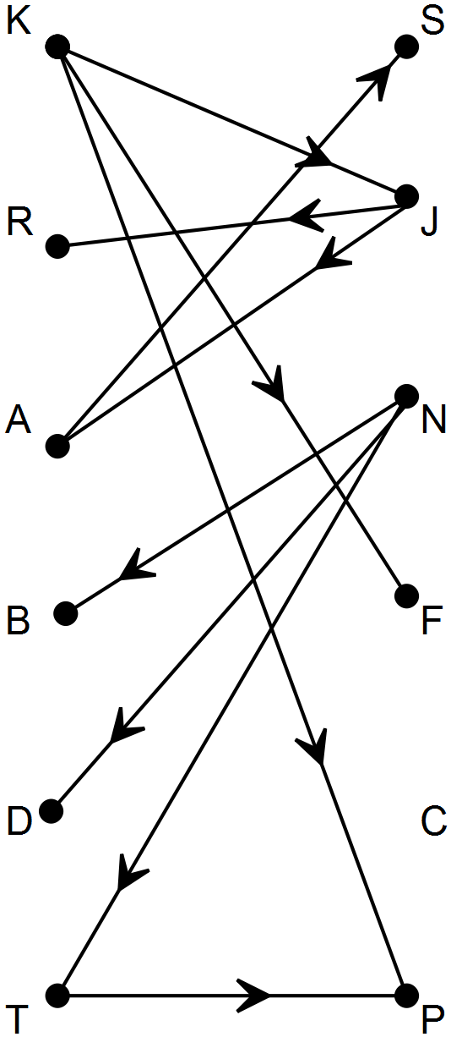

(a) The graph is bipartite. Explain.[2]

(b) Which player has not played any matches? [1]

(c) How many matches have been played?[1]

(d) Which players have

(i) won every match they have played? [1]

(ii) lost every match they have played? [2]

(e) Describe two of the features of the adjacency matrix for this network. [2]

**Question 5 (11 marks)**

Team E has five players: Lily (L), Nora (N), Tricia (T), Alison (A) and Deirdre (D).

They need to determine a playing order so they play each other.

The results of these matches are given in the table below.

|  |  |  |  |  |  |
| --- | --- | --- | --- | --- | --- |
|  | **L** | **N** | **T** | **A** | **D** |
| **L** beats | - | ✓ | ✓ | X | ✓ |
| **N** beats | X | - | ✓ | ✓ | ✓ |
| **T** beats | X | X | - | ✓ | ✓ |
| **A** beats | ✓ | X | X | - | ✓ |
| **D** beats | X | X | X | X | - |

(a) Who wins the most matches? [1]

(b) Who loses the most matches? [1]

(c) Use a digraph to represent this information. [2]

(d) Is the digraph drawn in part (c) bipartite? Justify your conclusion. [2]

(e) Determine the adjacency matrix for the digraph. [2]

(f) Explain the nature of the elements along the leading diagonal. [1]

(g) Describe and explain the symmetry of the adjacency matrix about the leading diagonal. [2]

**End of questions**

**Competition**

**In-class investigation**

**Solutions and marking key**

**Question 1(a)**

|  |  |
| --- | --- |
| Solution | |
| K S  R J  A N | |
| Mathematical behaviours | Marks |
| * Identifies edges which are undirected and travel between nodes * Makes the correct number of connections | 1  1 |

**Question 1(b)**

|  |  |
| --- | --- |
| Solution | |
| Each element equal to 1 represents an edge drawn from the vertex on the left (row headings) to the vertex on the right (column headings) | |
| Mathematical behaviours | Marks |
| * describes the element equalling 1 as representing an edge * describes source and destination of edges | 1  1 |

**Question 1(c)(i)**

|  |  |
| --- | --- |
| Solution | |
|  | |
| Mathematical behaviours | Marks |
| * draws bipartite graph with labelled nodes * completes all connections between nodes | 1  1 |

**Question 1(c)(ii)**

|  |  |
| --- | --- |
| Solution | |
| Matrix could also be labelled in reverse. | |
| Mathematical behaviours | Marks |
| * labels rows and columns * determines correct entries for matrix | 1  1 |

**Question 1(d)**

|  |  |
| --- | --- |
| Solution | |
| Square matrix with dimensions = *n*  All entries = 1 | |
| Mathematical behaviours | Marks |
| * identifies dimensions of matrix * determines elements of matrix | 1  1 |

**Question 2(a)**

|  |  |
| --- | --- |
| Solution | |
| Lou, Ali and Barb | |
| Mathematical behaviours | Marks |
| * reads table | 1 |

**Question 2(b)**

|  |  |
| --- | --- |
| Solution | |
| 15 | |
| Mathematical behaviours | Marks |
| * interprets table | 1 |

**Question 2(c)**

|  |  |
| --- | --- |
| Solution | |
|  | |
| Mathematical behaviours | Marks |
| * draws bipartite graph with labelled nodes * completes all connections between nodes | 1  1 |

**Question 2(d)**

|  |  |
| --- | --- |
| Solution | |
|  | |
| Mathematical behaviours | Marks |
| * completes connections to represent matches unplayed * excludes all connections for played matches | 1  1 |

**Question 2(e)**

|  |  |
| --- | --- |
| Solution | |
| (i) (ii) | |
| Mathematical behaviours | Marks |
| * labels rows and columns of both matrices * represents connections for played matches * represents connections for unplayed matches * matrices match bipartite graphs | 1  1  1  1 |

**Question 2(f)**

|  |  |
| --- | --- |
| Solution | |
| It is a 5 x 5 matrix in which all the elements = 1 | |
| Mathematical behaviours | Marks |
| * identifies matrix dimensions * identifies all elements | 1  1 |

**Question 3(a)**

|  |  |
| --- | --- |
| Solution | |
| 4 | |
| Mathematical behaviours | Marks |
| * interprets adjacency matrix | 1 |

**Question 3(b)**

|  |  |
| --- | --- |
| Solution | |
| 19 | |
| Mathematical behaviours | Marks |
| * interprets adjacency matrix | 1 |

**Question 3(c)**

|  |  |
| --- | --- |
| Solution | |
| Add up all the elements | |
| Mathematical behaviours | Marks |
| * identifies features of adjacency matrix | 1 |

**Question 3(d)**

|  |  |
| --- | --- |
| Solution | |
| Rod, Barry and Terry | |
| Mathematical behaviours | Marks |
| * interprets adjacency matrix | 1 |

**Question 3(e)**

|  |  |
| --- | --- |
| Solution | |
| Stefan  All entries are 1 in the complementary matrix. These would be 0 in the matrix for matches played | |
| Mathematical behaviours | Marks |
| * identifies non-player * identifies all entries of 1 * identifies entries of 1 for non-played equal to 0 for matches played | 1  1  1 |

**Question 3(f)**

|  |  |
| --- | --- |
| Solution | |
| Stefan | |
| Mathematical behaviours | Marks |
| * identifies disconnected node from adjacency matrix | 1 |

**Question 4(a)**

|  |  |
| --- | --- |
| Solution | |
| The nodes fall into two groups where there are no connections between nodes within the two groups, only from one group to another. The groups are KRABDT and SJNFCP | |
| Mathematical behaviours | Marks |
| * identifies nodes exist in two groups * explains connections between and within groups | 1  1 |

**Question 4(b)**

|  |  |
| --- | --- |
| Solution | |
| C | |
| Mathematical behaviours | Marks |
| * interprets bipartite graph | 1 |

**Question 4(c)**

|  |  |
| --- | --- |
| Solution | |
| 10 | |
| Mathematical behaviours | Marks |
| * identifies features of bipartite graph | 1 |

**Question 4(d)**

|  |  |
| --- | --- |
| Solution | |
| (i) Kyle, Nigel  (ii) Rod, Barry, Dong, Fraser, Stefan, Peter | |
| Mathematical behaviours | Marks |
| * interprets bipartite graph of winners * identifies 4 losers * identifies further 2 losers | 1  1  1 |

**Question 4(e)**

|  |  |
| --- | --- |
| Solution | |
| The matrix would be 12 x 12  0 represents a loss as well as a match not played  1 in row *i* column *j* means the person in row *i* beat the person in row *j* | |
| Mathematical behaviours | Marks |
| * identifies any two features of the adjacency matrix | 1 |

**Question 5(a)**

|  |  |
| --- | --- |
| Solution | |
| Lily and Nora | |
| Mathematical behaviours | Marks |
| * interprets data in table | 1 |

**Question 5(b)**

|  |  |
| --- | --- |
| Solution | |
| Deidre | |
| Mathematical behaviours | Marks |
| * interprets data in table | 1 |

**Question 5(c)**

|  |  |
| --- | --- |
| Solution | |
|  | |
| Mathematical behaviours | Marks |
| * determines correct number of nodes and connections * determines correct directions | 1  1 |

**Question 5(d)**

|  |  |
| --- | --- |
| Solution | |
| The graph is not bipartite  The nodes do not fall into two separate groups | |
| Mathematical behaviours | Marks |
| * concludes correctly * explains conclusion | 1  1 |

**Question 5(e)**

|  |  |
| --- | --- |
| Solution | |
|  | |
| Mathematical behaviours | Marks |
| * identifies 5 x 5 matrix with labelled rows and columns * enters all elements | 1  1 |

**Question 5(f)**

|  |  |
| --- | --- |
| Solution | |
| All elements are 0 because the players do not play against themselves | |
| Mathematical behaviours | Marks |
| * relates features of matrix to context | 1 |

**Question 5(g)**

|  |  |
| --- | --- |
| Solution | |
| The matrix is symmetrical about the leading diagonal in that where there is a 0 in row *i* column *j* there is a 1 in column *i* row *j* [not in leading diagonal]  If player 1 beats player 2 (1 in matrix) then the symmetrical position for player 2 beating player 1 is a zero | |
| Mathematical behaviours | Marks |
| * describes the symmetry of the adjacency matrix * explains the symmetry of the adjacency matrix | 1  1 |

**TASK 9**

**Investigative questions**

**Unit 3**

**Topic 3.3: Graphs and networks**

**Course-related information**

The concepts and skills covered in these investigative questions relate to the following dot points within the WA Mathematics Applications syllabus:

3.3.1 demonstrate the meanings of, and use, the terms: graph, edge, vertex, loop, degree of a vertex, subgraph, simple graph, complete graph, bipartite graph, directed graph (digraph), arc, weighted graph, and network

3.3.2 identify practical situations that can be represented by a network, and construct such networks

3.3.3 construct an adjacency matrix from a given graph or digraph and use the matrix to solve associated problems

3.3.4 demonstrate the meanings of, and use, the terms: planar graph and face

3.3.5 apply Euler’s formula, to solve problems relating to planar graphs.



The ability to choose and use appropriate technology to enhance and extend concept development is also required for some of the items

**Background information**

It is assumed that students have practised the skills and studied the concepts described by the dot points listed above. The students should be able to use calculator technology to manipulate matrices.

**Task conditions**

These items should be undertaken under test conditions, either as part of a test/examination or as stand-alone items. Student access to a graphical/CAS calculator is assumed. The time required to complete each question is left to the discretion of the teacher but the intention is that each question may be completed within 15 minutes.

**Investigative questions for Topic 3.3**

**Question 1 (11 marks)**

A graph is said to be complete if it is a simple graph with an edge from each vertex to every other vertex.

(a) Draw complete graphs for each of the following Using only the vertices that have been drawn. [2]

|  |  |  |  |
| --- | --- | --- | --- |
|  |  | |  |
|  | |  | |

(b) Complete the table below for the complete graphs drawn above [4]

|  |  |  |
| --- | --- | --- |
| **Number of vertices** | **Degree of each vertex** | **Total number of edges** |
|  |  |  |
|  |  |  |
|  |  |  |
|  |  |  |
|  |  |  |

(c) Describe the relationship between the number of vertices and the degree of each vertex in a complete graph. [1]

(d) The total number of edges, *e,* in a complete graph with *n* vertices is given by:

 . Show that this is true for *n* = 4. [1]

(e) In a survey of tourists visiting the Gold Coast one respondent recommended that there should be more railway lines connecting tourist destinations. They wanted to be able to travel from any one of the locations on their list of favourites to any other location on their list. [A railway line is a track connecting one town to another]

They listed the following places needing to be connected by railway lines.

Pemberton Onslow Kakadu Cooktown Tenterfield

Bega Ballarat Launceston Yass Geelong

(i) How many more railway lines from Onslow does this respondent recommend? [1]

(ii) How many more railway lines in total is this respondent recommending? Justify your answer.

[2]

**Question 2 (11 marks)**

Kim drives regularly between the shops (S), the cricket club (C), the pool (P), the beach (B) and her home (H). She has particular roads she likes to use and directions she likes to take. These are shown on the graph below.

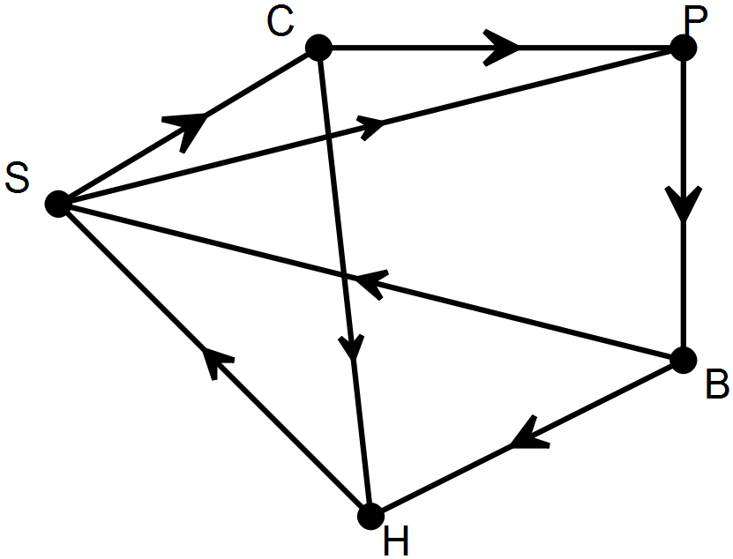

(a) Complete the adjacency matrix, R, for this digraph. [2]



(b) Describe what each element ( ***ri j* )** of R2 represents. [2]

(c) What does the sum of the numbers in the third column of R + R2 + R3 represent?

[3]

(d) Dave’s travels are shown in the diagram provided and D is the adjacency matrix for Dave’s travels.

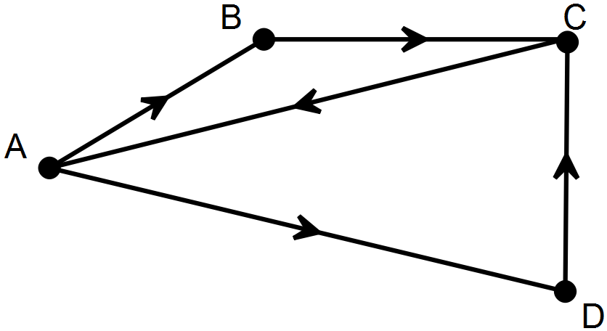

D5 is given below.



Describe in detail what the circled element represents. [4]

**Question 3 (10 marks)**

Mojo put forward the following conjecture:

*Every prism or pyramid can be represented as a planar graph.*

(a) Show that Euler’s rule applies to each of the 3-D shapes drawn below. [4]

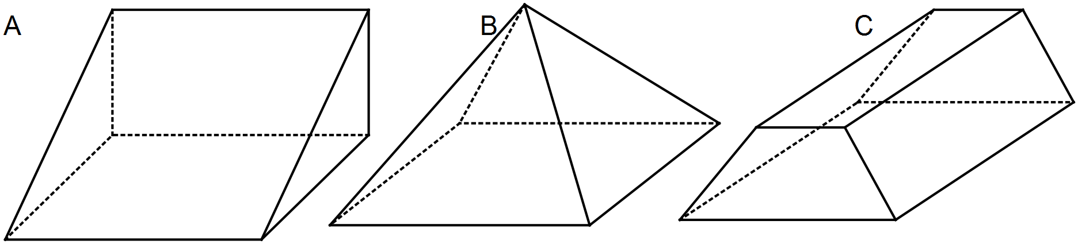

(b) Draw any one of these 3-D shapes as a planar graph. [2]

(c) Draw two different types of prisms or pyramids for the following planar graph. [2]

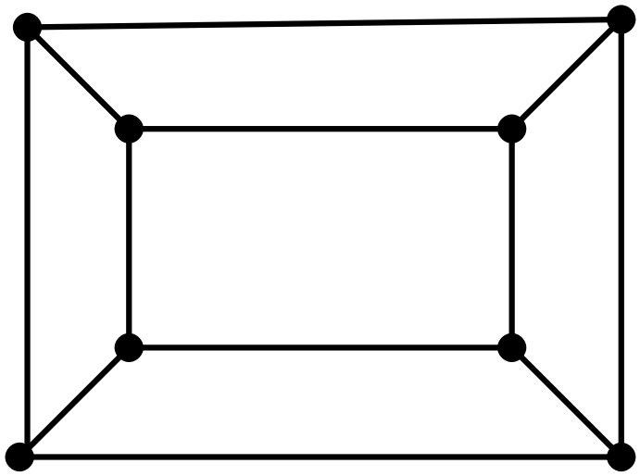

(d) What can you conclude about Mojo’s conjecture? Justify your conclusion. [2]

**Investigative questions in Topic 3.3**

**Solutions and marking key**

**Question 1(a)**

|  |  |
| --- | --- |
| Solution | |
| |  |  |  |  | | --- | --- | --- | --- | |  |  | |  | |  | |  | | | |
| Mathematical behaviours | Marks |
| * draws edges for 4 sets of vertices * draws edges for fifth set of edges | 1  1 |

**Question 1(b)**

|  |
| --- |
| Solution |
| |  |  |  | | --- | --- | --- | | **Number of vertices** | **Degree of each vertex** | **Total number of edges** | | 2 | 1 | 1 | | 3 | 2 | 3 | | 4 | 3 | 6 | | 5 | 4 | 10 | | 6 | 5 | 15 | |

**Question 1(b) (cont’d)**

|  |  |
| --- | --- |
| Mathematical behaviours | Marks |
| * enters number of vertices * enters degree of each vertex * calculates number of edges for 3 shapes * calculates number of edges for 4th and 5th shapes | 1  1  1  1 |

**Question 1(c)**

|  |  |
| --- | --- |
| Solution | |
| degree of each vertex = number of vertices - 1 | |
| Mathematical behaviours | Marks |
| * identifies relationship between variables | 1 |

**Question 1(d)**

|  |  |
| --- | --- |
| Solution | |
| As per table | |
| Mathematical behaviours | Marks |
| * substitutes into rule provided | 1 |

**Question 1(e)**

|  |  |
| --- | --- |
| Solution | |
| (i) 9  (ii) 10 x 9 ÷ 2 = 45 | |
| Mathematical behaviours | Marks |
| * identifies the number of edges from each vertex * uses the rule (or otherwise) determines the number of edges * draws a diagram showing the connections OR explains that these connections form a complete graph so the rule provided can be used. | 1  1  1 |

**Question 2(a)**

|  |  |
| --- | --- |
| Solution | |
|  | |
| Mathematical behaviours | Marks |
| * complete 4 rows or columns * completes fifth row or column | 1  1 |

**Question 2(b)**

|  |  |
| --- | --- |
| Solution | |
| Each element represents the number of ways of getting from one place to another using two consecutive connections between places. | |
| Mathematical behaviours | Marks |
| * identifies number of ways between locations * identifies each way consists of two connections | 1  1 |

**Question 2(c)**

|  |  |
| --- | --- |
| Solution | |
| The total number of ways consisting of 1 connection, 2 connections or 3 connections of getting from any of the 5 starting locations to the pool. | |
| Mathematical behaviours | Marks |
| * identifies total number of 3 different types of connections * identifies 5 starting vertices * identifies destination vertex | 1  1  1 |

**Question 2(d)**

|  |  |
| --- | --- |
| Solution | |
| The number of 5-stage paths from B to A is 2  The paths are BCADCA and BCABCA | |
| Mathematical behaviours | Marks |
| * identifies number and type of paths * identify start and finish of path * describes vertices along path 1 * describes vertices along path 2 | 1  1  1  1 |

.

**Question 3(a)**

|  |  |
| --- | --- |
| Solution | |
| |  |  |  |  |  | | --- | --- | --- | --- | --- | | Fig. | No. faces (*f*) | No. edges  (*e*) | No. vertices  (*v*) | *v* + *f* – *e* | | A | 5 | 9 | 6 | 2 ✓ | | B | 5 | 8 | 5 | 2 ✓ | | C | 6 | 12 | 8 | 2 ✓ | | |
| Mathematical behaviours | Marks |
| * identifies number of faces * identifies number vertices * identifies number of edges * checks rule | 1  1  1  1 |

**Question 3(b)**

|  |  |
| --- | --- |
| Solution | |
| A | |
| Mathematical behaviours | Marks |
| * graph is planar for the identified figure * graph has correct number of faces, vertices and edges | 1  1 |

**Question 3(c)**

|  |  |
| --- | --- |
| Solution | |
|  | |
| Mathematical behaviours | Marks |
| * draws first prism * draws second prism | 1  1 |

**Question 3(d)**

|  |  |
| --- | --- |
| Solution | |
| The conjecture appears to be true but has not been proven.  A counter example has not been found. An insufficient number of examples has been tested. | |
| Mathematical behaviours | Marks |
| * concludes correctly * justifies conclusion | 1  1 |

**TASK 10: SEASONAL CHANGE**

**Extended investigation**

**Unit 4**

**Topic 4.1: Time series analysis**

**Course-related information**

The concepts and skills covered in this investigation relate to the following dot points within the WA Mathematics Applications syllabus:

4.1.1 construct time series plots

4.1.2 describe time series plots by identifying features such as trend (long term direction), seasonality (systematic, calendar-related movements), and irregular fluctuations (unsystematic, short term fluctuations), and recognise when there are outliers

4.1.4 calculate seasonal indices by using the average percentage method

4.1.6 fit a least-squares line to model long-term trends in time series data

4.1.7 predict from regression lines, making seasonal adjustments for periodic data

4.1.8 implement the statistical investigation process to answer questions that involve the analysis of time series data

The ability to chose and use appropriate technology to enhance and extend concept development is also required for some of the items.

**Background information**

Student will have completed Unit 3.1 and should be familiar with the use of spreadsheets and the statistical investigation cycle. This task provides an opportunity for students to conduct an open investigation following the steps outlined in the statistical investigation process. Solutions are not provided for the preparation activities.

**Task conditions**

Students should bring the results of their investigation from the preparation activity to the in-class component of this investigation. The data from the Australian Bureau of Statistics (final page) should be provided during the in-class validation as a separate sheet. Solutions to the preparation activities are not provided as they will vary according to the information selected for study.

**Seasonal change**

**Extended investigation Part 1:** **Preparation activity**

For this task you are directed to collectquarterly data for at least the years 2012 to 2015 to answer the following questions.

1. What seasonal variation do the data show?

2. What is the long term trend of the seasonal data?

Some suggestions for data that would be suitable to investigate are listed. You may wish to suggest other data to collect. Check that your suggestion is suitable for the questions posed.

A. Cars sold in Adelaide

B. Water consumption in Perth

C. Hospital emergency admissions in Melbourne

D. Total of unemployed persons in Hobart

E. Number of boating accidents in Australia

F. Number of burglaries in Sydney

G. Babies born in Brisbane

To guide your investigation consider the following:

**Data collection**

Is it clear exactly what data is needed?

What data will you collect? How would you classify the data?

From where will you collect the data?

Where will you store your data?

**Data analysis and display**

The following graphs, displays and calculations should be used in your investigation where appropriate:

scatterplots trend lines

moving averages seasonal indices (average % method)

predictions tables

deseasonalised data correlation coefficients

least squares regression line coefficient of determination

measures of central tendency measures of dispersion

Familiarity with spreadsheets and with the statistical investigation process is assumed for Part 2 of this extended investigation.

**Data interpretation and communication**

Consider the two questions posed in the introduction.

Further to this:

* How can you seasonally adjust your data?
* Why would you seasonally adjust your data?
* How can you use the statistics you have generated to make predictions of future values?

**Seasonal change**

**Extended investigation Part 2:** **In-class validation (50 marks)**

**Question 1 (3 marks)**

You have been asked to investigate the following question:

*What seasonal variation occurs in the number of children travelling interstate for sporting matches?*

Two questions that you would need to ask are

1. Are the children travelling to play sport, watch sport or both?

2. Is travel by boat and bus included?

Pose three other questions to be answered so that the nature of the data to be collected is clarified.

**Question 2 (4 marks)**

You are conducting an investigation on the number of overseas visitors who travel to Alice Springs and you have been asked to collect quarterly data for the period from January 2011 to December 2015.

(a) What is the length of each season? (1)

(b) Describe the data that you would collect. (1)

(c) What is the minimum number of data items that you should have? (1)

(d) Data would be available through the internet but unlikely to be found on the weather websites. Name one area of government that is a likely source of such data. (1)

The remaining questions in this investigation use the data gathered from the Australian Bureau of Statistics. The data are provided on a separate page.

The data relate to the period June 2011 to May 2015 and are the estimates for the

1. short-term visitor arrivals into Australia and

2. short-term resident departures from Australia

On the table of data

* Monthly estimates are provided
* The figures are in thousands (‘000)
* The first column for both arrivals and departures are the trend estimates for the month
* The second column for both arrivals and departures are the seasonally adjusted (Seas. Adj.) estimates for the month
* The third column for both arrivals and departures are the original estimates, for example in June 2011, there were 390,100 short-term visitor arrivals.

**Question 3 (3 marks)**

(a) The estimate for the number of short term visitors for June 2011 was 390,100. Give a reason to justify the claim that these figures are estimates rather than the actual number of visitors. (1)

(b) What aspect of the data collection enables you to be confident that these estimates are reliable estimates? (1)

(c) Describe one possible method by which some of these data would have been collected. (1)

**Question 4 (7 marks)**

Some of the data have been copied to the table below. The estimates have been rounded to the nearest ten thousand.

Draw a scatter plot of the data shown in this table.

|  |  |  |  |
| --- | --- | --- | --- |
| **Time** | **Mon** | **Year** | **Arrivals Original Estimate (‘000)** |
| 1 | Jun | 2011 | 390 |
| 2 | Jul | 2011 | 510 |
| 3 | Aug | 2011 | 470 |
| 4 | Sep | 2011 | 430 |
| 5 | Oct | 2011 | 500 |
| 6 | Nov | 2011 | 520 |
| 7 | Dec | 2011 | 670 |
| 8 | Jan | 2012 | 500 |
| 9 | Feb | 2012 | 550 |
| 10 | Mar | 2012 | 540 |
| 11 | Apr | 2012 | 470 |
| 12 | May | 2012 | 390 |
| 13 | Jun | 2012 | 420 |
| 14 | Jul | 2012 | 500 |
| 15 | Aug | 2012 | 500 |

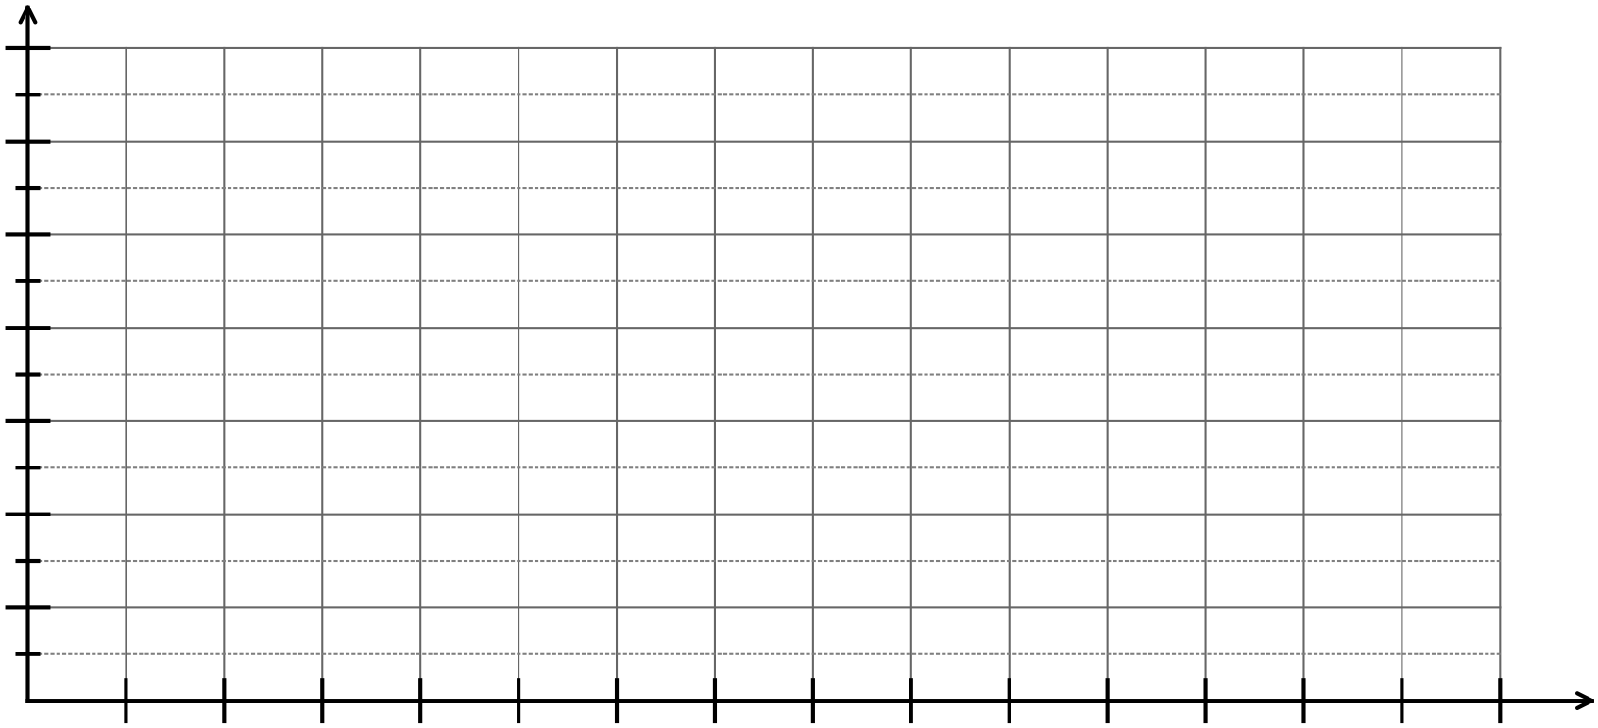

**Question 5 (7 marks)**

Part of the graph of the original estimates of the short-term departures from Australia from June 2011 to May 2015 is reproduced below.

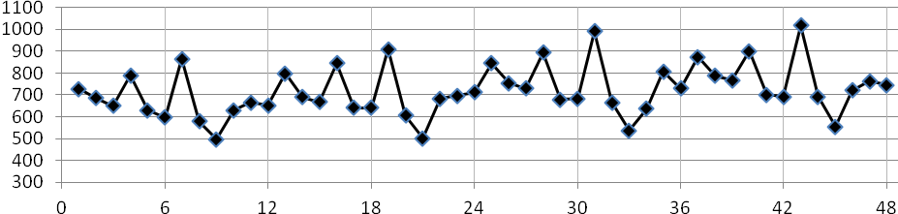

(a) Name three items missing from the graph (3)

(b) Select and describe two pieces of evidence on this graph that suggests the data are seasonal and in your description, identify the length of each season. (3)

(c) What evidence on this graph suggests that there is an overall positive trend in short-term departures. (1)

**Question 6 (6 marks)**

(a) To investigate the claim that the number of short term departures (original estimates) is always higher in December than in June, use the sheet of data provided to create a table showing these estimates for these months for the period June 2011 to December 2013. (3)

|  |  |
| --- | --- |
|  |  |
|  |  |
|  |  |
|  |  |
|  |  |
|  |  |
|  |  |

(b) (3)

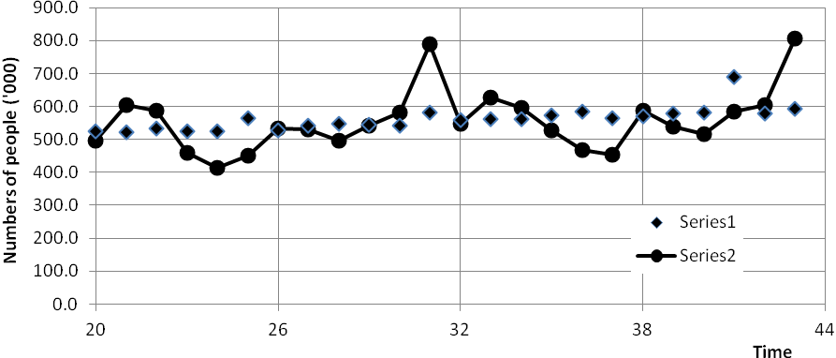

Use the table of data provided to:

(i) identify the time period for which the estimates are graphed. (1)

(ii) identify the data for Series 1. (1)

(iii) identify the data for Series 2. (1)

**Question 7 (6 marks)**

The data in the table provided below has been determined by combining the total seasonally-adjusted estimates of short term arrivals for periods of two months from January 2013 to December 2014. The data have been rounded to the nearest thousand.

|  |  |  |
| --- | --- | --- |
| **Time** | **Period** | **Arrivals (‘000)** |
| 1 | Jan-Feb 2013 | 1046 |
| 2 | Mar-Apr 2013 | 1057 |
| 3 | May-Jun 2013 | 1089 |
| 4 | Jul-Aug 2013 | 1069 |
| 5 | Sep-Oct 2013 | 1093 |
| 6 | Nov-Dec 2013 | 1123 |
| 7 | Jan-Feb 2014 | 1122 |
| 8 | Mar-Apr 2014 | 1134 |
| 9 | May-Jun 2014 | 1149 |
| 10 | Jul-Aug 2014 | 1149 |
| 11 | Sep-Oct 2014 | 1271 |
| 12 | Nov-Dec 2014 | 1170 |

(a) Use the data from the table to determine

(i) the least squares line that could be used to model the long term seasonally-adjusted figures for short-term arrivals. (3)

(ii) the coefficient of determination (1)

(b) Identify the next row of data for this table. (2)

**Question 8 (8 marks)**

The least squares line that can be used to model the long term seasonally-adjusted figures for short term departures is

Departures (thousands) = 3.0295 x month number + 643.3

where month number 1 is June 2011

The coefficient of determination for these data is 0.9108

(a) Describe the trend in the number of people leaving Australia for short periods of time. (1)

(b) Determine the correlation coefficient for the relationship between the month number and the estimated number of short term departures. (1)

(c) At what rate is the number of people leaving Australia for short term periods increasing? (2)

(d) In April 2014, the number of short term departures given as a trend estimate by the Bureau of Statistics was as predicted by the trend line was 789,700.

How different is this trend estimate to the one predicted by the trend line given above? Give your answer to the nearest thousand. (4)

**Question 9 (6 marks)**

For the original estimates of short term departures, the seasonal index for December is 127%.

(a) What does the seasonal index indicate about the original estimates of short term departures in December? (2)

(b) Using the data in the table of all data or the graph in question 5, determine the month for which the seasonal index will be below 100%. (1)

(c) Using references to the table of data, describe how this seasonal index would be calculated. (3)

**End of questions**

**Data for Task 10**

|  |  |  |  |  |  |  |  |  |  |
| --- | --- | --- | --- | --- | --- | --- | --- | --- | --- |
| **Time** | **Mon** | **Year** | **Arrivals (‘000)** | | |  | **Departures (‘000)** | | |
|  |  |  | **Trend** | **Seas. Adj.** | **Original** |  | **Trend** | **Seas. Adj.** | **Original** |
| 1 | Jun | 2011 | 475.6 | 473.7 | 390.1 |  | 656.7 | 640.7 | 727.1 |
| 2 | Jul | 2011 | 479.4 | 485.3 | 506.1 |  | 664.5 | 661.1 | 684.7 |
| 3 | Aug | 2011 | 491.0 | 500.4 | 468.6 |  | 664.9 | 661.5 | 648.9 |
| 4 | Sep | 2011 | 500.6 | 481.5 | 432.2 |  | 665.1 | 663.5 | 790.6 |
| 5 | Oct | 2011 | 503.6 | 505.4 | 498.1 |  | 656.2 | 654.5 | 629.0 |
| 6 | Nov | 2011 | 505.3 | 502.4 | 520.1 |  | 653.7 | 649.1 | 596.4 |
| 7 | Dec | 2011 | 505.0 | 502.0 | 673.6 |  | 651.2 | 652.7 | 864.2 |
| 8 | Jan | 2012 | 499.9 | 496.8 | 502.5 |  | 657.4 | 667.1 | 580.1 |
| 9 | Feb | 2012 | 498.9 | 501.2 | 554.4 |  | 657.3 | 655.8 | 496.6 |
| 10 | Mar | 2012 | 504.8 | 512.0 | 544.2 |  | 667.1 | 676.8 | 630.1 |
| 11 | Apr | 2012 | 508.3 | 509.2 | 466.6 |  | 673.6 | 675.0 | 664.7 |
| 12 | May | 2012 | 503.6 | 497.7 | 393.5 |  | 680.9 | 684.0 | 652.0 |
| 13 | Jun | 2012 | 508.9 | 515.1 | 420.8 |  | 688.3 | 691.3 | 799.2 |
| 14 | Jul | 2012 | 501.8 | 495.4 | 500.7 |  | 690.1 | 687.7 | 689.6 |
| 15 | Aug | 2012 | 506.3 | 514.1 | 497.5 |  | 689.2 | 683.3 | 667.1 |
| 16 | Sep | 2012 | 513.5 | 520.4 | 473.6 |  | 691.3 | 695.4 | 844.2 |
| 17 | Oct | 2012 | 520.1 | 522.2 | 513.4 |  | 685.0 | 679.6 | 642.2 |
| 18 | Nov | 2012 | 527.1 | 528.4 | 556.2 |  | 689.1 | 696.8 | 641.5 |
| 19 | Dec | 2012 | 534.0 | 537.6 | 720.9 |  | 692.1 | 695.5 | 908.6 |
| 20 | Jan | 2013 | 532.0 | 525.5 | 495.0 |  | 691.8 | 689.3 | 604.7 |
| 21 | Feb | 2013 | 526.2 | 520.6 | 604.6 |  | 689.8 | 686.7 | 501.0 |
| 22 | Mar | 2013 | 529.1 | 533.6 | 588.5 |  | 696.7 | 707.1 | 682.9 |
| 23 | Apr | 2013 | 525.9 | 523.7 | 459.9 |  | 708.4 | 715.0 | 696.8 |
| 24 | May | 2013 | 524.0 | 524.4 | 412.9 |  | 720.2 | 728.8 | 711.1 |
| 25 | Jun | 2013 | 526.3 | 564.1 | 450.1 |  | 730.6 | 734.1 | 844.6 |
| 26 | Jul | 2013 | 527.9 | 527.5 | 533.4 |  | 737.1 | 736.9 | 754.4 |
| 27 | Aug | 2013 | 534.8 | 541.4 | 530.9 |  | 739.5 | 736.0 | 730.4 |
| 28 | Sep | 2013 | 542.4 | 547.8 | 495.1 |  | 741.7 | 743.5 | 893.5 |
| 29 | Oct | 2013 | 548.4 | 545.5 | 541.7 |  | 739.3 | 733.9 | 679.9 |
| 30 | Nov | 2013 | 548.1 | 542.1 | 581.1 |  | 735.1 | 732.4 | 683.7 |
| 31 | Dec | 2013 | 564.9 | 580.9 | 789.4 |  | 747.9 | 764.8 | 991.4 |
| 32 | Jan | 2014 | 558.7 | 559.6 | 548.1 |  | 752.9 | 751.8 | 665.4 |
| 33 | Feb | 2014 | 562.6 | 562.3 | 627.1 |  | 749.7 | 740.6 | 535.9 |
| 34 | Mar | 2014 | 564.2 | 561.2 | 595.9 |  | 730.4 | 709.6 | 636.2 |
| 35 | Apr | 2014 | 569.3 | 573.2 | 526.4 |  | 754.4 | 789.7 | 807.5 |
| 36 | May | 2014 | 577.5 | 583.6 | 468.2 |  | 755.2 | 754.6 | 730.7 |
| 37 | Jun | 2014 | 574.1 | 565.0 | 452.4 |  | 759.6 | 769.7 | 874.3 |
| 38 | Jul | 2014 | 573.1 | 569.3 | 586.9 |  | 764.8 | 763.8 | 787.4 |
| 39 | Aug | 2014 | 577.4 | 579.3 | 538.8 |  | 768.5 | 767.0 | 766.8 |
| 40 | Sep | 2014 | 578.7 | 580.4 | 517.5 |  | 763.6 | 759.0 | 900.2 |
| 41 | Oct | 2014 | 584.1 | 690.9 | 583.8 |  | 755.3 | 756.5 | 700.0 |
| 42 | Nov | 2014 | 581.9 | 577.5 | 603.7 |  | 755.5 | 752.2 | 692.0 |
| 43 | Dec | 2014 | 588.5 | 592.6 | 807.1 |  | 761.8 | 773.1 | 1017.6 |
| 44 | Jan | 2015 | 584.8 | 578.9 | 546.2 |  | 768.7 | 774.5 | 692.2 |
| 45 | Feb | 2015 | 592.6 | 602.8 | 722.2 |  | 775.0 | 776.7 | 554.5 |
| 46 | Mar | 2015 | 606.0 | 618.6 | 674.5 |  | 788.1 | 795.9 | 720.7 |
| 47 | Apr | 2015 | 611.9 | 610.3 | 551.4 |  | 784.2 | 776.5 | 762.0 |
| 48 | May | 2015 | 613.6 | 606.8 | 483.0 |  | 776.6 | 766.1 | 744.2 |

**Seasonal change**

**Extended investigation Part 2:** **In-class validation**

**Solutions and marking key**

**Question 1**

|  |  |
| --- | --- |
| Solution | |
| Possible questions include  Can the children be any age from 0 to but not including 18?  Do the seasons refer to the weather seasons?  Does sport include chess competitions? | |
| Mathematical behaviours | Marks |
| * poses three appropriate question to clarify the data | 3 |

**Question 2(a)**

|  |  |
| --- | --- |
| Solution | |
| Three months OR a quarter of a year | |
| Mathematical behaviours | Marks |
| * identifies length of season | 1 |

**Question 2(b)**

|  |  |
| --- | --- |
| Solution | |
| Numeric, discrete | |
| Mathematical behaviours | Marks |
| * identifies type of data | 1 |

**Question 2(c)**

|  |  |
| --- | --- |
| Solution | |
| 20 | |
| Mathematical behaviours | Marks |
| * identifies number of data items | 1 |

**Question 2(d)**

|  |  |
| --- | --- |
| Solution | |
| Tourism  Bureau of Statistics | |
| Mathematical behaviours | Marks |
| * identifies possible source of data | 1 |

**Question 3(a)**

|  |  |
| --- | --- |
| Solution | |
| They are all expressed to the nearest thousand  It would be difficult to get exact numbers | |
| Mathematical behaviours | Marks |
| * justifies why numbers are estimates | 1 |

**Question 3(b)**

|  |  |
| --- | --- |
| Solution | |
| They are from the Australian Bureau of statistics  They are from a reliable source | |
| Mathematical behaviours | Marks |
| * justifies reliability of estimates | 1 |

**Question 3(c)**

|  |  |
| --- | --- |
| Solution | |
| From international airline companies – collecting number of passengers | |
| Mathematical behaviours | Marks |
| * provides one method for data collection | 1 |

**Question 4**

|  |  |
| --- | --- |
| Solution | |
|  | |
| Mathematical behaviours | Marks |
| * labels horizontal axis * labels and scales vertical axis * identifies estimates in thousands * plots 5 data points accurately * plots 5 data points accurately * plots 5 data points accurately | 1  2  1  1  1  1 |

**Question 5(a)**

|  |  |
| --- | --- |
| Solution | |
| Three of the following  Label for the horizontal axis  Label for the vertical axis  Units for the vertical axis  Title of the graph  Map of numbers to time on horizontal axis | |
| Mathematical behaviours | Marks |
| * identifies first item missing * identifies first item missing * identifies first item missing | 1  1  1 |

**Question 5(b)**

|  |  |
| --- | --- |
| Solution | |
| In months 7, 19, 31 and 43 there are peaks – these are occurring every 12 months  The lowest data points occur in months 9, 21, 33 and 45 – every 12 months  Every 12 months there are 3 peaks in the data  There is a pattern which repeats every 12 months | |
| Mathematical behaviours | Marks |
| * identifies length of the season * describes graphic evidence of a pattern * describes a second piece of graphic evidence of a pattern | 1  1  1 |

**Question 5(c)**

|  |  |
| --- | --- |
| Solution | |
| The numbers forming the peaks and troughs every 12 months are increasing | |
| Mathematical behaviours | Marks |
| * identifies graphic evidence of a positive trend | 1 |

**Question 6(a)**

|  |  |
| --- | --- |
| Solution | |
| |  |  | | --- | --- | | Time | Original Estimates for short term arrivals | | June 2011 | 727.1 | | Dec 2011 | 864.2 | | June 2012 | 799.2 | | Dec 2012 | 908.6 | | June 2013 | 844.6 | | Dec 2013 | 991.4 | | |
| Mathematical behaviours | Marks |
| * provides headings for the table * correctly copies correct time periods * correctly copies estimates | 1  1  1 |

**Question 6(b)**

|  |  |
| --- | --- |
| Solution | |
| (i) January 2013 to December 2014  (ii) Number of seasonally-adjusted short term arrivals  (iii) Original estimates for short term arrivals | |
| Mathematical behaviours | Marks |
| * identifies values for the horizontal axis * reads table to identify data for Series 1 * reads table to identify data for Series 2 | 1  1  1 |

**Question 7(a)**

|  |  |
| --- | --- |
| Solution | |
| (i)  Arrivals (thousands) = time x 14.8 + 1026.5  Time = 2-month period where Jan/Feb 2013 is 1  (ii)  0.7666 | |
| Mathematical behaviours | Marks |
| * determines slope and intercept of least squares line * expresses linear relationships as arrivals in thousands * describes “*x*” value in the rule * calculates coefficient of determination | 1  1  1  1 |

**Question 7(b)**

|  |  |
| --- | --- |
| Solution | |
| 13 Jan-Feb 2015 1182 | |
| Mathematical behaviours | Marks |
| * identifies time period * determines estimate | 1  1 |

**Question 8(a)**

|  |  |
| --- | --- |
| Solution | |
| Positive or increasing trend | |
| Mathematical behaviours | Marks |
| * identifies nature of trend | 1 |

**Question 8(b)**

|  |  |
| --- | --- |
| Solution | |
| 0.9544 | |
| Mathematical behaviours | Marks |
| * determines correlation coefficient | 1 |

**Question 8(c)**

|  |  |
| --- | --- |
| Solution | |
| About 3030 thousand per month | |
| Mathematical behaviours | Marks |
| * identifies rate | 1 |

**Question 8(d)**

|  |  |
| --- | --- |
| Solution | |
| Departures = 3.0295 x 35 + 643.3  = 749.3325  789,700 – 749,333 = 40,367  Estimate of 40,000 | |
| Mathematical behaviours | Marks |
| * substitutes 35 into equation * calculates number of departures * calculates difference * estimates difference to the nearest thousand | 1  1  1  1 |

**Question 9(a)**

|  |  |
| --- | --- |
| Solution | |
| On average the estimates are 27% above the yearly average | |
| Mathematical behaviours | Marks |
| * identifies 27% above average * identifies on average – above the yearly average | 1  1 |

**Question 9(b)**

|  |  |
| --- | --- |
| Solution | |
| February, January, November |  |
| Mathematical behaviours | Marks |
| * identifies months with low seasonal average | 1 |

**Question 9(c)**

|  |  |
| --- | --- |
| Solution | |
| Determine the monthly averages for each year  Determine the % that December is of the monthly average in each year  Average these percentage December averages |  |
| Mathematical behaviours | Marks |
| * identifies calculation of yearly average * describes the calculation of each December proportion * describes averaging of December proportions | 1  1  1 |

**TASK 11: DATA SMOOTHING**

**In-class investigation**

**Unit 4**

**Topic 4.1: Time series analysis**

**Course-related information**

The concepts and skills developed in this investigation relate to the following dot points within the WA Mathematics Applications syllabus:

4.1.1 construct time series plots

4.1.2 describe time series plots by identifying features such as trend (long term direction), seasonality (systematic, calendar-related movements), and irregular fluctuations (unsystematic, short term fluctuations), and recognise when there are outliers

4.1.3 smooth time series data by using a simple moving average, including the use of spreadsheets to implement this process

4.1.6 fit a least-squares line to model long-term trends in time series data

**Background information**

This task has been designed to introduce students to time series data. They are given the opportunity to study, consider and respond to questions which show changes in data over time. While it is not expected that the students have commenced this topic, they should have completed Topic 3.1. They should be able to draw and interpret scatter plots, calculate the correlation coefficient and determine the least squares line of regression.

**Task conditions**

This task consists of an in-class investigation for which students might need 40 – 55 minutes to complete. Students need to be familiar with tabulation and graphing using technology and it is expected that access to such technology will be available during the investigation.

**Data smoothing**

**In-class investigation (Total marks: 50)**

The two graphs below show details of the electricity accounts for one household at particular times from April 2012 to April 2015. The first graph shows the consumption (units used) and the second graph shows the costs incurred for the same household.

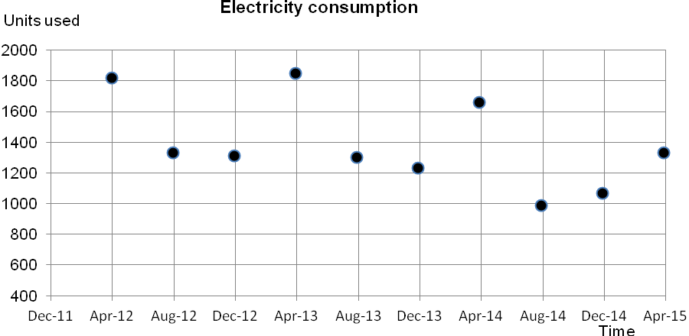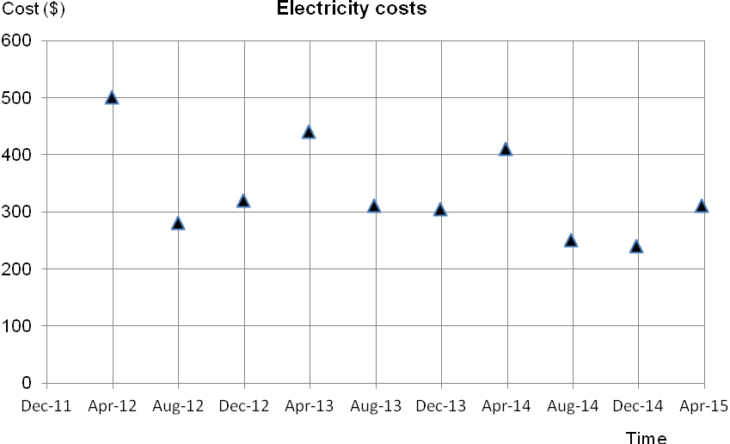

**Question 1 (15 marks)**

(a) Circle the data point representing the maximum cost for electricity during this period. (1)

(b) When did the household incur the maximum cost for electricity? (1)

**Question 1 (cont’d)**

(c) Draw triangles around the data points representing the minimum cost and the minimum consumption. (2)

(d) Give a reason to explain why the minimum cost has not occurred when the consumption was at a minimum. (1)

(e) How many times each year is the cost reported? (1)

(f) The costs rise and fall.

(i) At what time of year do the costs tend to be the highest? (1)

(ii) Give a reason to explain why costs might be the highest at that particular time of the year. (1)

(g) Describe the changes in electricity consumption from April 2012 until April 2015.

(3)

**Question 1 (cont’d) (12 marks) (6 mar**

(h) There were two occasions when the couple living in that household went away for at least a month and the house was unoccupied. Identify one of these occasions and justify your answer. (2)

(i) Describe two pieces of evidence from these graphs that suggest the costs of the electricity depend on the consumption. (2)

**Question 2 (14 marks)**

When data rises and falls as in the case of the electricity costs it may be difficult to determine an overall trend. To see this trend “moving averages” are calculated. For the electricity costs, the moving averages are calculated as follows:

* The mean of the first three data points (points 1 to 4) is calculated.

(500 + 280 + 320) ÷ 3 = $367 (rounded)

* The mean of data points 2 to 5 is calculated.

(280 + 320 + 440) ÷ 3 = $347 (rounded)

* And the process is continued in this manner

The table shows some of the moving average calculations.

|  |  |  |  |  |
| --- | --- | --- | --- | --- |
| **Time** | **Cost** | **Data point** | **Moving average calculations** | **Moving average** |
| Apr-12 | 500 | 1 |  |  |
| Aug-12 | 280 | 2 | (500 + 280 + 320) ÷ 3 | $367 |
| Dec-12 | 320 | 3 | (280 + 320 + 440) ÷ 3 | C |
| Apr-13 | 440 | 4 | (320 + 440 + 310) ÷ 3 | $357 |
| Aug-13 | 310 | 5 | A | $352 |
| Dec-13 | 305 | 6 | B | D |
| Apr-14 | 410 | 7 |  | $322 |
| Aug-14 | 250 | 8 |  | $300 |
| Dec-14 | 240 | 9 |  | $267 |
| Apr-15 | 310 | 10 |  |  |

(a) Determine the entries A, B, C and D for the table. (4)

(b) To show the trend graphically, the moving averages can be plotted on the same axes as the original data. The first data point is (Aug-12, 367) and the second is (Dec-12, 347).

Plot all the data points for the moving averages on the graph provided below. (4)



(c) Join the data points for

(i) reported electricity costs

(ii) and in a different colour or pattern, the moving averages (2)

(d) Draw a trend line “by eye” for the moving average data. (1)

(e) Describe the trend shown in the graph of the moving averages. (2)

(f) State one way in which the graph for the moving averages is different to the graph for the reported electricity costs. (1)

**Question 3 (9 marks)**

The trend line for the moving averages of the electricity costs, as described in the previous question, is given by

Moving average ($) = 388 – 12.5 x time

with time = 1 for Apr-12, 2 for Aug-12, 3 for Dec 12, etc..

The correlation coefficient = -0.91

(a) Predict the moving average for April 2015. (3)

(b) How reliable is your prediction of the moving average for April 2015?

Justify your decision about the reliability of your prediction. (3)

(c) Use the moving average from part (a) to predict the cost of electricity for August 2015. Give mathematical justification for your prediction. (3)

**Question 4 (12 marks)**

The electricity consumption is shown on the graphs below. The first graph shows the recorded data and for the second graph the averages of the data points are plotted.

[These averages were calculated as in the previous question with the mean determined for each three data points]

**A. Recorded data**

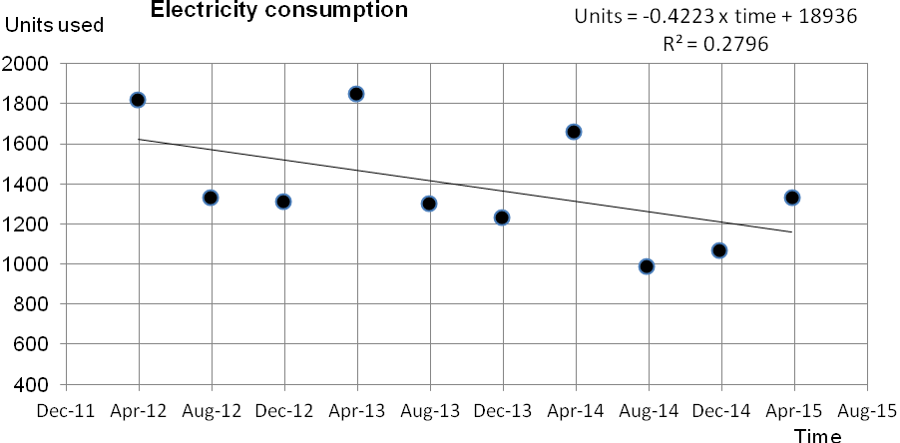

**B. Moving averages**

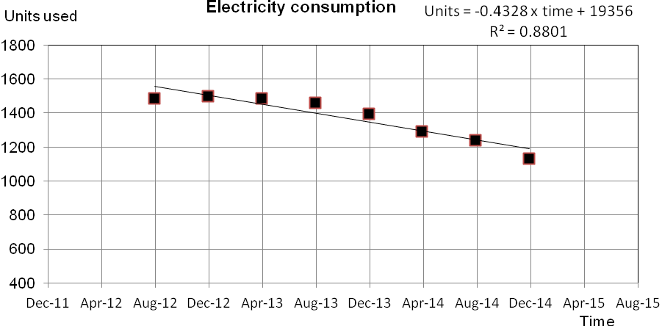

(a) Identify the response variable. Explain your decision. (2)

(b) The trend in consumption for both sets of data is negative.

(i) Describe one item of evidence to justify this conclusion. (1)

(ii) Describe the long-term outcome for this trend. Justify your decision. (2)

(c) Use the graphs of the trend lines to determine an estimate for

(i) recorded data for August 2015. (1)

(ii) a moving average for August 2015. (2)

(d) Comment on the reliability of the estimates determined in part (c). (4)

Justify your comments with evidence provided in this question.

**End of questions**

**Data smoothing**

**In-class investigation**

**Solutions and marking key**

**Question 1**

|  |  |  |  |
| --- | --- | --- | --- |
|  | Solution | Mathematical behaviours | Marks |
| (a) | circle around 500 in the second graph | * selects correct data point | 1 |
| (b) | April 2012 | * interprets scatter graph | 1 |
| (c) | triangles around 1000 on the first graph and 240 on the second graph | * selects correct data points | 2 |
| (d) | There may have been other costs included in the account. OR  The charge per unit may have differed | * provides mathematical argument for the difference | 1 |
| (e) | 3 | * interprets time series | 1 |
| (f) | (i) April  (ii) Consumption is always higher in this household in the period before that account is sent out.  (It is the end of summer so maybe using a pool filter or an air-conditioner) | * interprets scatter graph * justifies maximum cost for that time of year – relates to consumption | 1  1 |
| (g) | The consumption rises and falls in a regular pattern  Appears to be decreasing overall  Always much higher in April  Similar consumption in August and December | identifies three of the following points   * increase and decrease * pattern of changes * apparent downward trend * maximum in April * similarity at other times | 1  1  1 |
| (h) | Period before August 2014 because consumption was the lowest overall (fell significantly) OR  Period before April 2015 – the 2015 April reading was the lowest of all the April readings | * identifies time * justifies decision | 1  1 |
| (i) | The consumption and the cost rise and fall at the same time. OR  When the consumption is high, the cost is high. When the consumption is low, the cost is low | * describes both variables rising at the same time * describes both variables falling at the same time | 1  1 |

**Question 2(a)**

|  |  |
| --- | --- |
| Solution | |
| |  |  |  |  |  | | --- | --- | --- | --- | --- | | **Time** | **Cost** | **Data point** | **Moving average calculations** | **Moving average** | | Apr-12 | 500 | 1 |  |  | | Aug-12 | 280 | 2 | (500 + 280 + 320) ÷ 3 | $367 | | Dec-12 | 320 | 3 | (280 + 320 + 440) ÷ 3 | C **$347** | | Apr-13 | 440 | 4 | (320 + 440 + 310) ÷ 3 | $357 | | Aug-13 | 310 | 5 | A **(440 + 310 + 305) ÷ 3** | $352 | | Dec-13 | 305 | 6 | B **(310 + 305 + 410) ÷ 3** | D **$342** | | Apr-14 | 410 | 7 |  | $322 | | Aug-14 | 250 | 8 |  | $300 | | Dec-14 | 240 | 9 |  | $267 | | Apr-15 | 310 | 10 |  |  | | |
| Mathematical behaviours | Marks |
| * determines a value for A * determines a value for B * determines a value for C * determines a value for D | 1  1  1  1 |

**Question 2(b,c,d)**

|  |
| --- |
| Solution |
|  |

**Question 2(b,c,d) (cont’d)**

|  |  |
| --- | --- |
| Mathematical behaviours | Marks |
| * plots costs for two given data points * plots costs in correct time positions for given data points * plots costs for 7 other values in table * plots costs for D * joins data points for reported costs * joins data points for moving average * draws a trend line for moving averages | 1  1  1  1  1  1  1 |

**Question 2(e)**

|  |  |
| --- | --- |
| Solution | |
| Downward  Linear  (As times passes the consumption decreases linearly) | |
| Mathematical behaviours | Marks |
| * describes direction of trend * describes nature of trend | 1  1 |

**Question 2(f)**

|  |  |
| --- | --- |
| Solution | |
| Less fluctuation in the cost for data in the moving averages graph | |
| Mathematical behaviours | Marks |
| * identifies one difference between graphs for reported data and moving average | 1 |

**Question 3**

|  |  |  |  |
| --- | --- | --- | --- |
|  | Solution | Mathematical behaviours | Marks |
| (a) | t = 10  MA = 388 – 12.5 x 10  MA = $263 | * identifies value for t * substitutes into equation provided * determines moving average | 1  1  1 |
| (b) | Not very reliable  Extrapolated beyond data  Usual April peak not considered | * describes reliability * gives one reason for conclusion * gives second reason for conclusion | 1  1  1 |
| (c) | 263 = (240 + 310 + Aug) ÷ 3  Aug = $239 | * selects correct data for calculation * establishes expression to calculate answer * determines value for August | 1  1  1 |

**Question 4**

|  |  |  |  |
| --- | --- | --- | --- |
|  | Solution | Mathematical behaviours | Marks |
| (a) | Units used  It varies according to time | * identifies response variable * justifies decision | 1  1 |
| (b) | (i)  The line has a negative slope  (ii)  The electricity consumption will continue to decrease if the trend continues OR  The trend is unlikely to continue so one expects the consumption to stabilise | * explains negative trend * determines long-term outcome * relates conclusion about outcome to the trend in consumption | 1  1  1 |
| (c) | Both trends indicate the consumption is about 1100 units | * uses the graphs to determine estimates in both sets of data * determines estimates | 1  2 |
| (d) | Neither are reliable  Both extrapolated  First graph – low correlation and data vary widely  Second graph better correlation but data not original | * describes reliability * recognises extrapolation * identifies widely fluctuating data in the first graph * identifies prediction is not based on original data | 1  1  1  1 |

**TASK 12**

**Investigative questions**

**Unit 4**

**Topic 4.1: Time series analysis**

**Course-related information**

The concepts and skills covered in these investigative questions relate to the following dot points within the WA Mathematics Applications syllabus:

4.1.1 construct time series plots

4.1.2 describe time series plots by identifying features such as trend (long term direction), seasonality (systematic, calendar-related movements), and irregular fluctuations (unsystematic, short term fluctuations), and recognise when there are outliers

4.1.3 smooth time series data by using a simple moving average, including the use of spreadsheets to implement this process

4.1.5 deseasonalise a time series by using a seasonal index, including the use of spreadsheets to implement this process

4.1.6 fit a least-squares line to model long-term trends in time series data

4.1.7 predict from regression lines, making seasonal adjustments for periodic data

The ability to choose and use appropriate technology to enhance and extend concept development is also required for some of the items

**Background information**

The ability to determine and interpret the correlation coefficient, the coefficient of determination and the least squares line is assumed knowledge from Unit 3.1.

**Task conditions**

These items should be undertaken under test conditions, either as part of a test/examination or as stand-alone items. Student access to a graphical/CAS calculator is assumed. The time required to complete each question is left to the discretion of the teacher but the intention is that each question may be completed within 15 minutes.

**Investigative questions for Topic 4.1**

**Question 1 (13 marks)**

The graph below shows the maximum temperature in Esperance for the months of January, May and September from January 2011 to May 2015. Use the information provided to answer the questions.

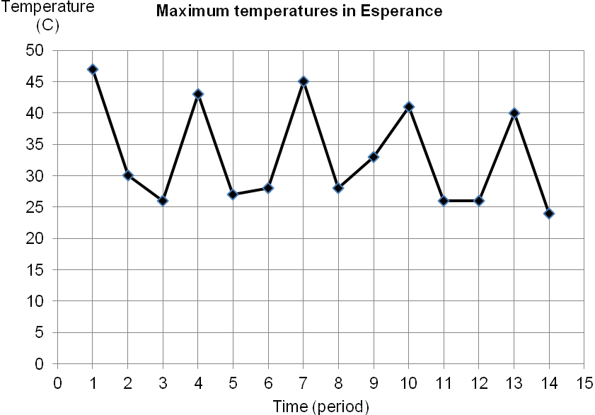

(a) Is January always the hottest month in Esperance? Justify your conclusion. (2)

(b) Explain why a 3-point moving average would be appropriate to use to smooth this data. (1)

(c) Why are lines drawn between the data points? (1)

Data on the graph comes from the table below.

(d) Plot the moving averages on the same axes as the observed values. (2)

(e) Another process for smoothing the data is to calculate a moving median.

The process is the same as for the moving average except that the median is calculated instead of the mean. Determine the 3-point moving medians and enter them in the final column. (3)

(f) Compare the two ways of smoothing data described in part (e). Give mathematical justification for your conclusions. (4)

|  |  |  |  |  |  |
| --- | --- | --- | --- | --- | --- |
| **Year** | **Period** | **Month** | **Maximum temperature** | **Moving average** | **Moving median** |
| 2011 | 1 | Jan | 47 |  |  |
|  | 2 | May | 30 | 34 |  |
|  | 3 | Sep | 26 | 33 |  |
| 2012 | 4 | Jan | 43 | 32 |  |
|  | 5 | May | 27 | 33 |  |
|  | 6 | Sep | 28 | 33 |  |
| 2013 | 7 | Jan | 45 | 34 |  |
|  | 8 | May | 28 | 35 |  |
|  | 9 | Sep | 33 | 34 |  |
| 2014 | 10 | Jan | 41 | 33 |  |
|  | 11 | May | 26 | 31 |  |
|  | 12 | Sep | 26 | 31 |  |
| 2015 | 13 | Jan | 40 | 30 |  |
|  | 14 | May | 24 |  |  |
|  | 15 | Sep |  |  |  |

**Question 2 (12 marks)**

The data provided gives the mean daily solar exposure (MJ per m2) for each month from January 2012 until August 2015.

[Data from the Bureau of Meteorology]

|  |  |  |  |  |  |  |  |  |  |  |  |  |
| --- | --- | --- | --- | --- | --- | --- | --- | --- | --- | --- | --- | --- |
|  | Jan | Feb | Mar | Apr | May | Jun | Jul | Aug | Sep | Oct | Nov | Dec |
| 2012 | 19 | 23 | 20 | 23 | 20 | 18 | 20 | 23 | 26 | 28 | 28 | 25 |
| [2013](http://www.bom.gov.au/jsp/ncc/cdio/weatherData/av?p_display_type=dailyDataFile&p_nccObsCode=193&p_stn_num=003003&p_c=-1904404&p_startYear=2013) | 24 | 22 | 25 | 22 | 18 | 14 | 19 | 22 | 24 | 25 | 26 | 23 |
| [2014](http://www.bom.gov.au/jsp/ncc/cdio/weatherData/av?p_display_type=dailyDataFile&p_nccObsCode=193&p_stn_num=003003&p_c=-1904404&p_startYear=2014) | 21 | 22 | 23 | 22 | 19 | 18 | 18 | 22 | 25 | 27 | 25 | 25 |
| [2015](http://www.bom.gov.au/jsp/ncc/cdio/weatherData/av?p_display_type=dailyDataFile&p_nccObsCode=193&p_stn_num=003003&p_c=-1904404&p_startYear=2015) | 21 | 24 | 21 | 19 | 19 | 18 | 18 | 20 |  |  |  |  |

Use the data provided to investigate the following statements. Use mathematical evidence to justify the accuracy of each claim.

1. Solar exposure is lowest during the month of June. (2)

2. Solar exposure reaches its yearly maximum in October. (2)

3. The solar exposure varies according to the time of the year. (4)

4. The mean daily solar exposure shows an increasing trend. (4)

**Question 3 (14 marks)**

Lou has used a spreadsheet package to analyse the quarterly gas accounts for their household. Statistics and diagrams from the analysis of the amounts charged every 3 months from July 2009 to July 2015 are reproduced below.

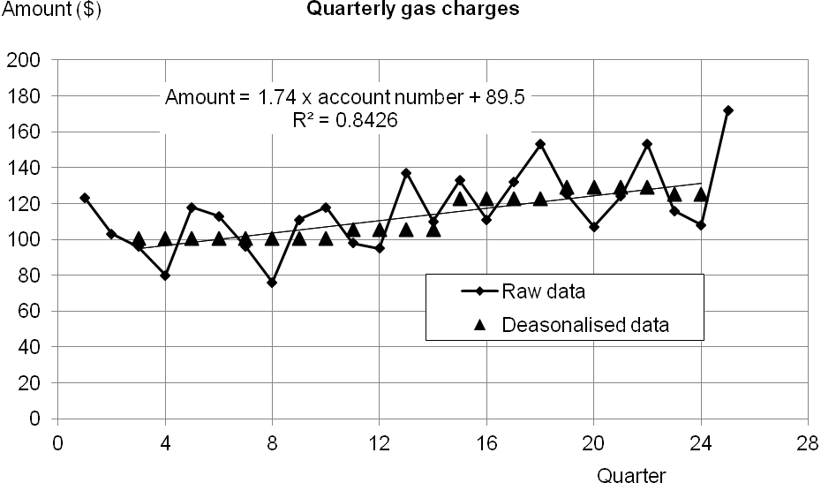

The equation for the line of regression of the deseasonalised data and the coefficient of determination have been provided by the spreadsheet software.

|  |  |
| --- | --- |
| **Seasonal indices** |  |
| July | 110% |
| October | 109% |
| January | 97% |
| April | 84% |

Select the appropriate data and provide mathematical justification to:

(a) Describe the trend in the amount charged for gas. (4)

(b) Describe the seasonal nature of the gas charges. (4)

(c) Give an estimate for the amount charged in April 2016. (4)

(d) Indicate during which quarter the price of gas increased. (2)**Investigative questions in Topic 4.1**

**Solutions and marking key**

**Question 1(a)**

|  |  |
| --- | --- |
| Solution | |
| It is difficult to tell because there are no data for other summer months. | |
| Mathematical behaviours | Marks |
| * concludes accurately * provides justification for conclusion | 1  1 |

**Question 1(b)**

|  |  |
| --- | --- |
| Solution | |
| The data points occur three times a year.  The pattern is repeated every 3 data points | |
| Mathematical behaviours | Marks |
| * identifies a repeating pattern in threes. | 1 |

**Question 1(c)**

|  |  |
| --- | --- |
| Solution | |
| To make the changes easier to see | |
| Mathematical behaviours | Marks |
| * justifies connecting data points | 1 |

**Question 1(d)**

|  |  |
| --- | --- |
| Solution | |
|  | |
| Mathematical behaviours | Marks |
| * plots at least half the moving averages on the axes * plots all moving averages | 1  1 |

**Question 1(e)**

|  |  |
| --- | --- |
| Solution | |
| |  |  |  |  |  |  | | --- | --- | --- | --- | --- | --- | | **Year** | **Period** | **Month** | **Maximum temperature** | **Moving average** | **Moving median** | | 2011 | 1 | Jan | 47 |  |  | |  | 2 | May | 30 | 34 | 30 | |  | 3 | Sep | 26 | 33 | 30 | | 2012 | 4 | Jan | 43 | 32 | 27 | |  | 5 | May | 27 | 33 | 28 | |  | 6 | Sep | 28 | 33 | 28 | | 2013 | 7 | Jan | 45 | 34 | 28 | |  | 8 | May | 28 | 35 | 33 | |  | 9 | Sep | 33 | 34 | 33 | | 2014 | 10 | Jan | 41 | 33 | 33 | |  | 11 | May | 26 | 31 | 26 | |  | 12 | Sep | 26 | 31 | 26 | | 2015 | 13 | Jan | 40 | 30 | 26 | |  | 14 | May | 24 |  |  | |  |  |  |  |  |  | |  | 15 | Sep |  |  |  | | |
| Mathematical behaviours | Marks |
| * uses the correct three values in the calculation of the moving median * determines medians * places medians in appropriate rows of table | 1  1  1 |

**Question 1(f)**

|  |  |
| --- | --- |
| Solution | |
| The range of the medians is greater than the range of the moving averages (6 compared to 5)  A downward trend is more obvious in the moving medians – the values seem to go down more consistently  They both smooth the effect of the high values – in neither case is the value over 35 but the raw data reaches 47 | |
| Mathematical behaviours | Marks |
| * states two conclusions * provides justification for the first conclusion * provides justification for the second conclusion | 2  1  1 |

**Question 2.1**

|  |  |
| --- | --- |
| Solution | |
| For each of the years 2012-2014, the June mean daily solar exposure is the minimum for that year: 18 in 2012, 14 in 2013, 18 in 2014 | |
| Mathematical behaviours | Marks |
| * identifies the June mean exposure is lowest in every year * provides figures for June exposure | 1  1 |

**Question 2.2**

|  |  |
| --- | --- |
| Solution | |
| One cannot conclude this statement is true.  The mean for exposure is only slightly higher in October than in November (26.7 cf 26.3). These figures are mean values and do not give daily readings so the maximum could be at any time. | |
| Mathematical behaviours | Marks |
| * states correct conclusion * provides mathematical justification for conclusion | 1  1 |

**Question 2.3**

|  |  |
| --- | --- |
| Solution | |
| Graph shows changes to mean daily solar exposure for each month from January 2012 to December 2014  The data is seasonal as a pattern is repeated each year  The year starts with a mean in the range of 19 to 25 then this falls to reach a minimum mean about June. From June to December the mean increases each month and the peak mean is reached in December each year. | |
| Mathematical behaviours | Marks |
| * graphs all or some data points at regular intervals. * describes the data as seasonal and justifies the conclusion referring to repeating pattern of data rise and fall each year * describes the data at one particular time of the year * describes the data for a second time of the year | 1  1  1  1 |

**Question 2.4**

|  |  |
| --- | --- |
| Solution | |
| This statement is false  The data points on the graph above do not have increasing peaks or troughs  The moving averages are not increasing in value (quotes at least three as evidence)   |  |  |  |  |  |  | | --- | --- | --- | --- | --- | --- | | Jan-12 |  | Jan-13 | 23 | Jan-14 | 22 | | Feb-12 |  | Feb-13 | 23 | Feb-14 | 22 | | Mar-12 |  | Mar-13 | 23 | Mar-14 | 22 | | Apr-12 |  | Apr-13 | 22 | Apr-14 | 22 | | May-12 |  | May-13 | 22 | May-14 | 22 | | Jun-12 |  | Jun-13 | 22 | Jun-14 | 22 | | Jul-12 | 23 | Jul-13 | 22 | Jul-14 | 22 | | Aug-12 | 23 | Aug-13 | 22 | Aug-14 | 22 | | Sep-12 | 23 | Sep-13 | 22 | Sep-14 | 22 | | Oct-12 | 23 | Oct-13 | 22 | Oct-14 | 22 | | Nov-12 | 23 | Nov-13 | 22 | Nov-14 | 21 | | Dec-12 | 23 | Dec-13 | 22 | Dec-14 | 21 | |  |  |  |  | Jan-15 | 21 | |  |  |  |  | Feb-15 | 22 | | |
| Mathematical behaviours | Marks |
| * identifies appropriate conclusion * justifies using graphic evidence * justifies using moving averages * quotes values as evidence | 1  1  1  1 |

**Question 3(a)**

|  |  |
| --- | --- |
| Solution | |
| The trend is linear and positive.  The gradient is positive and this suggests and upward trend.  The correlations coefficient is 0.918 and this indicates a strong linera relationship with the deseasonalised data | |
| Mathematical behaviours | Marks |
| * identifies positive trend * links positive trend to positive slope * identifies linear trend * links linearity to strength of relationship | 1  1  1  1 |

**Question 3(b)**

|  |  |
| --- | --- |
| Solution | |
| The amount charged shows seasonal variation with a yearly pattern which repeats each year: the lowest accounts occur each year in April and accounts in January and April are usually lower than those in July and October.  The accounts in April are on average 84% of the value of the mean for the year and for July the accounts are on average 110% of the mean for the year. | |
| Mathematical behaviours | Marks |
| * identifies time for pattern of data repeating * describes the seasonal variation pointing to one repeating factor * describes the seasonal variation pointing to another repeating factor * provides mathematical justification for seasonal change | 1  1  1  1 |

**Question 3(c)**

|  |  |
| --- | --- |
| Solution | |
| Account number = 28  Deseasonalised amount = 28 x 1.74 + 89.5 = 138  Predicted value = 84% of 138 = $116 | |
| Mathematical behaviours | Marks |
| * identifies account number * substitutes into formula for deseasonalised data * determines deseasonalised data * calculates predicted value | 1  1  1  1 |

**Question 3(d)**

|  |  |
| --- | --- |
| Solution | |
| January 2012  There is a distinct jump in the deasonalised data in account number 15. Until then, and after that time the deasonalised figures were almost in a straight line. | |
| Mathematical behaviours | Marks |
| * identifies possible time for cost increase * justifies decision using change in graph behaviour | 1  1 |

**TASK 13: GOING DOWN**

**Extended investigation**

**Unit 4**

**Topic 4.2: Loans, investments and annuities**

**Course-related information**

The concepts and skills covered in this investigation relate to the following dot points within the WA Mathematics Applications syllabus:

4.2.3 with the aid of a calculator or computer-based financial software, solve problems involving compound interest loans, investments and depreciating assets

4.2.4 use a recurrence relation to model a reducing balance loan and investigate (numerically or graphically) the effect of the interest rate and repayment amount on the time taken to repay the loan

4.2.5 with the aid of a financial calculator or computer-based financial software, solve problems involving reducing balance loans

The ability to chose and use appropriate technology to enhance and extend concept development is also required for some of the items.

**Background information**

Students will have studied arithmetic and geometric sequences. They should be familiar with recursive notation and first order linear recursive relations. This investigation could be completed during the early part of topic 4.2. Detailed knowledge of effective interest rates and reducing balance loans is not required.

**Task conditions**

Students may need up to one week for the preparation activities. Students should bring the results of their research to the in-class validation so that they can look up terminology and applications of depreciation. The suggested time for the completion of the in-class validation is 45-55 minutes. Access to calculators with sequence facilities is assumed for the validation test. Solutions are not provided for the preparation activities, nor are marks allocated.

**Going down**

**Extended investigation Part 1:** **Preparation activity**

For this investigation there is a series of preparation activities for which the information is readily available in textbooks and on the internet. Solutions to these activities are not provided. It is recommended that students prepare a page of notes summarising what they have learned during these preparation activities and bring this page to the validation test.

Activity 1

What is depreciation? Locate 5 items which are generally believed to depreciate in value. What is the opposite to “depreciate”? Name 5 items which generally gain value over time.

Activity 2

Locate and investigate these three methods of calculating depreciation

1. diminishing value method

2. unit cost method

3. prime cost method

Activity 3

When does the financial year start and finish in Australia?

What is meant by a *one off deduction if item under $300*? See Australian Taxation Office (ATO) website

Why are people interested in the depreciated value of an asset?

Read about the taxation rules for claiming depreciation on rental or business assets.

Activity 4

Investigate the following terminology:

depreciation reducing balance method

diminishing value method straight line depreciation

unit cost method prime cost depreciation method

effective life asset

base value scrap value

written off

**Going down**

**Extended investigation Part 2:** **In-class validation (45 marks)**

**Question 1 (6 marks)**

(a) An entertainment system is purchased for $4000. It is expected to decline in value by losing one quarter of the value it had at the beginning of that year.

Determine the value of the entertainment system at the beginning of each year for the first five years. (3)

|  |  |
| --- | --- |
| **Year** | **Value** |
|  |  |
|  |  |
|  |  |
|  |  |
|  |  |

(b) Toby purchased his lawnmower for $690. It is deemed to decline in value at a fixed rate of $110 each year and will be written off when it is worth less than $50. Determine the value of the lawnmower at the beginning of each year for the first five years.

|  |  |
| --- | --- |
| **Year** | **Value** |
|  |  |
|  |  |
|  |  |
|  |  |
|  |  |

When will the lawnmower be written off? (3)

**Question 2 (16 marks)**

Jana purchased a printer for $450 on July 1, 2014. It was deemed to have an effective life of 5 years or 50 000 pages (print capacity) and she printed 5000 pages in the first year. Jana is investigating her depreciation options for taxation and is looking at three different methods for calculating the amount of depreciation that she can claim for the first year of ownership.

**Method 1**: Unit cost method

Deduction = original price x pages printed ÷ print capacity

**Method 3**: Prime cost method (straight line depreciation)

Deduction = original price x (number of days owned ÷ 365) x 100% ÷ effective life

**Method 3:** Diminishing value method (reducing balance method)

Deduction = original price x (number of days owned ÷ 365) x 200% ÷ effective life

(a) Determine the amount by which the printer had depreciated after one year according to the unit cost method. (2)

(b) If the rate of printing is maintained, when will the printer lose all capacity to print?

(2)

(c) Determine the loss of value for the printer during the first year of ownership using the prime cost method. (2)

(d) Determine the recursive rule that could be used to calculate the value of the printer at the beginning of each year if the prime cost method is used.

(2)

(e) Determine the loss of value for the printer during the first year of ownership using the diminishing value method. (2)

(f) Determine the recursive rule that could be used to calculate the value of the printer at the beginning of each year if the diminishing value method is used.

(3)

(g) Complete the table of values to show the printer values for both the prime cost and the diminishing value methods. (2)

|  |  |  |
| --- | --- | --- |
| **Time** | **Prime cost method** | **Diminishing value method** |
| **1 July 2014** | $450.00 | $450.00 |
| **1 July 2015** |  |  |
| **1 July 2016** |  |  |
| **1 July 2017** |  |  |
| **1 July 2018** |  |  |
| **1 July 2019** |  |  |

(h) For which method will the printer first reach a value of $0? (1)

**Question 3 (17 marks)**

Lisa and Bert each purchased the same type fire extinguisher for their rental properties and they both paid $1800. For depreciation purposes the fire extinguishers were deemed to have an effective life of 15 years and each year the depreciation on the fire extinguishers was 13.33% of their current value.

(a) Determine the value, to the nearest ten dollars, by which each extinguisher depreciated during the first year of ownership.

(2)

(b) Given  determine the recursive rule to determine  . (1)

(c) Bert decides to pay $100 annually to have the fire extinguisher serviced and this adds $100 to the value of his fire extinguisher each year. This value can be modelled by a first order linear recurrence relation.

Given  determine the recursive rule to determine , the value of Bert’s fire extinguisher. (1)

(d) Use the rules you have developed in parts (b) and (c) to create a table showing the values of the both fire extinguishers after every 3 years. Round all values to the nearest dollar. (4)

|  |  |  |
| --- | --- | --- |
| Years passed | Value of Lisa’s extinguisher | Value of Bert’s extinguisher |
| 0 |  |  |
| 3 |  |  |
| 6 |  |  |
| 9 |  |  |
| 12 |  |  |
| 15 |  |  |

(e) Use the grid provided to show the changing values for both fire extinguishers over the period of the suggested effective life. (3)

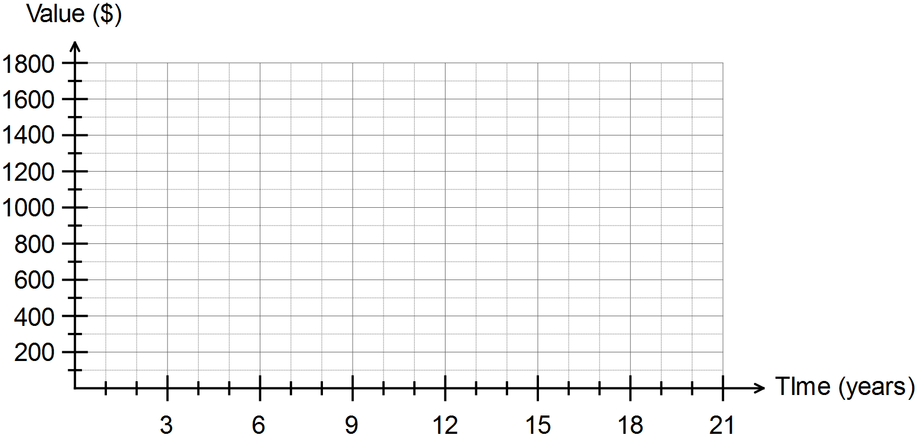

(f) What are the values of both fire extinguishers at the end of their effective lives?

(2)

(g) How does having the fire extinguisher serviced affect the rate at which it actually depreciates in value? (1)

(h) Continue the pattern by approximating changing values and plot on the grid to show the values after 21 years. (2)

(i) Bert’s fire extinguisher appears to reach a value and it does not go below that value. Explain how this could be occurring. (1)

**Question 4 (6 marks)**

Assets depreciate in value and in some cases these depreciated amounts can be deducted from taxable income. Asset owners must claim the depreciation according to the time for which they have owned the goods and in proportion to how much they own.

Two methods for calculating depreciation are the diminishing value method and the prime cost depreciation method.

(a) Tee and Jay jointly own a fishing trawler though Jay has the larger share. The trawler is currently worth $585 000 and the ratio of ownership is 1:4. Given a loss of 15% per year on the boat, what could Jay claim as a deduction for his share of the depreciation after one more year? (3)

(b) Fergie purchased a laptop for her business on the last day of April in 2015. What proportion of the depreciated amount was she entitled to claim as a taxation deduction? (1)

(c) Which method of depreciation calculation would you choose for a taxation deduction under the following circumstances? (2)

(i) You want to be able to claim a consistent amount each year.

(ii) You want to be able to claim most of the deduction in the first few years.

**End of questions**

**Going down**

**Extended investigation Part 2:** **In-class validation**

**Solutions and marking key**

**Question 1(a)**

|  |  |
| --- | --- |
| Solution | |
| |  |  | | --- | --- | | **Year** | **Value** | | 1 | $4000 | | 2 | $3000 | | 3 | $2250 | | 4 | $1687.50 | | 5 | $1265.63 | | |
| Mathematical behaviours | Marks |
| * completes years and initial value * determines 2 more values at the beginning of the year * determines 2 more values at the beginning of the year | 1  1  1 |

**Question 1(b)**

|  |  |
| --- | --- |
| Solution | |
| |  |  | | --- | --- | | **Year** | **Value** | | 1 | $690 | | 2 | $580 | | 3 | $470 | | 4 | $360 | | 5 | $250 |   It wll be written off at the end of By the end of the 7th year / beginning of the 8th year | |
| Mathematical behaviours | Marks |
| * completes years and initial value * determines remaining values for beginning of each year * identifies total loss of value | 1  1  1 |

**Question 2(a)**

|  |  |
| --- | --- |
| Solution | |
| 450 x 5000 ÷ 50000 = 45  So $45 | |
| Mathematical behaviours | Marks |
| * substitutes into formula for unit cost method * determines deduction | 1  1 |

**Question 2(b)**

|  |  |
| --- | --- |
| Solution | |
| 50 000 ÷ 5000 = 10  30 June 2024 | |
| Mathematical behaviours | Marks |
| * determines 10 year capacity * identifies data for loss of capacity | 1  1 |

**Question 2(c)**

|  |  |
| --- | --- |
| Solution | |
| 450 x 365 ÷ 365 x 100% ÷ 5 = 90  So $90 | |
| Mathematical behaviours | Marks |
| * substitutes into formula for prime cost method * determines deduction | 1  1 |

**Question 2(d)**

|  |  |
| --- | --- |
| Solution | |
|  | |
| Mathematical behaviours | Marks |
| * identifies initial terms * expresses recursive relationship with correct difference | 1  1 |

**Question 2(e)**

|  |  |
| --- | --- |
| Solution | |
| 450 x 365 ÷ 365 x 200% ÷ 5 = 180  So $180 | |
| Mathematical behaviours | Marks |
| * substitutes into formula for diminishing value method * determines loss of value | 1  1 |

**Question 2(f)**

|  |  |
| --- | --- |
| Solution | |
|  | |
| Mathematical behaviours | Marks |
| * identifies initial term * determines correct ratio * expresses rule in recursive notation | 1  1  1 |

**Question 2(g)**

|  |  |
| --- | --- |
| Solution | |
| |  |  |  | | --- | --- | --- | | **Time** | **Prime cost method** | **Diminishing value method** | | **1 July 2014** | $450 | $450.00 | | **1 July 2015** | $360 | $360.00 | | **1 July 2016** | $270 | $288.00 | | **1 July 2017** | $180 | $230.40 | | **1 July 2018** | $90 | $184.32 | | **1 July 2019** | 0 | $147.46 | | |
| Mathematical behaviours | Marks |
| * completes table for prime cost method * completes table for diminishing value method | 1  1 |

**Question 2(h)**

|  |  |
| --- | --- |
| Solution | |
| Prime cost method | |
| Mathematical behaviours | Marks |
| * identifies method by which printer first reaches 0 in value | 1 |

**Question 3(a)**

|  |  |
| --- | --- |
| Solution | |
| 1800 x 13.33% = $239.94 so $240 | |
| Mathematical behaviours | Marks |
| * determines value by which item depreciated * rounds value to nearest $10 | 1  1 |

**Question 3(b)**

|  |  |
| --- | --- |
| Solution | |
|  | |
| Mathematical behaviours | Marks |
| * identifies remaining part of recursive rule | 1 |

**Question 3(c)**

|  |  |
| --- | --- |
| Solution | |
|  | |
| Mathematical behaviours | Marks |
| * identifies remaining part of recursive rule | 1 |

**Question 3(d)**

|  |  |
| --- | --- |
| Solution | |
| |  |  |  | | --- | --- | --- | | Years passed | Value of Lisa’s extinguisher | Value of Bert’s extinguisher | | 0 | $1800 | $1800 | | 3 | $1172 | $1434 | | 6 | $763 | $1195 | | 9 | $497 | $1040 | | 12 | $323 | $939 | | 15 | $211 | $873 | | |
| Mathematical behaviours | Marks |
| * compiles data at 3 year intervals * provides accurate data for Lisa * provides accurate data for Bert * rounds values to nearest dollar | 1  1  1  1 |

**Question 3(e)**

|  |  |
| --- | --- |
| Solution | |
| Bert Lisa | |
| Mathematical behaviours | Marks |
| * plots points accurately for Lisa * plots points accurately for Bert * provides legend | 1  1  1 |

**Question 3(f)**

|  |  |
| --- | --- |
| Solution | |
| Lisa’s extinguisher is worth $211  Bert’s extinguisher is worth $873 | |
| Mathematical behaviours | Marks |
| * identifies value for each graph after 15 years * identifies ownership of extinguishers | 1  1 |

**Question 3(g)**

|  |  |
| --- | --- |
| Solution | |
| The rate of depreciation is slowed | |
| Mathematical behaviours | Marks |
| * identifies correct change of rate | 1 |

**Question 3(h)**

|  |  |
| --- | --- |
| Solution | |
| Bert Lisa | |
| Mathematical behaviours | Marks |
| * continues pattern for Lisa * continues pattern for Bert | 1  1 |

**Question 3(h)**

|  |  |
| --- | --- |
| Solution | |
| The amount by which it is depreciating is affected by the value added through servicing. The $100 gained by servicing is equal to the loss through the depreciation factor. | |
| Mathematical behaviours | Marks |
| * explains the plateau effect of the loss and gain | 1 |

**Question 4(a)**

|  |  |
| --- | --- |
| Solution | |
| Jay owns 0.8 of the trawler  Depreciation = 0.15 x 585 000 = $87750  Jay’s share = 0.8 x 87750 = $70 200 | |
| Mathematical behaviours | Marks |
| * determines proportion of Jay’s ownership * determine value of depreciation * determines Jay’s share of the depreciation | 1  1  1 |

**Question 4(b)**

|  |  |
| --- | --- |
| Solution | |
| 61 ÷ 365 or 0.167  30 June 2024 | |
| Mathematical behaviours | Marks |
| * determines proportion | 1 |

**Question 4(c)**

|  |  |
| --- | --- |
| Solution | |
| (i) prime cost method  (ii) diminishing value method | |
|  | Marks |
| * identifies appropriate method for calculation * identifies appropriate method for calculation | 1  1 |

**TASK 14: INVESTIGATING INTEREST**

**In-class investigation**

**Unit 4**

**Topic 4.2: Loans, investments and annuities**

**Course-related information**

The concepts and skills developed in this investigation relate to the following dot points within the WA Mathematics Applications syllabus:

4.2.1 use a recurrence relation to model a compound interest loan or investment and investigate (numerically or graphically) the effect of the interest rate and the number of compounding periods on the future value of the loan or investment

**Background information**

Students should have completed the topic 3.2 Growth and decay in sequences. They will have studied simple and compound interest in Years 9 and 10 but are not expected to have an extensive knowledge of these types of interest calculations. This task would be appropriate to use as an introduction to topic 4.2 and does not require students to have started the topic.

**Task conditions**

This task consists of an in-class investigation for which students might need 40 – 55 minutes to complete. It is expected that access to calculator technology is available during the investigation. Students will not require knowledge of specialised financial software.

**Investigating interest**

**In-class investigation (Total marks: 50)**

The focus of this investigation is on examining interest on investments.

Key terms:

*Interest:* the extra money paid out on an investment.

*Simple interest*: the interest is charged at a percentage of the original amount invested. Growth or decay is linear.

*Compound interest*: the interest is periodically added to the amount invested and the next interest calculation is based on the new total (rather than the starting amount). Growth or decay is geometric.

**Question 1 (9 marks) (12 marks) (6 marks)**

(a) The table below shows the value of two investments over a period of 5 years.

The only money added to the account is the interest earned.

|  |  |  |  |  |  |  |
| --- | --- | --- | --- | --- | --- | --- |
| **Time elapsed**  **(years)** | **0** | **1** | **2** | **3** | **4** | **5** |
| **A** | $150 | $165 | $180 | $195 | $210 | $225 |
| **B** | $140.00 | $151.20 | $162.40 | $173.60 | $184.80 | $196.00 |

Describe each of these two investments as earning either simple interest or compound interest and justify your decision. (3)

(b) The following graph shows the changes in the values of investments owned by Tom and Tina over a period of years. The only changes to the investments are the interest earned.

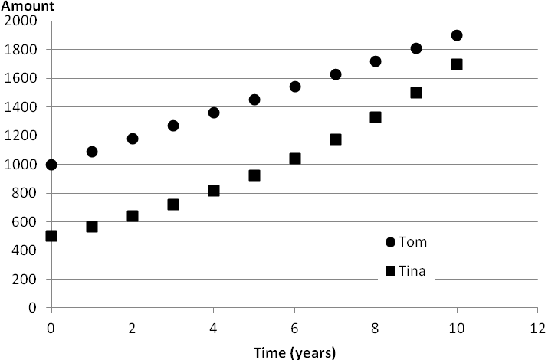

Describe the type of interest paid by Tom and Tina as either simple or compound interest. Use evidence from the graph to justify your decision. (3)

(c) Lee and Lou have each invested $1000 and the equations for the calculations of their investment totals after interest is added are given below.

Lee:  Lou:  with 

Describe the type of interest paid by Lee and Lou as either simple or compound interest. Use these formulae to justify your decision. (3)

**Question 2 (12 marks)**

The table shows the value of different investments after 5, 10 and 15 years. The interest has been determined using compound interest.

|  |  |  |  |  |  |  |
| --- | --- | --- | --- | --- | --- | --- |
|  | **Interest at 3%** | | | **Interest at 5%** | | |
|  | **Length of investment (years)** | | | | | |
| **Amount invested** | **5** | **10** | **15** | **5** | **10** | **15** |
| $100,000 | $115,927 | $134,392 | $155,797 | $127,628 | $162,889 | $207,893 |
| $200,000 | $231,855 | $268,783 | $311,593 | $255,256 | $325,779 | $415,786 |
| $300,000 | $347,782 | $403,175 | $467,390 | $382,884 | $488,668 | $623,678 |
| $400,000 | $463,710 | $537,567 | $623,187 | $510,513 | $651,558 | $831,571 |
| $500,000 | $579,637 | $671,958 | $778,984 | $638,141 | $814,447 | $1,039,464 |

(a) What is the value of an investment of $400,000 after 5 years at 5%? (1)

(b) How much interest was earned on an investment of $300,000 over 10 years at 3%? (1)

(c) To get between $810,000 and $850,000 from your investment, how much would you need to invest, for how long and at what interest rate? (2)

(d) The formula used to calculate the future value of these investments is

Future value = starting value x (1 + interest rate as a decimal)*t*

where *t* represents the number of years for which the money is invested.

Show the substitution necessary to complete this calculation

$1,039,464 = (2)

(e) Fully describe evidence from the table to justify each of these claims.

(i) *For a fixed investment over a set number of years a higher rate of interest will earn greater interest.* (2)

(ii) *At the same rate and over the same time,* d*oubling the amount of the investment will result in twice the finishing value.* (2)

(iii) *For the same investment at the same rate*, *doubling the length of time it is invested results in more than double the amount of interest earned*. (2)

**Question 3 (9 marks)**

A geometric sequence can be used to model compound interest on an investment.

For an investment of $10,000 on which interest is paid annually at 5% the recursive rule would be



(a) Determine the amounts the investment would be worth at the end of each of the first two years. (3)

(b) Determine the rule for the *nth* term. (2)

(c) Determine the monthly interest rate. (1)

(d) If interest was paid monthly instead of yearly, how much would this investment be worth after one year? (3)

**Question 4 (7 marks)**

The graph below shows four different investments for which interest is paid annually.

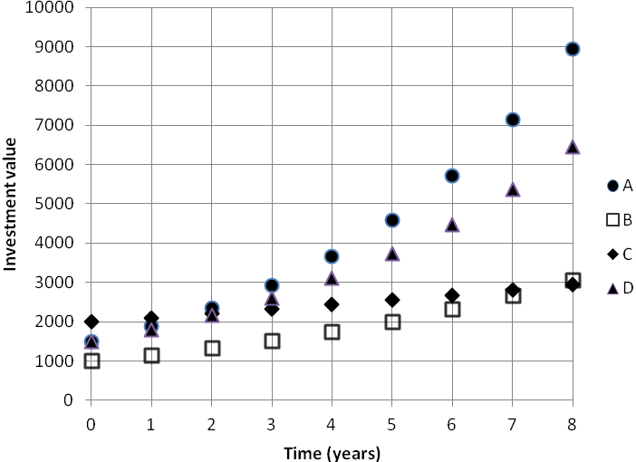

(a) Explain why it is inappropriate to join the points for each graph. (1)

(b) Which investment has the highest initial value? (1)

(c) Which investment is growing at the fastest rate? (1)

(d) Match the graphs to the recursive rules provided. (4)

|  |  |
| --- | --- |
| **Recursive rules** | **Graph** |
|  |  |
|  |  |
|  |  |
|  |  |

**Question 5 (13 marks)**

Interest is calculated and added to an investment at regular intervals e.g., weekly, monthly, daily, etc.. In the table below the value of the investment is shown for four possible intervals of interest calculation. The time at which the investment value is shown relates to the interval of interest calculation. For example, after one month the investment would be worth $15,036 if interest is calculated monthly and if interest is calculated quarterly, the investment would be worth $15,108 after three months.

|  |  |  |  |  |
| --- | --- | --- | --- | --- |
| **Time** | **Monthly** | **Quarterly** | **Every 6 months** | **Yearly** |
| 0 | $15,000 | $15,000 | $15,000 | $15,000 |
| 1 | $15,036 | $15,108 | $15,216 | $15,432 |
| 2 | $15,072 | $15,217 | $15,435 | $15,876 |
| 3 | $15,108 | $15,326 | $15,657 | $16,334 |
| 4 | $15,145 | $15,437 | $15,883 | $16,804 |
| 5 | $15,181 | $15,548 | $16,112 | $17,288 |
| 6 | $15,217 | $15,660 | $16,344 | $17,786 |
| 7 | $15,254 | $15,773 | $16,579 | $18,298 |
| 8 | $15,290 | $15,886 | $16,818 | $18,825 |
| 9 | $15,327 | $16,000 | $17,060 | $19,367 |
| 10 | $15,364 | $16,116 | $17,305 | $19,925 |
| 11 | $15,401 | $16,232 | $17,555 | $20,499 |
| 12 | $15,438 | $16,349 | $17,807 | $21,089 |
| 13 | $15,475 | $16,466 | $18,064 | $21,697 |
| 14 | $15,512 | $16,585 | $18,324 | $22,322 |
| 15 | $15,549 | $16,704 | $18,588 | $22,964 |
| 16 | $15,586 | $16,825 | $18,856 | $23,626 |
| 17 | $15,624 | $16,946 | $19,127 | $24,306 |
| 18 | $15,661 | $17,068 | $19,402 | $25,006 |
| 19 | $15,699 | $17,191 | $19,682 | $25,726 |
| 20 | $15,737 | $17,314 | $19,965 | $26,467 |
| 21 | $15,774 | $17,439 | $20,253 | $27,230 |
| 22 | $15,812 | $17,565 | $20,544 | $28,014 |
| 23 | $15,850 | $17,691 | $20,840 | $28,821 |
| 24 | $15,888 | $17,818 | $21,140 | $29,651 |

(a) What was the amount invested? (1)

(b) For each column, indicate by shading or highlighting, the values of the investments at the end of each of the first two years only. (3)

For the four time periods provided:

(c) Which investment had gained the most interest at the end of the first year?

Use mathematical evidence to justify your decision. (3)

(d) Which investment was growing at the fastest rate?

Use mathematical evidence to justify your decision. (2)

(e) Would the daily calculation of interest result in a higher value for the investment after one year than the ones provided above? Explain your decision. (2)

(f) Describe two ways by which the investment value could be increased beyond the amounts provided in the table. (2)

**End of questions**

**Investigation interest**

**In-class investigation**

**Solutions and marking key**

**Question 1(a)**

|  |  |
| --- | --- |
| Solution | |
| Both investments are earning simple interest  There is a fixed amount of increase each year  For A, this is $15, for B it is $11.20 | |
| Mathematical behaviours | Marks |
| * identifies simple interest in each case * explains the fixed increase amount * states the increased amount | 1  1  1 |

**Question 1(b)**

|  |  |
| --- | --- |
| Solution | |
| Tom’s investment is earning simple interest  Tina’s investment is earning compound interest  Tom’s graph goes up evenly – it is linear  Tina’s graph appears to be exponential | |
| Mathematical behaviours | Marks |
| * identifies the type of interest in each case * identifies linear graph for simple interest * identifies changing curvature for compound interest | 1  1  1 |

**Question 1(c)**

|  |  |
| --- | --- |
| Solution | |
| Lou’s investment is earning simple interest, it is increasing by 10.1  Lee’s investment is earning compound interest, it is increased by a factor of 1.01 | |
| Mathematical behaviours | Marks |
| * identifies the type of interest in each case * links simple interest to fixed amount being added * identifies ratio increase for compound interest | 1  1  1 |

**Question 2(a)**

|  |  |
| --- | --- |
| Solution | |
| $510,513 | |
| Mathematical behaviours | Marks |
| * correctly reads table | 1 |

**Question 2(b)**

|  |  |
| --- | --- |
| Solution | |
| $103,175 | |
| Mathematical behaviours | Marks |
| * calculates interest | 1 |

**Question 2(c)**

|  |  |
| --- | --- |
| Solution | |
| Invest $400,000 for 15 years at 5%  Invest $500,000 for 10 years at 5% | |
| Mathematical behaviours | Marks |
| * describes first option for investment * describes second option for investment | 1  1 |

**Question 2(d)**

|  |  |
| --- | --- |
| Solution | |
| $1,039,464 =500,000 x (1.05)15 | |
| Mathematical behaviours | Marks |
| * substitutes two variables into equation * substitutes third variable into equation | 1  1 |

**Question 2(e)**

|  |  |
| --- | --- |
| Solution | |
| Answers will vary. Examples include  (i) On $100,000 over 10 years the interest is higher at 10% ($62,889) than at 5% ($34,392)  (ii) An investment of $400,000 over 5 years at 3% is worth $463,710 and this is double $231,855 which is earned on half the amount at the same rate over the same time.  (iii) Interest on $500 000 at 3% over 5 years is $79,637 and over 10 years is $171,958. Twice $79,637 ~ $160,000 | |
| Mathematical behaviours | Marks |
| for each statement (i) to (iii)   * describes the example chosen with respect to time, rate and investment * provides evidence of the claim by quoting relevant data | 3  3 |

**Question 3(a)**

|  |  |
| --- | --- |
| Solution | |
|  | |
| Mathematical behaviours | Marks |
| * substitutes into formula provided * determines investment value for *V*1 * determines investment value for *V*2 | 1  1  1 |

**Question 3(b)**

|  |  |
| --- | --- |
| Solution | |
| where *n* represents the number of years that have passed | |
| Mathematical behaviours | Marks |
| * uses the correct format for a general rule * substitutes correctly into general equation | 1  1 |

**Question 3(c)**

|  |  |
| --- | --- |
| Solution | |
| 0.417% or 0.00417 | |
| Mathematical behaviours | Marks |
| * determines rate | 1 |

**Question 3(d)**

|  |  |
| --- | --- |
| Solution | |
| $10,511.60 | |
| Mathematical behaviours | Marks |
| * selects correct formula and substitutes correctly * determines value of the investment * communicates answer with appropriate rounding and $ format | 1  1  1 |

**Question 4**

|  |  |  |  |
| --- | --- | --- | --- |
|  | Solution | Mathematical behaviours | Marks |
| (a) | The amounts do not change between the years | * identifies type of information | 1 |
| (b) | C | * interprets graph | 1 |
| (c) | A | * interprets graph | 1 |
| (d) | C  B  D  A | * correctly matches 1 graphs * correctly matches second graph * correctly matches third graph * correctly matches fourth graph | 1  1  1  1 |

**Question 5(a)**

|  |  |
| --- | --- |
| Solution | |
| $15000 | |
| Mathematical behaviours | Marks |
| * reads table accurately | 1 |

**Question 5(b)**

|  |  |
| --- | --- |
| Solution | |
| |  |  |  |  |  | | --- | --- | --- | --- | --- | | **Time** | **Monthly** | **Quarterly** | **Every 6 months** | **Yearly** | | 0 | $15,000 | $15,000 | $15,000 | $15,000 | | 1 | $15,036 | $15,108 | $15,216 | $15,432 | | 2 | $15,072 | $15,217 | $15,435 | $15,876 | | 3 | $15,108 | $15,326 | $15,657 | $16,334 | | 4 | $15,145 | $15,437 | $15,883 | $16,804 | | 5 | $15,181 | $15,548 | $16,112 | $17,288 | | 6 | $15,217 | $15,660 | $16,344 | $17,786 | | 7 | $15,254 | $15,773 | $16,579 | $18,298 | | 8 | $15,290 | $15,886 | $16,818 | $18,825 | | 9 | $15,327 | $16,000 | $17,060 | $19,367 | | 10 | $15,364 | $16,116 | $17,305 | $19,925 | | 11 | $15,401 | $16,232 | $17,555 | $20,499 | | 12 | $15,438 | $16,349 | $17,807 | $21,089 | | 13 | $15,475 | $16,466 | $18,064 | $21,697 | | 14 | $15,512 | $16,585 | $18,324 | $22,322 | | 15 | $15,549 | $16,704 | $18,588 | $22,964 | | 16 | $15,586 | $16,825 | $18,856 | $23,626 | | 17 | $15,624 | $16,946 | $19,127 | $24,306 | | 18 | $15,661 | $17,068 | $19,402 | $25,006 | | 19 | $15,699 | $17,191 | $19,682 | $25,726 | | 20 | $15,737 | $17,314 | $19,965 | $26,467 | | 21 | $15,774 | $17,439 | $20,253 | $27,230 | | 22 | $15,812 | $17,565 | $20,544 | $28,014 | | 23 | $15,850 | $17,691 | $20,840 | $28,821 | | 24 | $15,888 | $17,818 | $21,140 | $29,651 | | |
| Mathematical behaviours | Marks |
| * shades columns correctly for two time periods * shades column correctly for next time period * shades column correctly for next time period | 1  1  1 |

**Question 5(c)**

|  |  |
| --- | --- |
| Solution | |
| Monthly: The interest was $1 more than for 6-monthly, $3 more than for every 6 months and $6 more than yearly result. | |
| Mathematical behaviours | Marks |
| * identifies correct investment type * provides evidence of being greater than one other type * provides evidence of being greater than all other types | 1  1  1 |

**Question 5(d)**

|  |  |
| --- | --- |
| Solution | |
| Monthly: The rate was $888 in 2 years compared to $886 (quarterly), $883 (6-monthly) and $876 (yearly) | |
| Mathematical behaviours | Marks |
| * identifies correct investment type * provides evidence of rate being greater than all other types | 1  1 |

**Question 5(e)**

|  |  |
| --- | --- |
| Solution | |
| Daily interest would be better  The table suggests the more often interest is calculated the quicker the investment grows.  The amount on which interest is calculated is growing more quickly | |
| Mathematical behaviours | Marks |
| * concludes correctly * justifies conclusion | 1  1 |

**Question 5(f)**

|  |  |
| --- | --- |
| Solution | |
| Invest a greater amount initially  Try to get a better rate  Add more to the investment throughout | |
| Mathematical behaviours | Marks |
| * identifies one way to improve the investment outcome * identifies a second way to improve the investment outcome | 1  1 |

**TASK 15**

**Investigative questions**

**Unit 4**

**Topic 4.2: Loans, investments and annuities**

**Course-related information**

The concepts and skills covered in these investigative questions relate to the following dot points within the WA Mathematics Applications syllabus:

4.2.1 use a recurrence relation to model a compound interest loan or investment and investigate (numerically or graphically) the effect of the interest rate and the number of compounding periods on the future value of the loan or investment

4.2.2 calculate the effective annual rate of interest and use the results to compare investment returns and cost of loans when interest is paid or charged daily, monthly, quarterly or six-monthly

4.2.4 use a recurrence relation to model a reducing balance loan and investigate (numerically or graphically) the effect of the interest rate and repayment amount on the time taken to repay the loan

The ability to choose and use appropriate technology to enhance and extend concept development is also required for some of the items

**Background information**

The ability to create and interpret spreadsheets is assumed knowledge for the first questions. Students should be familiar with the concepts of the loans attracting interest calculated using a compound interest model, repayments, frequency of compounding and the calculation of effective interest rates.

**Task conditions**

These items should be undertaken under test conditions, either as part of a test/examination or as stand-alone items. Student access to a graphical/CAS calculator is assumed. The time required to complete each question is left to the discretion of the teacher but the intention is that each question may be completed within 15 minutes.

**Investigative questions for Topic 4.2**

**Question 1 (10 marks)**

The table below shows part of a spreadsheet containing data about a loan including the repayments and the amounts owed. The interest rate is the same for both loans.

The data are as follows:

Column A: Time elapsed (months)

Rows 3-12 of column B: Amount owing on first loan at the end of each month

Rows 3-12 of column C: Amount owing on second loan at the end of each month

(Amounts are given to the nearest dollar.)

|  |  |  |  |
| --- | --- | --- | --- |
|  | A | B | C |
| 1 | **Month** | **500** | **100** |
| 2 | 0 | **10000** | **10000** |
| 3 | **1** | $9,542 | $9,942 |
| 4 | **2** | $9,081 | $9,883 |
| 5 | **3** | $8,619 | $9,824 |
| 6 | **4** | $8,155 | $9,765 |
| 7 | **5** | $7,689 | $9,706 |
| 8 | **6** | $7,221 | $9,646 |
| 9 | **7** | $6,751 | $9,587 |
| 10 | **8** | $6,279 | $9,526 |
| 11 | **9** | $5,806 | $9,466 |
| 12 | **10** | $5,330 | $9,406 |

(a) How much was owed on the first loan after nine months? (1)

(b) After how many months had nearly $300 been paid off the second loan? (1)

(c) Describe what the data in cell C11 represents. (2)

(d) The formula for calculating the contents of cell B5 is

=B4*(1+0.05/12) - $B$1

where * is the symbol for multiplication and / is the symbol for division.

Show the substitution needed to calculate the value in B5 (2)

(e) What does the value in $B$1 represent? (1)

(f) Why do the amounts in column B decrease more quickly than those in column C?

(1)

(g) Using the symbols defined in part (d) if needed, determine the formula to calculate the contents of C5. (2)

**Question 2 (11 marks)**

The graph below shows the amounts owed by Gill and Tran at the end of each month for the first ten months of their loan period. The interest rates were the same (10% per annum) for both loans and both were calculated using a compound interest model.

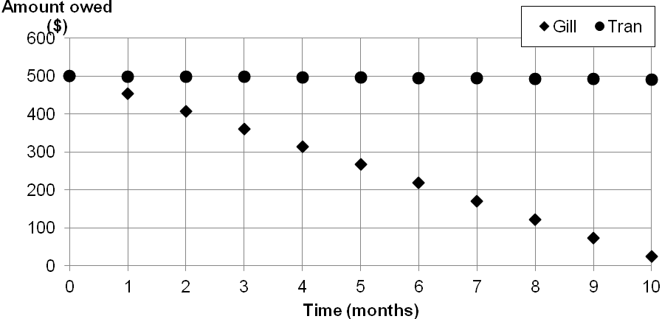

(a) Give an estimate for the amount owed by Gill after four months. (1)

(b) Estimate the difference in what the two people owe after two months. (1)

(c) Gill is paying back $50 per month on a $500 loan. Explain why the loan has not been paid off after 10 months. (1)

(d) Determine the formula to calculate the amount owed by Gill after *n* months. (3)

(e) Compare the two loans by summarising their similarities and differences. (4)

(f) Explain the differences in the amounts owed by these two people over the 10- month period. (1)

**Question 3 (9 marks)**

The table below shows the values of an investment of $50,000 at 6.00% per annum after six months, one year and two years for different compounding periods. The compounding periods are daily, weekly, monthly and yearly. Values have been rounded to the nearest dollar.

|  |  |  |  |  |  |
| --- | --- | --- | --- | --- | --- |
|  |  | **Daily** | **Weekly** | **Monthly** | **Yearly** |
|  |  |  |  |  |  |
| $50,000.00 |  |  |  |  |  |
| 6.00% | Interest | 0.000164384 | 0.001153846 | 0.005 | 0.06 |
|  | After |  |  |  |  |
|  | **6 months** | $51,527 | $51,522 | $51,519 |  |
|  | **1 year** | $53,092 | $53,090 | $53,084 | $53,000 |
|  | **2 years** | $56,374 | $56,371 | $56,358 | $56,180 |
|  |  |  |  |  |  |
| Effective annual interest rate |  | 6.1831% | 6.1800% | 6.1678% | **A** |

(a) What was the value of the investment after two years when interest was compounded monthly? (1)

(b) By how much was the investment increased after one year when the interest was calculated daily rather than weekly? (1)

(c) Use evidence from the table to support the statement below.

*The value of this investment was increased by compounding more often.* (2)

(d) How was the figure of 0.000164384 calculated? (1)

(e) What value should be written in the cell marked **A**? (1)

(f) Summarise the effect of increasing the frequency of compounding on the effective interest rate. (1)

(g) Estimate a value for the effective annual interest rate when compounding occurs fortnightly. Justify your estimate using data from the table. (2)

**Investigative questions in Topic 4.2**

**Solutions and marking key**

**Question 1(a)**

|  |  |
| --- | --- |
| Solution | |
| $5806 | |
| Mathematical behaviours | Marks |
| * reads table of values | 1 |

**Question 1(b)**

|  |  |
| --- | --- |
| Solution | |
| 7 | |
| Mathematical behaviours | Marks |
| * reads table of values | 1 |

**Question 1(c)**

|  |  |
| --- | --- |
| Solution | |
| Amount owing on the second loan after 9 months | |
| Mathematical behaviours | Marks |
| * identifies the amount and the type of loan * identifies correct time period | 1  1 |

**Question 1(d)**

|  |  |
| --- | --- |
| Solution | |
| =9081*(1+0.05/12) - 500 | |
| Mathematical behaviours | Marks |
| * substitutes 9081 into formula provided * substitutes 500 | 1  1 |

**Question 1(e)**

|  |  |
| --- | --- |
| Solution | |
| Monthly repayment | |
| Mathematical behaviours | Marks |
| * identifies contribution to loan | 1 |

**Question 1(f)**

|  |  |
| --- | --- |
| Solution | |
| Repayments are higher for the first loan | |
| Mathematical behaviours | Marks |
| * identifies higher repayments | 1 |

**Question 1(g)**

|  |  |
| --- | --- |
| Solution | |
| =C4*(1+0.05/12)-$C$1 | |
| Mathematical behaviours | Marks |
| * uses correct formula * substitutes cell references | 1  1 |

**Question 2(a)**

|  |  |
| --- | --- |
| Solution | |
| $310 | |
| Mathematical behaviours | Marks |
| * reads value from graph | 1 |

**Question 2(b)**

|  |  |
| --- | --- |
| Solution | |
| $100 | |
| Mathematical behaviours | Marks |
| * reads values from graph | 1 |

**Question 2(c)**

|  |  |
| --- | --- |
| Solution | |
| Interest is being added to the loan | |
| Mathematical behaviours | Marks |
| * identifies the addition of money to the loan | 1 |

**Question 2(d)**

|  |  |
| --- | --- |
| Solution | |
| Amount owed = 500 (1 – 0.1 ÷ 12)*n* | |
| Mathematical behaviours | Marks |
| * uses compound interest (or recursive ) formula * identifies starting amount of 500 * determines monthly interest rate | 1  1  1 |

**Question 2(e)**

|  |  |
| --- | --- |
| Solution | |
| The loans are similar in that $500 is borrowed in each case, the annual interest rate is the same (10%), the compounding period is the same (monthly), the loan repayments must be different. | |
| Mathematical behaviours | Marks |
| * identifies three similarities * identifies difference | 3  1 |

**Question 2(f)**

|  |  |
| --- | --- |
| Solution | |
| Repayments are different – Tran is paying back the loan more slowly | |
| Mathematical behaviours | Marks |
| * identifies different repayments | 1 |

**Question 3(a)**

|  |  |
| --- | --- |
| Solution | |
| $56,358 | |
| Mathematical behaviours | Marks |
| * reads table of values | 1 |

**Question 3(b)**

|  |  |
| --- | --- |
| Solution | |
| $92 | |
| Mathematical behaviours | Marks |
| * determines difference in values on table | 1 |

**Question 3(c)**

|  |  |
| --- | --- |
| Solution | |
| After 6 months the values went from $51,519 up to $51,522 up to $51,527.  After one year the increases went from 3000 to $3,084 to $3,090 to $53,092  There was a similar increase after 2 years. | |
| Mathematical behaviours | Marks |
| * identifies increase for each compounding period * identifies the increase occurs after each investment period | 1  1 |

**Question 3(d)**

|  |  |
| --- | --- |
| Solution | |
| =0.06 ÷ 365 | |
| Mathematical behaviours | Marks |
| * identifies correct calculation | 1 |

**Question 3(e)**

|  |  |
| --- | --- |
| Solution | |
| 6.00% | |
| Mathematical behaviours | Marks |
| * identifies effective annual interest = nominal with yearly compounding | 1 |

**Question 3(f)**

|  |  |
| --- | --- |
| Solution | |
| The greater the frequency of compounding the greater the effective interest rate | |
| Mathematical behaviours | Marks |
| * identifies relationship between variables | 1 |

**Question 3(g)**

|  |  |
| --- | --- |
| Solution | |
| 6.173%  The value must be less than 6.18% and more than 6.1678% | |
| Mathematical behaviours | Marks |
| * determines a suitable estimate * provides mathematical justification using data from the table. | 1  1 |

**TASK 16: PLANNING**

**Extended investigation**

**Unit 4**

**Topic 4.3: Project planning and scheduling using critical path analysis (CPA)**

**Course-related information**

The concepts and skills covered in this investigation relate to the following dot points within the WA Mathematics Applications syllabus:

4.3.4 construct a network to represent the durations and interdependencies of activities that must be completed during the project

4.3.5 use forward and backward scanning to determine the earliest starting time (EST) and latest starting times (LST) for each activity in the project

4.3.6 use ESTs and LSTs to locate the critical path(s) for the project

4.3.7 use the critical path to determine the minimum time for a project to be completed

4.3.8 calculate float times for non-critical activities

The ability to chose and use appropriate technology to enhance and extend concept development is also required for some of the items.

**Background information**

Students need to have had some exposure to project networks but the preparation activities can serve to focus their efforts to prepare for this investigation.

**Task conditions**

It is suggested that the students are given the preparation activity approximately one week before the in-class validation. They should prepare solutions to the exercises notes on their work and bring these to the validation.

**Planning**

**Extended investigation Part 1:** **Preparation activity**

The preparation activity for this investigation consists of a series of exercises which should be completed before the validation component of the investigation. Students should bring two pages of notes to the validation and it is recommended that the notes include the answers to the exercises in the preparation activity and notes on dot points 4.3.4 to 4.3.8 from the course syllabus.

**Exercise 1:**

(a) Describe what is meant by a project in the context of this course.

(b) Explain how a network diagram can be used to represent a project.

(c) Milly had to do a project on “Coral” for her Year 2 study of the environment.

How could this assignment be an example of a project in the mathematical sense?

(d) Identify ten different examples of projects that could be studied in this course.

**Exercise 2:**

Study the network provided. Times are given in days.

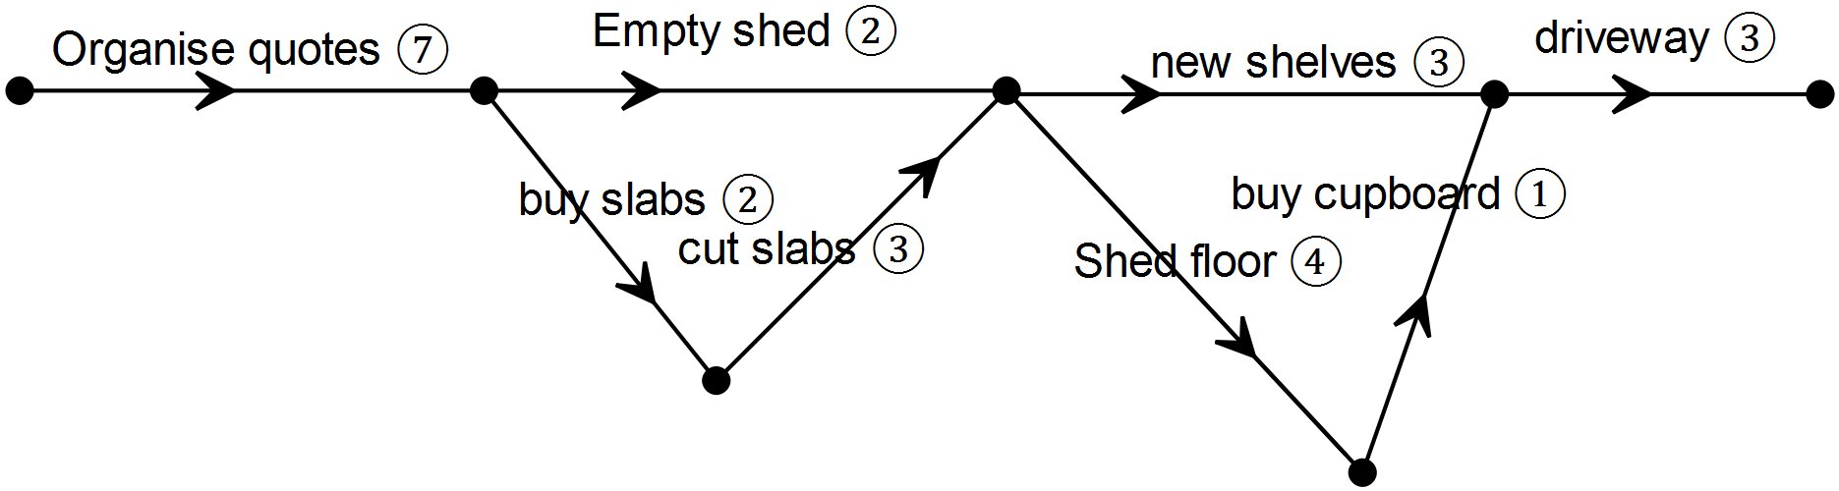

(a) For each activity identify which other activities needed to be completed before it could start (immediate predecessors).

(b) How long did the renovation take altogether?

(c) Determine the float time for emptying the shed.

(d) In this network could the new shelves be built while the shed floor was being done?

(e) The rubbish generated from the cleaning and building activities had to be removed before the driveway started. If Tim started organising quotes on 1 September 2015, by what date did the rubbish need to be removed?

**Exercise 3:**

Construct a network to represent the tasks that needed to be completed in the following project. Show the order and interdependencies of the tasks and their duration.

Sarah applied for a position in an early learning centre. The tasks carried out were as follows with times and immediate predecessors provided.

|  |  |  |
| --- | --- | --- |
| Activity | Time (days) | Immediate predecessors |
| A: Sarah saw an advertisement for the position and investigated the documents needed for an application | 2 | none |
| B: Sarah waited for a Working With Children card which she had to take to the first interview | 10 | A |
| C: Sarah worked on her CV | 2 | A |
| D: Sarah’s referees prepared her references | 3 | A |
| E: Sarah prepared her application form | 3 | C |
| F: Sarah decided to buy a new outfit after submitting the application | 2 | E, D |
| G: Sarah had to wait to be notified of her success in getting an interview | 10 | E, D |
| H: Sarah had two interviews | 7 | B,F,G |
| I: Sarah learned that she was successful | 4 | H |

Use a logical process to determine the time that passed from Sarah seeing the advertisement until she learnt that she had the position.

**Exercise 4:**

Select one of the following “projects” and create your own network.

* Cooking your favourite meal
* Getting ready for work
* Getting together with friends
* Going to a sporting fixture
* Visiting an elderly relative

**Exercise 5:**

In this exercise the following terms are used:

forward scanning backward scanning

earliest start times (EST) latest start times (LST)

critical path float times

The following project network represents some of the activities that need to be completed in preparing the early learning centre before the children arrive each morning. The estimated time for each activity is given in minutes.

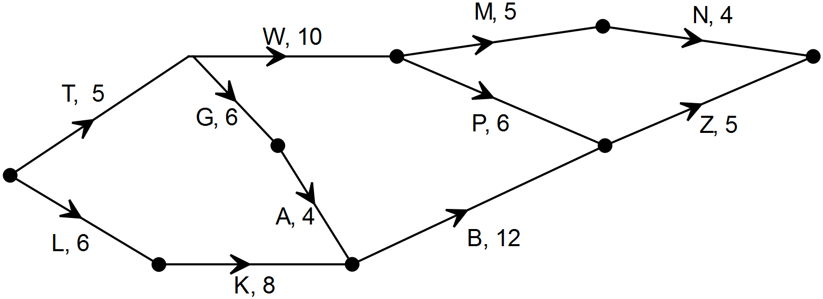

(a) Determine the EST and LST for each activity.

(b) Use the ESTs and the LSTs to determine the critical path.

(c) Determine the minimum time needed for the centre to be prepared each morning.

(d) If the centre needs to be ready by 7:00 am each morning, when should the preparations commence?

(e) Identify the non-critical activities.

(f) If filling up the water bottles (W) needs more time, how much more time can be allocated without changing the overall time to prepare.

(g) Identify other activities that can take more time without changing the overall preparation time.

**Planning**

**Extended investigation Part 2:** **In-class validation (50 marks)**

**Question 1 (8 marks)**

The project network from the preparation activity is copied below. It shows the tasks to be completed each morning before the children arrive at the early learning centre. The estimated time for each activity is given in minutes.



(a) Identify the critical path. [1]

(b) Determine the overall minimum completion time for all activities. [2]

(c) How much more time can be allocated to filling up the water bottles (W) without changing the overall time to complete the preparations. [1]

(d) Complete the table below. [4]

|  |  |  |
| --- | --- | --- |
| **Activity** | **Duration (minutes)** | **Immediate predecessors** |
| T |  |  |
| L |  |  |
| G |  |  |
| A |  |  |
|  |  |  |
|  |  |  |
|  |  |  |
|  |  |  |
|  |  |  |
|  |  |  |
|  |  |  |

**Question 2 (19 marks)**

The Centre Director wanted the staff to take more time to complete the preparations and rescheduled the activities by adding on an extra two minutes for each task. The network representing this new schedule is presented below.

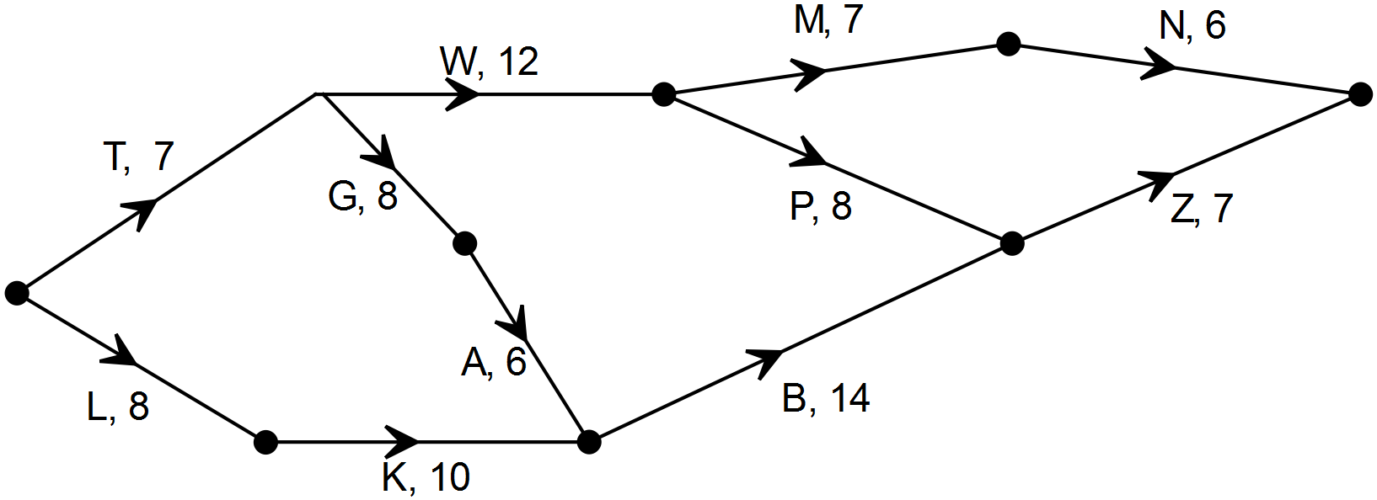

(a) On the copy of the schedule provided below, write the earliest start times (ESTs) for each activity at the vertex where the activity commences. [4]



(b) On the copy of the schedule provided below, write BOTH the ESTs and the LSTs for each activity at the vertex where the activity commences. Write the LSTs next to and on the right of the ESTs e.g. 3, 5 [4]



(c) Explain, using an example from this network, how you can use the ESTs and the LSTs to locate the critical path. [3]

(d) Identify the critical path and determine the time needed to prepare the centre with this new schedule. [3]

(e) By how much was the time needed to schedule all activities altered when each activity was allocated an extra 2 minutes? [1]

(f) If the scheduled length of each activity is increased by *k* minutes;

(i) what is the total time needed for the activities to be completed? [1]

(ii) will the critical path for this network change? Explain your decision. [3]

**Question 3 (14 marks)**

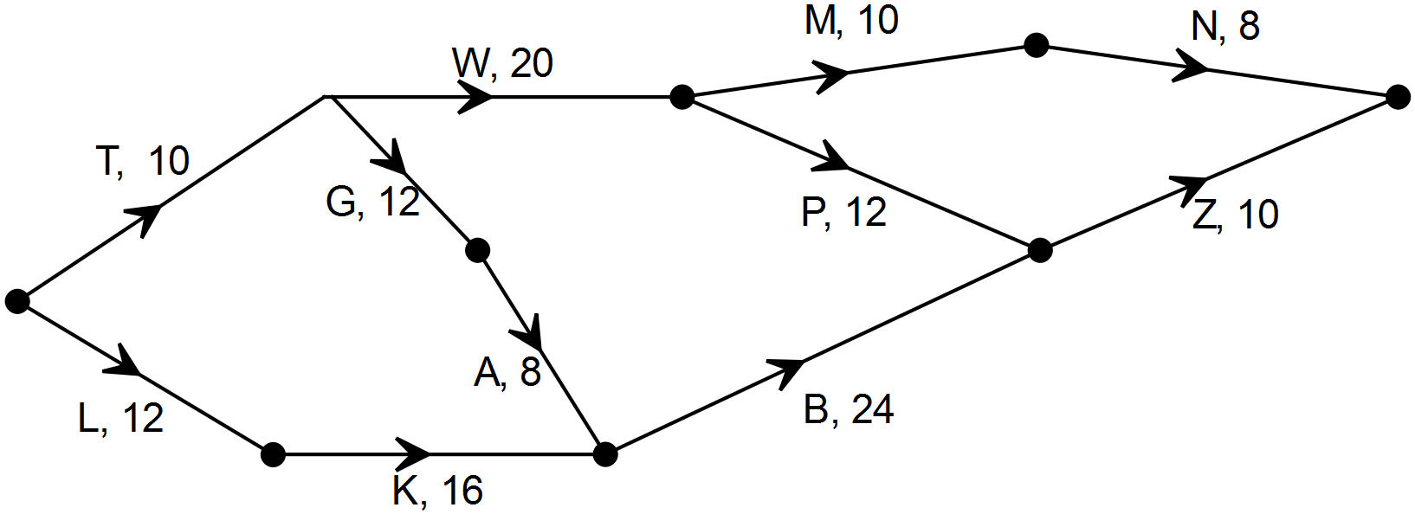

The original network is copied below and is used in this question.



(a) Identify the critical path [1]

(b) Identify the non-critical activities and explain why they are “non-critical”. [3]

(c) If sweeping the floors (L) took 7 minutes one day, by how much can putting out the paints (K) be extended without increasing the overall time to prepare? Justify your answer. [2]

(d) One day there was a significant drop on the water pressure and filling up the water bottles took 15 minutes and wiping the benches (P) took 10 minutes. How was the critical path affected? Justify your answer. [3]

If the Director decides to allow children to come at 6.30 am rather than 7.00 am:

(e) At what time should the watering of the pots (T) begin? [1]

(f) By what time should staff finish putting out the paints (K)? [1]

(g) What is the latest time that staff should start sweeping the floors (L)? [1]

(h) Between which two times can the staff begin putting the water bottles into each child’s toy box (M)? [2]

**Question 4 (9 marks)**

The Centre Director decided to experiment with the scheduling and decided to double the time allocated to each activity to see what impact the doubling would have on the total preparation time. The network showing the doubling is presented below.

(a) Show that the critical path remains the same as in the original network (see Question 1) and the total preparation takes twice as long. Provide evidence of systematic working so that your answers can be checked. [5]

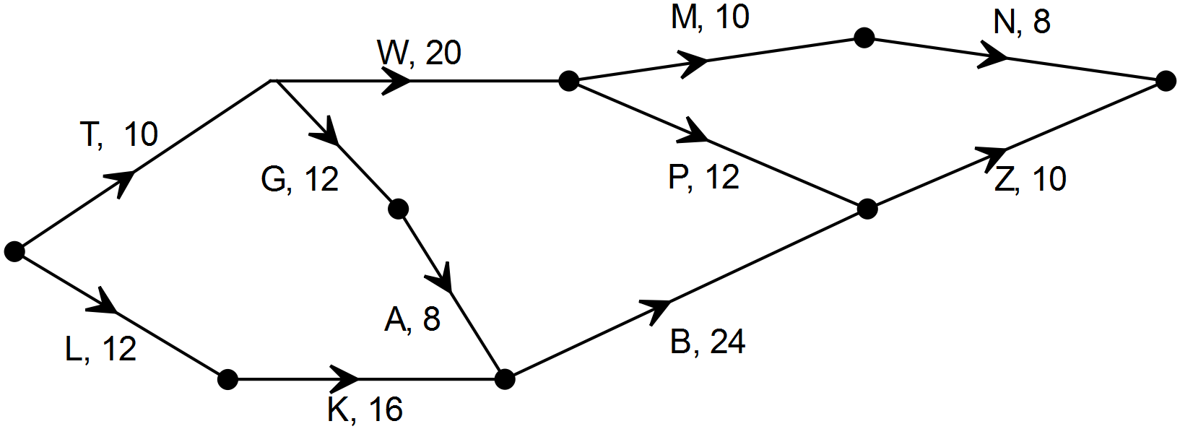

(b) The Director has proposed the following conjecture.

*If the activities remain the same but the time allocated to each activity is increased by multiplying the time by w, then the overall completion time is multiplied by w.*

Show that the conjecture is true. [4]



**End of questions**

**Planning**

**Extended investigation Part 1:** **Preparation activity**

**Solutions**

**Exercise 1**

|  |
| --- |
| Solution |
| (a) A project is a series of related activities which together need to be completed for the project to be finished.  (b) The edges represent the activities. The vertices represent the completion of one activity and the beginning of the next. The arrows on the edges point to the activity to be done next. At the junction of the vertices, activities (edges) which meet and point to the next activity are immediate predecessors for that next activity.  (c) Milly would have a series of activities and some could not be done (e.g. writing up her work) before others (e.g. finding out what coral is)  (d) Answers will vary |

**Exercise 2**

|  |
| --- |
| Solution |
| (a)   * The shed is emptied only after the quotes are obtained * The slabs are bought only after the quotes are obtained * The slabs are cut after they are bought * The new shelves are obtained and the shed floor is done after the shed is emptied and the slabs are cut. * The cupboard is bought after the shed floor is done * The driveway is done after the shelves are installed and the cupboard is obtained.   (b) 20 days  (c) 3 days  (d) yes  (e) 18 September 2015 |

**Exercise 3**

|  |
| --- |
| Solution |
| 24 days |

**Exercise 4**

|  |
| --- |
| Solution |
| Answers will vary |

**Exercise 5**

|  |
| --- |
| Solution |
| (a) The EST and the LST for each activity are on the left and right of the line at each vertex.  (b) Where EST = LST locate the critical path. The diagram shows the coloured, marked critical path TGABZ  (c) 32 minutes  (d) 6:28 am  (e) W, P, M, N, L , K  (f) 6 minutes  (g) K, L, M, N |

**Planning**

**Extended investigation Part 2:** **In-class validation**

**Solutions and marking key**

**Question 1(a)**

|  |  |
| --- | --- |
| Solution | |
| TGABZ | |
| Mathematical behaviours | Marks |
| * identifies critical path | 1 |

**Question 1(b)**

|  |  |
| --- | --- |
| Solution | |
| 32 minutes | |
| Mathematical behaviours | Marks |
| * determines time * identifies units | 1  1 |

**Question 1(c)**

|  |  |
| --- | --- |
| Solution | |
| 6 minutes | |
| Mathematical behaviours | Marks |
| * determines float time | 1 |

**Question 1(d)**

|  |  |
| --- | --- |
| Solution | |
| |  |  |  | | --- | --- | --- | | **Activity** | **Duration (minutes)** | **Immediate predecessors** | | T | 5 | - | | L | 6 | - | | G | 6 | T | | A | 4 | G | | K | 8 | L | | W | 10 | T | | B | 12 | A, K | | P | 6 | W | | M | 5 | W | | Z | 5 | P, B | | N | 4 | M | | |
| Mathematical behaviours | Marks |
| * identifies remaining activities * allocates time for each activity * determines 1 immediate predecessor for each activity\ * determines all other immediate predecessors | 1  1  1  1 |

**Question 2(a)**

|  |  |
| --- | --- |
| Solution | |
|  | |
| Mathematical behaviours | Marks |
| * starts with 0 * determines all EST with direct addition * determines EST where comparisons required * follows through to correct conclusion | 1  1  1  1 |

**Question 2(b)**

|  |  |
| --- | --- |
| Solution | |
|  | |
| Mathematical behaviours | Marks |
| * starts with 0 * determines all EST with direct addition * determines EST where comparisons required * follows through to correct conclusion | 1  1  1  1 |

**Question 2(c)**

|  |  |
| --- | --- |
| Solution | |
| Where the EST = LST the vertex links edges which are on the critical path.  For example at the junction of B and Z, EST = LST = 35 so the critical path goes along edges B and Z | |
| Mathematical behaviours | Marks |
| * identifies equal start times along the critical path * nominates relevant junction * describes times at the junction | 1  1  1 |

**Question 2(d)**

|  |  |
| --- | --- |
| Solution | |
| TGABZ  42 minutes | |
| Mathematical behaviours | Marks |
| * uses a systematic method to identify critical path * identifies critical path * determines length of critical path | 1  1  1 |

**Question 2(e)**

|  |  |
| --- | --- |
| Solution | |
| 10 minutes | |
| Mathematical behaviours | Marks |
| * determines difference | 1 |

**Question 2(f)**

|  |  |
| --- | --- |
| Solution | |
| (i) 32 + 5 *k*  (ii) No . TGABZ is already the longest path but it also has 5 edges. All other paths have 4 edges. If all edges are increased by a fixed number then TGABZ increases by more than the other paths so will remain the longest. | |
| Mathematical behaviours | Marks |
| * determines length * concludes path unchanged * links higher increase to number of edges being higher * compares critical path to other paths | 1  1  1  1 |

**Question 3(a)**

|  |  |
| --- | --- |
| Solution | |
| TGABZ | |
| Mathematical behaviours | Marks |
| * identifies critical path | 1 |

**Question 3(b)**

|  |  |
| --- | --- |
| Solution | |
| L, K, W, M N, P  They are not on the critical path | |
| Mathematical behaviours | Marks |
| * determines 3 non-critical paths * determines the other three non-critical paths * explains why paths are non-critical | 1  1  1 |

**Question 3(c)**

|  |  |
| --- | --- |
| Solution | |
| It cannot be extended at all.  TGA takes 15 minutes  The new LK now takes 15 minutes | |
| Mathematical behaviours | Marks |
| * concludes correctly * justifies conclusion | 1  1 |

**Question 3(d)**

|  |  |
| --- | --- |
| Solution | |
| The critical path changes to TWPZ  The preparation time would be 35 minutes  Activity GAB is still 22 but WP would have been 30 | |
| Mathematical behaviours | Marks |
| * identifies new critical path * identifies new completion time * relates the change to network section | 1  1  1 |

**Question 3(e)**

|  |  |
| --- | --- |
| Solution | |
| 5.58 am | |
| Mathematical behaviours | Marks |
| * determines time difference | 1 |

**Question 3(f)**

|  |  |
| --- | --- |
| Solution | |
| 6.13 am | |
| Mathematical behaviours | Marks |
| * backtracks to starting time | 1 |

**Question 3(g)**

|  |  |
| --- | --- |
| Solution | |
| 5.59 am | |
| Mathematical behaviours | Marks |
| * backtracks to starting time | 1 |

**Question 3(h)**

|  |  |
| --- | --- |
| Solution | |
| 6.13 am to 6.26 am | |
| Mathematical behaviours | Marks |
| * identifies earliest time * identifies the later time | 1  1 |

**Question 4(a)**

|  |  |
| --- | --- |
| Solution | |
| TGABZ  64 minutes  Note: 64 = 2 x 32 | |
| Mathematical behaviours | Marks |
| * identifies critical path on diagram or by listing * identifies length of critical paths * compares to original path * shows systematic working | 1  1  1  2 |

**Question 4(b)**

|  |  |
| --- | --- |
| Solution | |
| TGABZ = 5*w + 6w + 4w + 12w + 5w =*  32*w*  This is *w* times the original path | |
| Mathematical behaviours | Marks |
| * identifies length of edges on the critical paths * sums the lengths of the edges * calculates length as a variable * compares to original path | 1  1  1  1 |

**TASK 17: TREES**

**In-class investigation**

**Unit 4**

**Topic 4.3: Networks and decision mathematics**

**Course-related information**

The concepts and skills developed in this investigation relate to the following dot points within the WA Mathematics Applications syllabus:

4.3.1 Identify practical examples that can be represented by trees and spanning trees

4.3.2 identify a minimum spanning tree in a weighted connected graph, either by inspection or by using Prim’s algorithm

**Background information**

For this investigation students should have a working knowledge of the main concepts in Topic 3.3. They should know the terminology for vertices, edges, degrees of a vertex, odd and even vertices, loops, multiple edges, connected graphs and cycles. The task could be used as an introduction to trees and to the content of the dot points listed above. It is not necessary for students to have started Unit 4.

**Task conditions**

This task consists of an in-class investigation for which students might need 40 – 50 minutes to complete.

**Trees**

**In-class investigation (Total marks: 48)**

This investigation introduces the concept of “trees” in graph theory and provides some insight into how they are applied.

***A tree is a connected graph with no cycles, loops or multiple edges.***

**(6 marks)**

Diagrams A to E represent trees

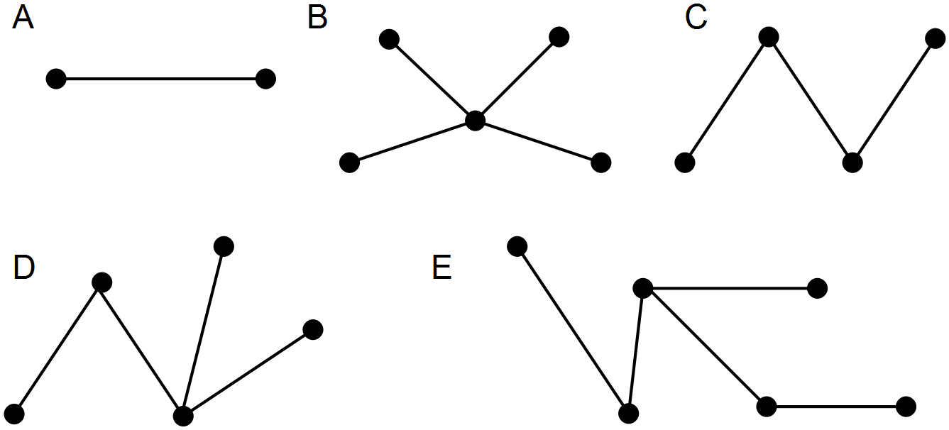

**End of questions**

**Title in sentence case and font 12 and no task number**

Diagrams F to I show graphs which are not trees.

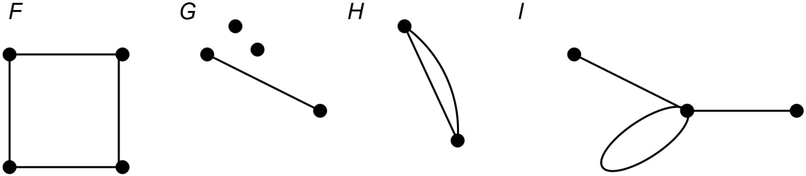

**Question 1 (4 marks)**

Briefly describe why the graphs F to I are not trees.

F

G

H

I

**Question 2 (12 marks)**

(a) Use the trees provided in the Introduction to complete the table below. [5]

|  |  |  |  |
| --- | --- | --- | --- |
| **Tree** | **Number of vertices** | **Number of edges** | **Total degrees for all vertices** |
| **A** |  |  |  |
| **B** |  |  |  |
| **C** |  |  |  |
| **D** |  |  |  |
| **E** |  |  |  |

(b) Describe the relationship between the number of edges and the total degrees for all vertices. [1]

(c) Is the relationship described in part (b) true for all trees? Explain. [2]

(d) In which tree is there a vertex with degree = 4? [1]

(e) Can trees with both odd and even vertices exist? Justify your conclusion. [1]

(f) Can a tree have only even vertices? Justify your conclusion. [2]

**Question 3 (8 marks)**

Draw trees with the following features.

(a) A tree with at least one vertex with degree = 6 [1]

(b) A tree with 8 edges. [1]

(c) A tree with 12 vertices, 11 edges and the sum of all the degrees for each vertex is 22. [2]

(d) A tree with four odd and four even vertices. [2]

(e) A tree with 8 vertices and 7 edges. [2]

**Question 4 (7 marks)**

The complete graph drawn shows the walkways between four activities at the local show. The activities are Sheep shearing (S), Wood chopping (W), Baby Animals (B) and the Cake Stall (C).

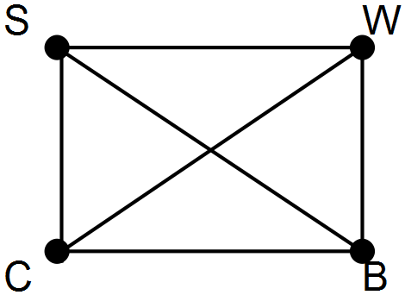

If the Show organisers wanted to upgrade the bike paths between these activities but not upgrade every single connection, they would be considering various “trees”.

Three trees for these activities are drawn below.

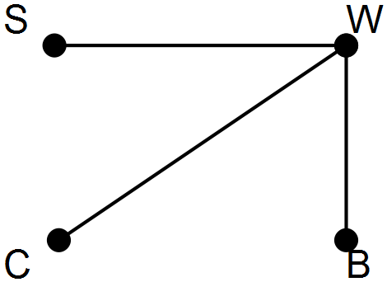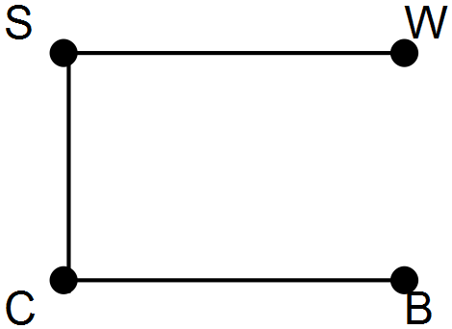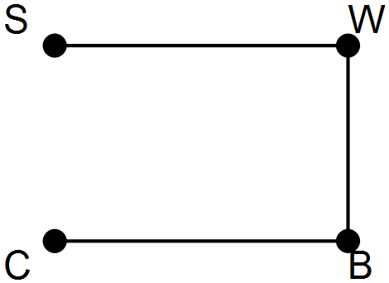

Draw other possible “trees” to represent the arrangement of bike paths that could be upgraded. Try to draw as many different ones as possible.

**Question 5 (6 marks)**

Some of the routes between animal enclosures at the zoo need to be upgraded for use by parents with prams. The graph below shows the existing routes between the tigers (T), frogs (F), wallabies (W), monkeys (M), penguins (P) and elephants (E).

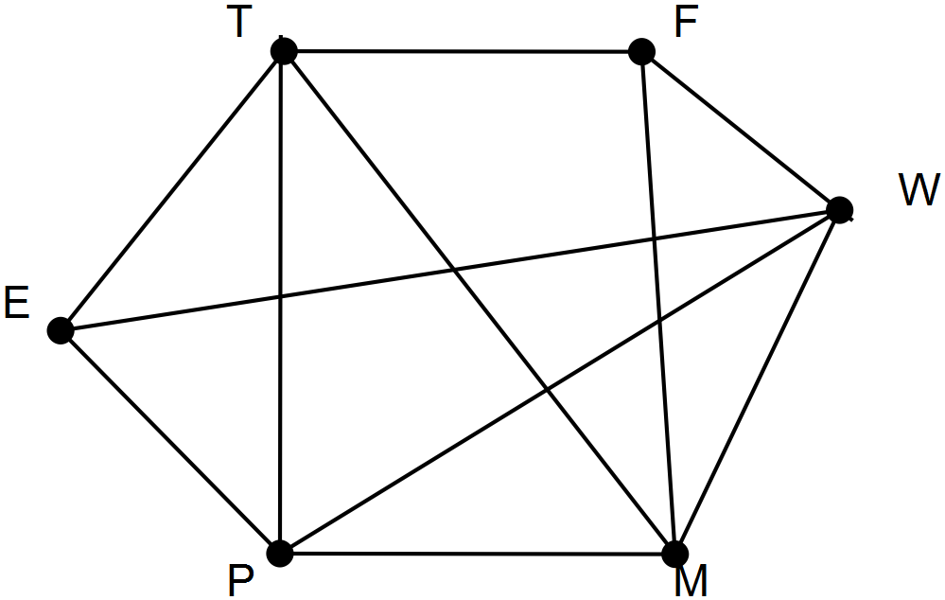

By highlighting, colouring or shading edges clearly, show 6 different trees which could represent the minimum number of routes to be upgraded so that the animal enclosures are connected.



**Question 6 (11 marks)**



In another part of the Zoothe routes that could be upgraded have beenmeasured and the diagram below shows the routes between animal enclosures and the length of each route (metres).To upgrade the minimum number of routes a tree needs to be identified.

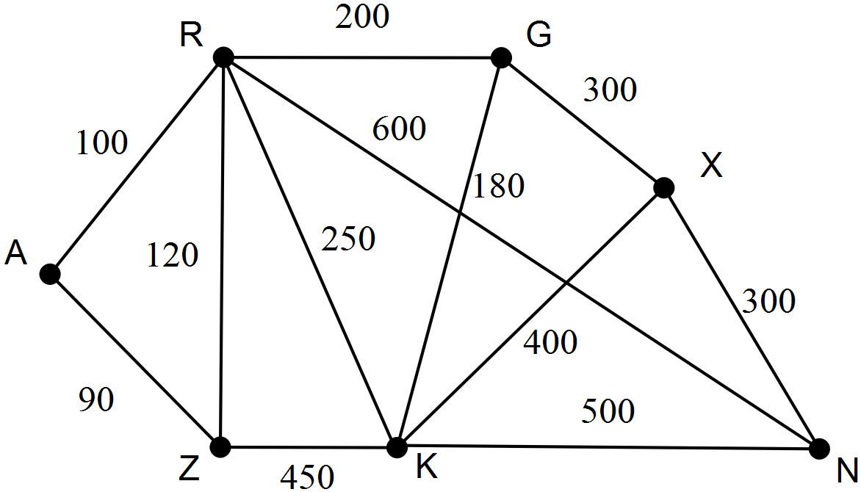

(a) If the tree chosen for upgrade is KNXGRAZ, how long is it? [1]

(b) Determine four other trees that could be used to identify the routes to be upgraded. Identify the tree and the total length of the routes in the tree. [8]

[The graph is copied to the next page and you can use the diagrams to mark the edges for the four trees.]

|  |  |  |
| --- | --- | --- |
| **Tree** | **Edges** | **Length** |
| **1** |  |  |
| **2** |  |  |
| **3** |  |  |
| **4** |  |  |

(c) If the cost of upgrading is $3500 per 100 metres, which of the five trees identified here would be the cheapest to upgrade? Determine the cost of this upgrade. [2]



**Trees**

**In-class investigation**

**Solutions and marking key**

**Question 1**

|  |  |
| --- | --- |
| Solution | |
| F: has a cycle  G: is not connected  H: has multiple edges  I: has a loop | |
| Mathematical behaviours | Marks |
| * identifies cycle * identifies lack of connection * identifies multiple edges * identifies loop | 1  1  1  1 |

**Question 2(a)**

|  |  |
| --- | --- |
| Solution | |
| |  |  |  |  | | --- | --- | --- | --- | | **Tree** | **Number of vertices** | **Number of edges** | **Total degrees for all vertices** | | **A** | 2 | 1 | 2 | | **B** | 5 | 4 | 8 | | **C** | 4 | 3 | 6 | | **D** | 5 | 4 | 8 | | **E** | 6 | 5 | 10 | | |
| Mathematical behaviours | Marks |
| * determines number of vertices * determines numbers of edges * determines total degrees in each tree (1 - 2 trees, 2-4 trees ) | 1  1  3 |

**Question 2(b)**

|  |  |
| --- | --- |
| Solution | |
| The total degrees for all vertices = 2 x number of edges | |
| Mathematical behaviours | Marks |
| * describes relationship between variables | 1 |

**Question 2(c)**

|  |  |
| --- | --- |
| Solution | |
| Yes. Each edge is only joined to two vertices so the total number of edges coming out of each vertex (its degree) is twice the number of edges. | |
| Mathematical behaviours | Marks |
| * concludes correctly * justifies conclusion | 1  1 |

**Question 2(d)**

|  |  |
| --- | --- |
| Solution | |
| B | |
| Mathematical behaviours | Marks |
| * identifies vertex with degree = 4 | 1 |

**Question 2(e)**

|  |  |
| --- | --- |
| Solution | |
| Yes. B, C, D and E all have both types | |
| Mathematical behaviours | Marks |
| * justifies conclusion | 1 |

**Question 2(f)**

|  |  |
| --- | --- |
| Solution | |
| No. It would form a cycle. There needs to be at least two vertices with degree = 1 (odd) at the ends of the tree. | |
| Mathematical behaviours | Marks |
| * concludes correctly * justifies conclusion | 1  1 |

**Question 3(a,b)**

|  |  |
| --- | --- |
| Solution | |
|  | |
| Mathematical behaviours | Marks |
| * represents tree vertex with degree = 6 * represents tree with 8 edges | 1  1 |

**Question 3(c)**

|  |  |
| --- | --- |
| Solution | |
|  | |
| Mathematical behaviours | Marks |
| * represents tree with 12 vertices * tree has 11 edges | 1  1 |

**Question 3(d)**

|  |  |
| --- | --- |
| Solution | |
|  | |
| Mathematical behaviours | Marks |
| * represents tree with 4 even vertices * tree has 4 odd vertices | 1  1 |

**Question 3(e)**

|  |  |
| --- | --- |
| Solution | |
|  | |
| Mathematical behaviours | Marks |
| * represents tree with 8 vertices * tree has 7 edges | 1  1 |

**Question 4**

|  |  |
| --- | --- |
| Solution | |
|  | |
| Mathematical behaviours | Marks |
| * At least 7 different trees exist: 1 mark for each different one found | 7 |

**Question 5**

|  |  |
| --- | --- |
| Solution | |
|  | |
| Mathematical behaviours | Marks |
| * identifies different trees | 2 |

**Question 5 (cont’d)**

|  |  |
| --- | --- |
| Solution | |
|  | |
|  | |
| Mathematical behaviours | Marks |
| * identifies different trees | 4 |

**Question 6(a)**

|  |  |
| --- | --- |
| Solution | |
| 1490 m | |
| Mathematical behaviours | Marks |
| * determines length of path | 1 |

**Question 6(b)**

|  |  |
| --- | --- |
| Solution | |
| |  |  |  | | --- | --- | --- | | **Tree** | **Edges** | **Length** | | **1** | Path along KZARGXN | 1440 m | | **2** | Path along ARZKGXN | 1450 m | | **3** | Path along NRAZKGX | 1720 m | | **4** | Path along RNXGKZA | 1920 m |   Answers will vary but include those listed above | |
| Mathematical behaviours | Marks |
| * For each path and length 2 marks | 8 |

**Question 6(c)**

|  |  |
| --- | --- |
| Solution | |
| 1440 x 35 = $50 400 | |
| Mathematical behaviours | Marks |
| * identifies minimum tree * calculates cost | 1  1 |

**TASK 18**

**Investigative questions**

**Unit 4**

**Topic 4.3: Networks and decision mathematics**

**Course-related information**

The concepts and skills covered in these investigative questions relate to the following dot points within the WA Mathematics Applications syllabus:

3.3.7 investigate and solve practical problems to determine the shortest path between two vertices in a weighted graph (by trial-and-error methods only)

3.3.9 demonstrate the meanings of, and use, the terms: Hamiltonian graph and semi-Hamiltonian graph, and use these concepts to investigate and solve practical problems

4.3.2 identify a minimum spanning tree in a weighted connected graph, either by inspection or by using Prim’s algorithm

4.3.9 solve small-scale network flow problems, including the use of the ‘maximum flow-minimum cut’ theorem

4.3.10 use a bipartite graph and/or its tabular or matrix form to represent an assignment/ allocation problem

4.3.11 determine the optimum assignment(s), by inspection for small-scale problems, or by use of the Hungarian algorithm for larger problems

The ability to choose and use appropriate technology to enhance and extend concept development is also required for some of the items

**Background information**

Some questions cover Topic 3.3.

**Task conditions**

These items should be undertaken under test conditions, either as part of a test/examination or as stand-alone items. Student access to a graphical/CAS calculator is assumed. The time required to complete each question is left to the discretion of the teacher but the intention is that each question may be completed within 15 minutes.

**Investigative questions for Topic 4.3**

**Question 1 (12 marks)**

Nick, Lottie, Bert and Grace are going to prepare the hall for the final Year 12 assembly. There are four tasks to allocate

1. Create a list of students

2. Collect the prizes

3. Put up the House banners

4. Order the certificates

Danny has started using the Hungarian algorithm to determine the least amount of time needed to complete all the tasks if each student is allocated one of the four tasks.

|  |  |  |  |  |
| --- | --- | --- | --- | --- |
|  | **Create a student list** | **Collect prizes** | **Put up banners** | **Order the certificates** |
| **Nick** | 20  ~~40~~ | 5  ~~25~~ | 0 | 45  ~~65~~ |
| **Grace** | 20  ~~50~~ | 0 | 5  ~~35~~ | 20  ~~50~~ |
| **Lottie** | 0 | 5  ~~45~~ | 5  ~~45~~ | 15  ~~55~~ |
| **Bert** | 40  ~~55~~ | 20  ~~35~~ | 0 | 10  ~~25~~ |

(a) The table above shows the result after Danny has completed the first step.

The time is given in minutes. Describe in detail what Danny has done. [3]

(b) What is the next step for Danny to do? [1]

(c) Complete the step described in part (b) on the table above. [1]

(d) Describe how you know the tasks can now be assigned. [2]

(e) Allocate the tasks to minimise the completion time. [3]

(f) Determine the total minimum time required to complete all four tasks. [2]

Assume the tasks are not done simultaneously.

**Question 2 (13 marks)**

The links between facilities in a suburban park are represented in the network drawn below where the distances are given in metres.

(a) Access to the facilities has to be improved to allow children to ride their bikes between the facilities. At a cost of $100 per metre, what is the cost of the most economical set of links to improve? [5]

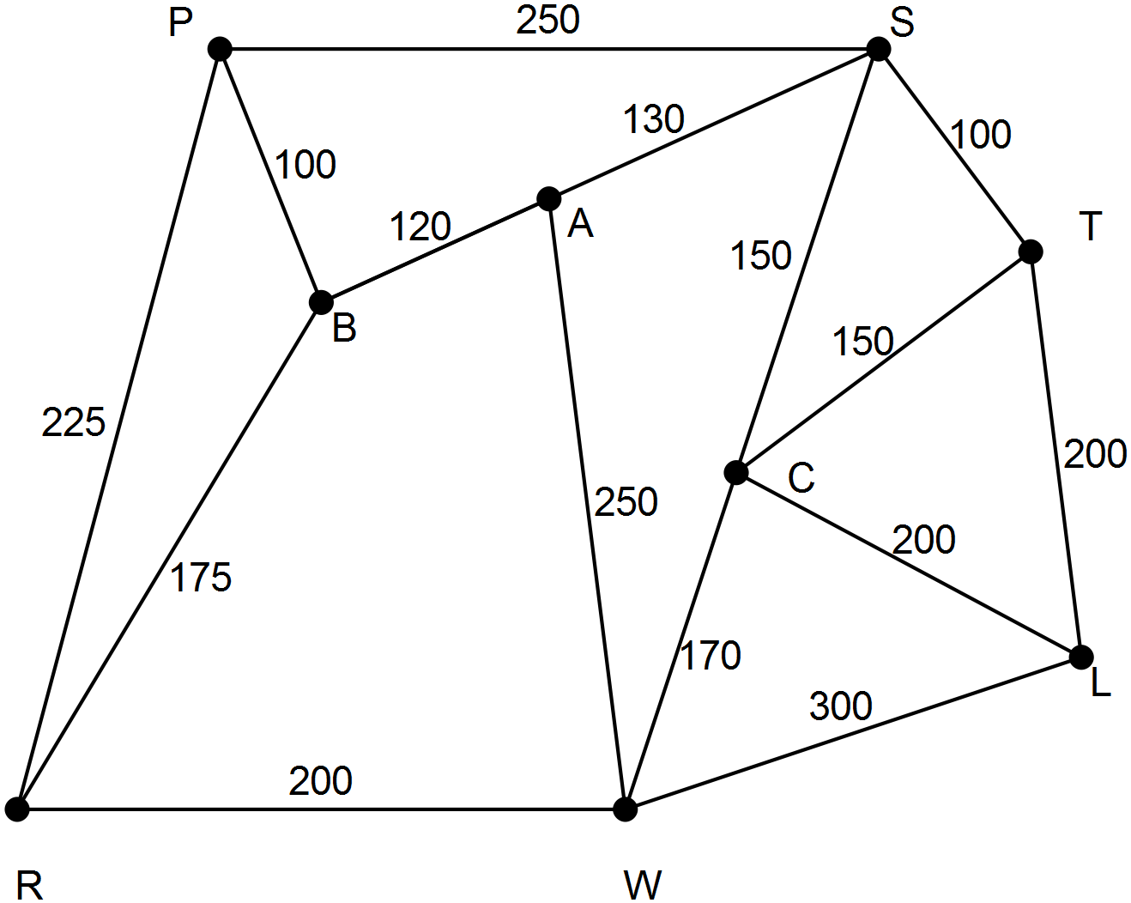

(b) Mary is walking from the picnic area (P) to the Little Theatre (L) via the barbecue facilities (B). Determine the length of the shortest route she could take. [4]



(c) There are bins located at each of the facilities. Mark a route starting and finishing at L that a rubbish truck could use to go to each facility and empty the bins. [2]



(d) It is possible to close three links between pairs of facilities so that the ranger can start at one facility and ride along each edge once without needing to backtrack. Identify the three links.

[2]

**Question 3 (11 marks)**

Part of the network of pipes in a block of units is shown in the diagram below. The labels on the pipes indicate the carrying capacity of that pipe in litres per minute. In this part of the network water comes in at the junction marked W and exits to the apartment at the junction marked K. Water can flow from left to right (e.g. M 🡪 K) , down (e.g. Q 🡪 R), or from the back to the front (e.g. Q 🡪 P).

(a) Identify the

(i) source [1]

(ii) sink [1]

(iii) the maximum number of litres that can flow from the source at any one time

[1]

(iv) the maximum number of litres that can flow into the sink at any one time

[1]

(b) Use your answers from part (a) to identify the number of litres per hour that the maximum flow cannot exceed. [1]

(c) Show the use of a systematic method to determine the actual maximum flow of water through this part of the pipe network. [4]

(d) Water is leaking out of the pipe from T to R at a rate of 5 litres per minute. How does this leak alter the maximum amount of water flowing out of this part of the system? Explain your conclusion. [2]

**Investigative questions in Topic 4.3**

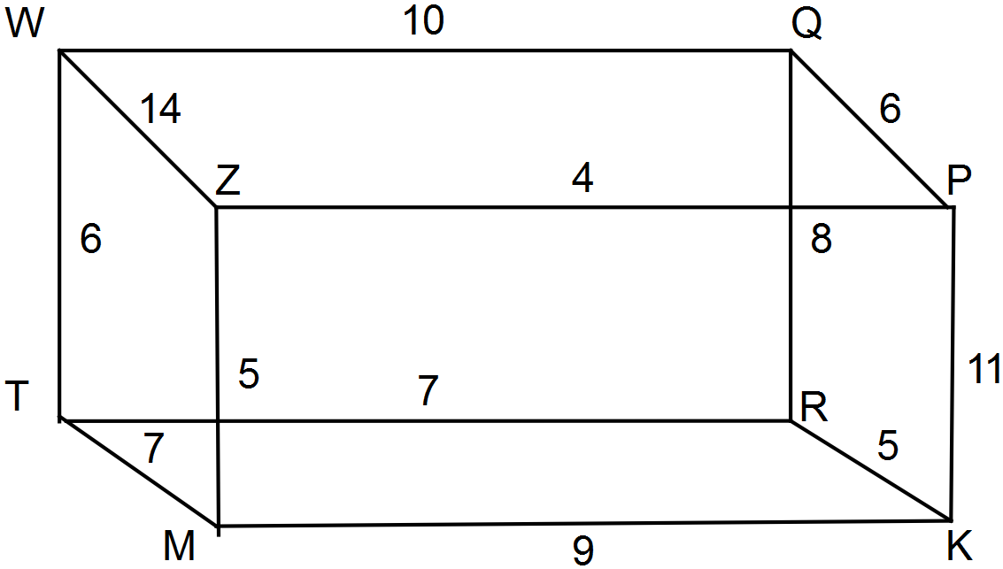

**Solutions and marking key**

**Question 1(a)**

|  |  |
| --- | --- |
| Solution | |
| Subtracted 20 off the first row, 30 off the second, 40 off the third and 15 off the last row | |
| Mathematical behaviours | Marks |
| * describes subtraction from each row * describes the amount by which the numbers are reduced for 2 rows * describes the amount by which the numbers are reduced for row 3 | 1  1  1 |

**Question 1(b)**

|  |  |
| --- | --- |
| Solution | |
| Subtract 10 from every element in the last column | |
| Mathematical behaviours | Marks |
| * identifies next step of Hungarian algorithm | 1 |

**Question 1(c)**

|  |  |
| --- | --- |
| Solution | |
| |  |  |  |  |  | | --- | --- | --- | --- | --- | |  | Create a student list | Collect prizes | Put up banners | Order the certificates | | Nick | 20  ~~40~~ | 5  ~~25~~ | 0 | ~~45~~ 35  ~~65~~ | | Grace | 20  ~~50~~ | 0 | 5  ~~35~~ | ~~20~~ 10  ~~50~~ | | Lottie | 0 | 5  ~~45~~ | 5  ~~45~~ | ~~15~~ 5  ~~55~~ | | Bert | 40  ~~55~~ | 20  ~~35~~ | 0 | ~~10~~ 0  ~~25~~ | | |
| Mathematical behaviours | Marks |
| * identifies next step of Hungarian algorithm | 1 |

. **Question 1(d)**

|  |  |
| --- | --- |
| Solution | |
| Need 4 straight lines and 4 is the dimension of the matrix to cross out all the zeroes. | |
| Mathematical behaviours | Marks |
| * identifies next step of the Hungarian algorithm * links number of rows to dimensions of matrix (table) | 1  1 |

**Question 1(e)**

|  |  |
| --- | --- |
| Solution | |
| Lottie creates the student list  Grace collects the prizes  Bert orders the certificates  Nick puts up the banners | |
| Mathematical behaviours | Marks |
| * identifies two allocations * identifies further two allocations | 1  1 |

. **Question 1(f)**

|  |  |
| --- | --- |
| Solution | |
| Total time = 40 + 30 + 25 + 20 = 115 minutes | |
| Mathematical behaviours | Marks |
| * identifies time to be added back into the rows * calculates total time needed | 1  1 |

**Question 2(a)**

|  |  |
| --- | --- |
| Solution | |
| Cost = 100 x (100 + 175 + 120 + 130 + 100 + 150 + 200 + 170 ) = $114 500 | |
| Mathematical behaviours | Marks |
| * identifies 4 edges of the minimum spanning tree * identifies another set of 4 edges of the minimum spanning tree * does not include unnecessary links * does not include any cycles * calculates cost | 1  1  1  1  1 |

**Question 2(b)**

|  |  |
| --- | --- |
| Solution | |
| Length = 100+ 120 + 130 + 100 + 200 = 650 m | |
| Mathematical behaviours | Marks |
| * provides evidence of a systematic approach to determine shortest path * determines shortest path * calculates total distance | 2  1  1 |

**Question 2(c)**

|  |  |
| --- | --- |
| Solution | |
|  | |
| Mathematical behaviours | Marks |
| * route goes through every vertex once * no vertex is repeated | 1  1 |

**Question 2(d)**

|  |  |
| --- | --- |
| Solution | |
| RP, WL and AW | |
| Mathematical behaviours | Marks |
| * reduces the number of odd vertices, leaving only two odd vertices * route goes through every vertex once only | 1  1 |

**Question 3(a)**

|  |  |
| --- | --- |
| Solution | |
| (i) W  (ii) K  (iii) 30 litres per minute  (iv) 25 litres per minute | |
| Mathematical behaviours | Marks |
| * identifies source * identifies sink * determines maximum input to the system * determines maximum output from the system | 1  1  1  1 |

**Question 3(b)**

|  |  |
| --- | --- |
| Solution | |
| Cannot exceed 1500 litres per hour | |
| Mathematical behaviours | Marks |
| * identifies maximum output at the sink cannot be exceeded | 1 |

**Question 3(c)**

|  |  |
| --- | --- |
| Solution | |
| 6 along WQPK (QP=0)  4 along WQRK (WQ=0)  4 along WZPK (ZP=0)  4 along WZMK (MK=0)  1 along WTRK ((RK=0)  5 along WTMK (WT=0)  Total 24 litres per minute | |
| Mathematical behaviours | Marks |
| * selects appropriate routes * identifies maximum capacity for routes * identifies all routes possible * determines maximum flow | 1  1  1  1 |

**Question 3(d)**

|  |  |
| --- | --- |
| Solution | |
| It makes no difference because R still has a capacity of 6 litres per minute | |
| Mathematical behaviours | Marks |
| * concludes correctly * justifies conclusion | 1  1 |